TOP VIEW

Ø32" TWIST & LOCK LID W/
INFLATABLE WATERTIGHT SEAL

LOCKING TABS FOR PADLOCK

2'-8 1/4" I.D.
1'-6"
TOP 18" GEL-COAT

ISOMETRIC VIEW

A

2'-6" I.D.

Ø30" FRP RISER W/ BELL END FOR EPOXY SOCKET
3"
SHEET TITLE:
Ø30" FRP RISER W/ Ø32" TWIST & LOCK WATERTIGHT LID

DRAWN DATE:
08/14/21

DRAWN BY:
JACK

REV.
00

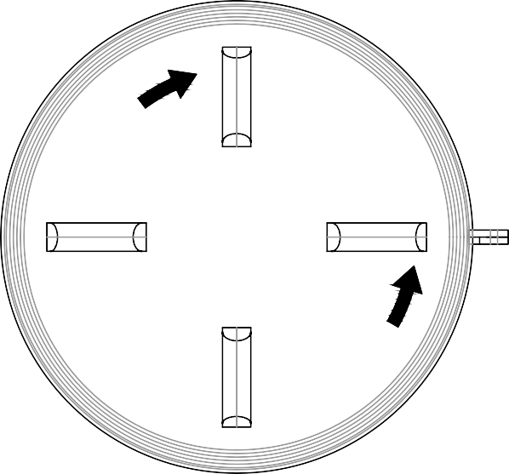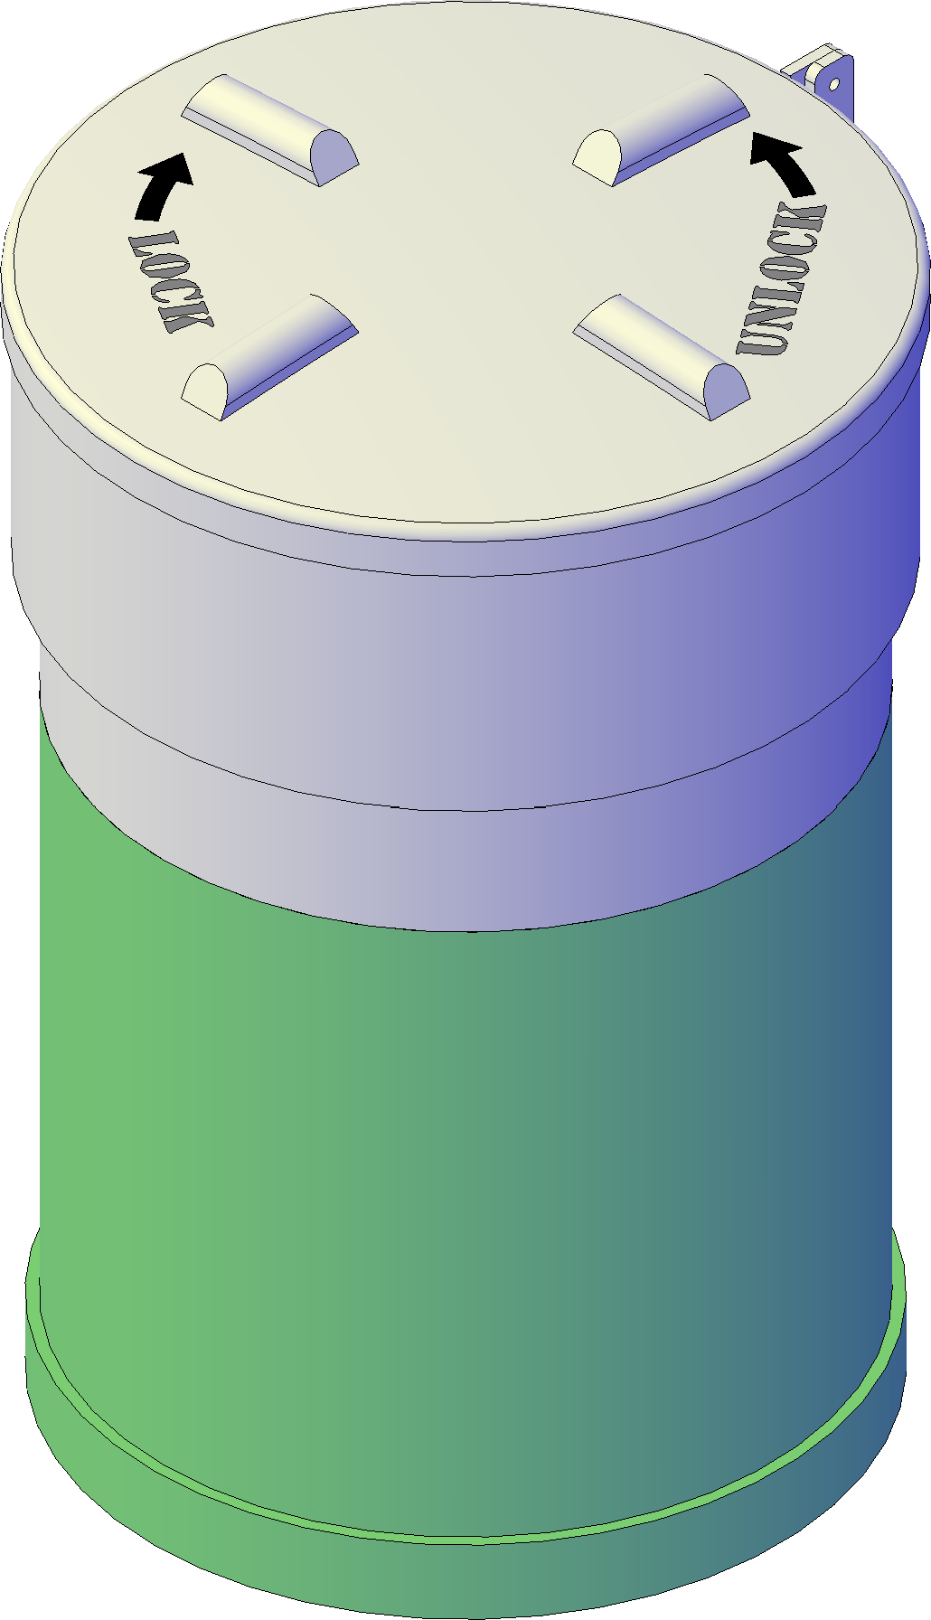2'-7"
2'-7 1/2"

FRONT VIEW

Mailing: P.O. BOX 326, Montreal, MO 65591 MFG: 147 Opportunity Rd.,
Camdenton, MO 65020
P: 573-317-9620

