Ø24" ACCESS OPENING W/ EPOXY SOCKET TO FIT FRP RISERS
Ø30" ACCESS OPENING W/ EPOXY SOCKET TO FIT FRP RISERS
Ø42" ACCESS OPENING W/ EPOXY SOCKET TO FIT FRP RISERS

ISOMETRIC VIEW
ISOMETRIC VIEW
ISOMETRIC VIEW

TOP VIEW

26 1/2"
26"
24 1/2"
10"
3"
24"
TOP VIEW

32 1/2"
32"
30 1/2"
3"
30"
TOP VIEW

44 1/2"
44"
42 1/2"
3"
42"

SHEET TITLE:
ACCESS OPENINGS W/ EPOXY SOCKET FOR FRP RISERS
6"

DRAWN DATE:
6"
12"
6"
14"
11/12/20
DRAWN BY:
JACK
REV.
00

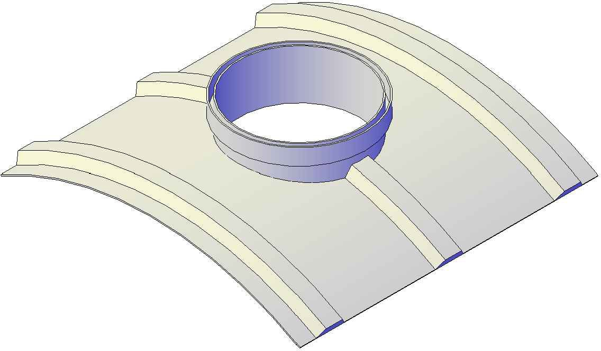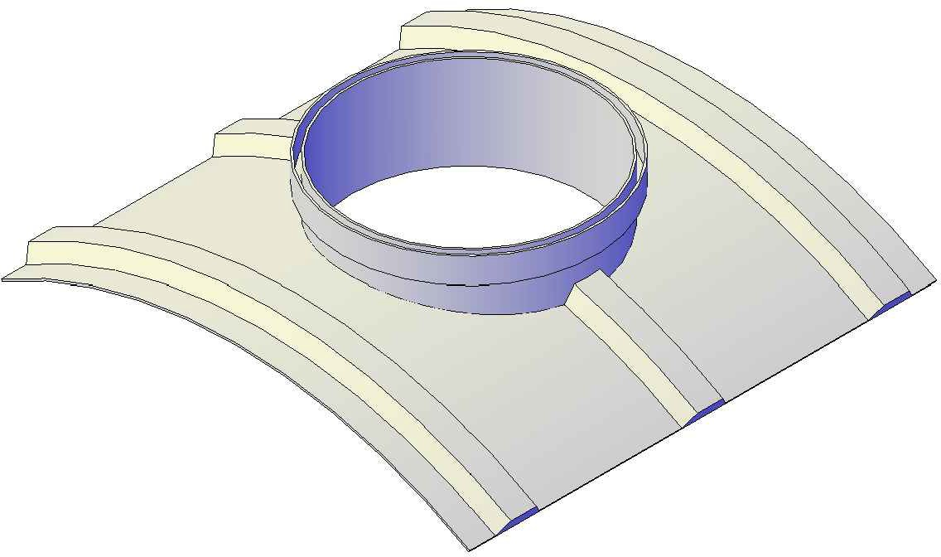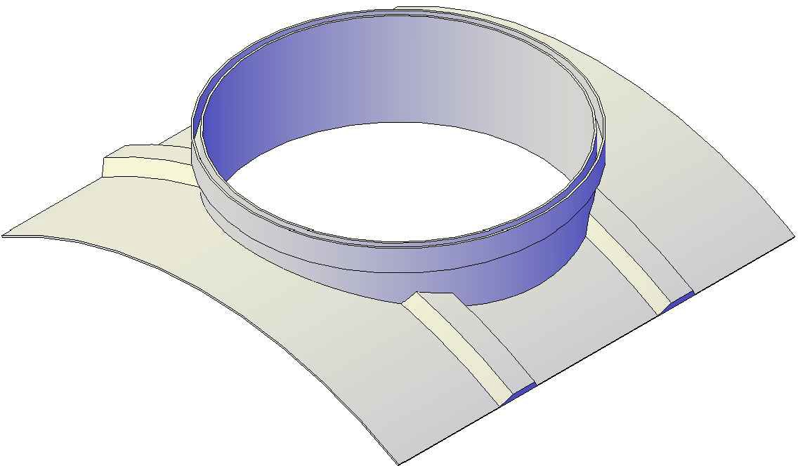FRONT VIEW
FRONT VIEW
FRONT VIEW
Mailing: P.O. BOX 326, Montreal, MO 65591 MFG: 147 Camdenton Bus. Prk. Dr., Camdenton, MO 65020
P: 573-317-9620

