024" ACCESS OPENING W/ INTERNAL FLANGE TO FIT PVC RISERS

030" ACCESS OPENING W/ INTERNAL FLANGE TO FIT PVC RISERS

ISOMETRIC VIEW ISOMETRIC VIEW

TOP VIEW TOP VIEW

23" O.D.
10"

22 1/2" I.D.
2'-5" O.D.
28 1/2" I.D.
1'-0"

SHEET TITLE:
ACCESS OPENINGS W/ INTERNAL FLG FOR PVC RISERS
6"

DRAWN DATE:
6"
11/12/20
1/4"
1/4"
DRAWN BY:
JACK
REV.
00

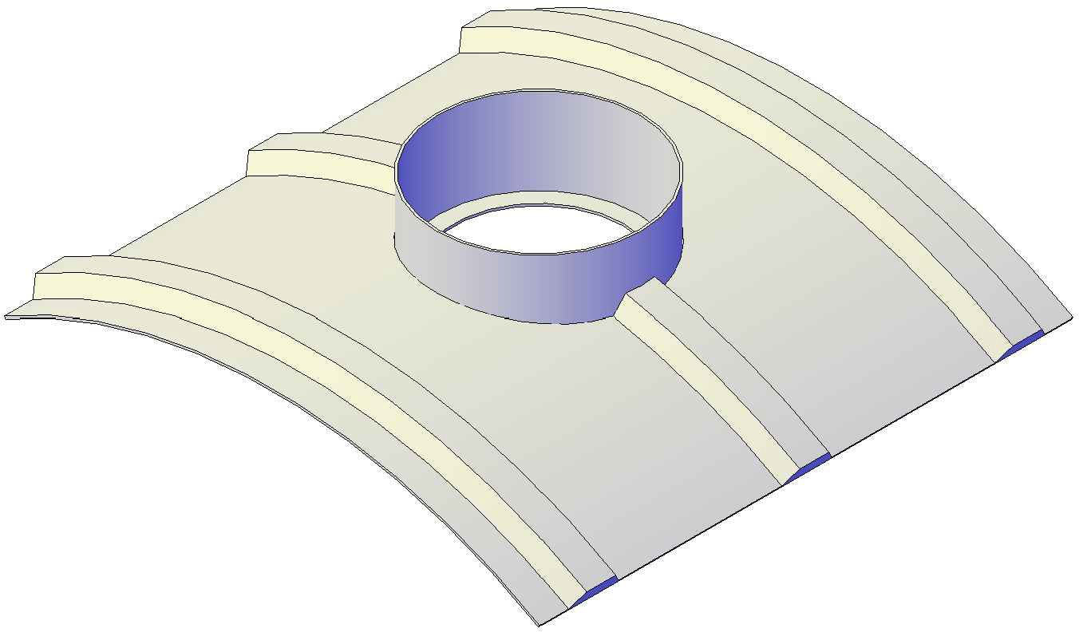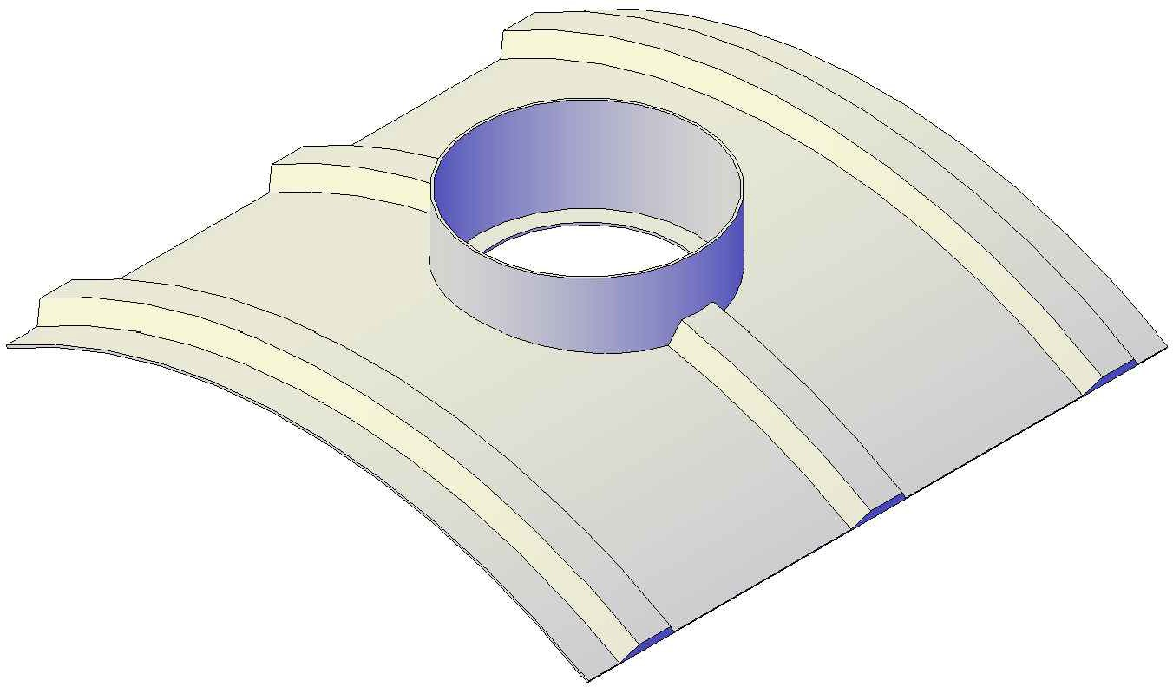FRONT VIEW
FRONT VIEW
Mailing: P.O. BOX 326, Montreal, MO 65591 MFG: 147 Camdenton Bus. Prk. Dr., Camdenton, MO 65020
P: 573-317-9620

