FLAT BAFFLE WALLS

FLOW THROUGH HOLES

CROSSOVER INVERT IF APPLICABLE
A

FULL FLAT BAFFLE

FLOW THROUGH HOLES

CROSSOVER INVERT IF APPLICABLE
A
A

7/8 FLAT BAFFLE

BAFFLE CROSSOVER WILL BE: (PLEASE CHECK ONE)

IF USING FLOW-THROUGH HOLES:
A
FLOW THROUGH HOLES CROSSOVER PIPING
DIAMETER OF HOLE (S) QUANTITY OF HOLE (S)

SHEET TITLE:
SELECTION GUIDE
PROJECT:
FLAT BAFFLE WALLS

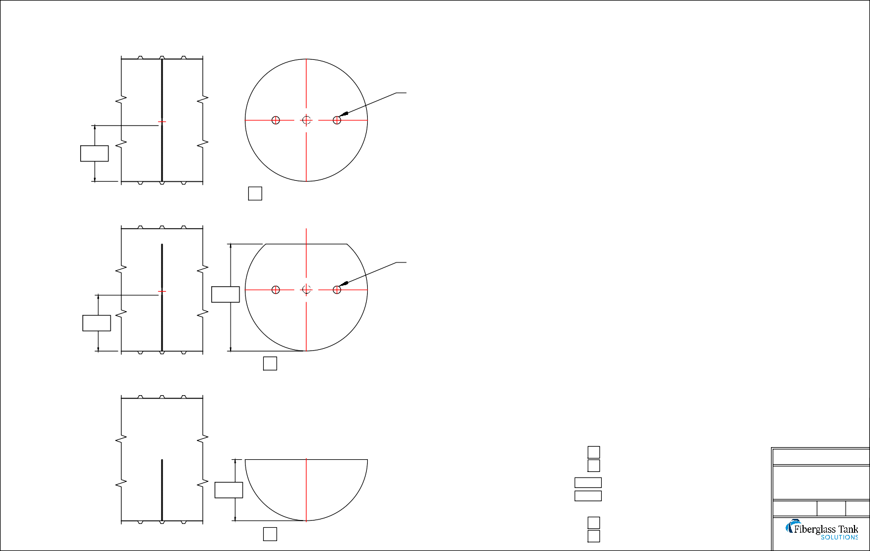

1/2 FLAT BAFFLE

BAFFLE MUST PROVIDE A SOLID BARRIER FOR LIQUIDS/ SOLIDS SEPARATION

YES NO
DRAWN DATE: DRAWN BY: REV.
01/10/20 JACK 00

P.O. BOX 326, Montreal, MO 65591 P: 573-317-9620

