FRP Composite Services Composite Engineering Design Finite Element Analysis
D2020·02·01 jdu@frpcompositeservices.com (o) 417·708-6651 (c) 310·913-5502

Rev.O

ENGINEERING DESIGN REPORT
FIBERGLASS REINFORCED PLASTIC UNDERGROUND HORIZONTAL STORAGE TANK

End User: TBD Project Name: TBD
Customer: Fiberglass Tank Solutions, LLC Equipment Name:
Equipment Number:
Dimension: 12'-0" Inside Diameter X 56'-8" Straight Shell Length Design Water Table: Flooded to Grade
Configuration: Dished Heads, Cylindrical Shell, Horizontal Construction: Filament Wound & Hand Layup
Resin System: Stypol DCPD Resin w/ CoNAP/MEKP Corrosion Barrier: 120 mil, w/ 1 Ply C-Veil
Design Pressure: Atmospheric
Design Temperature: 100 deg. F max. Liquid Content: TBD.
Design Content Specific Gravity: 1.0 Seismic Load: NA
WmdLoad:NA
Design Ref. Standards: ASTM D3753-19 Equipment Service Location: TBD

Design Engineer: Joann Du, P.E. Revision: 0
Issue Date: 2/4/2020

Table of Contents

Chapter 1 Design Inputs

Chapter 2 Design of Cylindrical Shell Chapter 3 Dished Heads Design Chapter 4 Component Weight Chapter 5 Buoyancy Design
Chapter 6 Lifting Lug Design Chapter 7 Opening Reinforcement

Appendix A Design Summaries and Sketches Appendix B Lamination Analysis

Chapter 1 Design Inputs

Shell Inside Diameter D := 12⋅ft = 144⋅in

Shell Inside Radius R :=
D = 72⋅in 2

Total Straight Shell Height H := 56⋅ft + 8⋅in = 680 in

Design Burial Depth to the Top of the Tank

hbu := 7⋅ft

Design Water Table Hwt := D + hbu = 228 in

Applied Internal Pressure Pint := 0⋅psi

Applied External Pressure Pext := 0⋅psi

Corrosion Barrier Thk. tcb := 0.12⋅in

Max. Design Temperature Tmax := 100⋅F

Content Specific Gravity sg := 1.0

Water Density: ρw := 0.0361⋅ lb in
3

FRP Density ρfrp := 0.065⋅ lb in
3

Submerged Soil Density ρws := 70⋅ lb ft
3

Concrete Desity
ρc := 150⋅ lb
ft
3

Design Safety Factor for Sustained Load Fs := 10

Design Safety Factor for Transient Load Ft := 5

Design Safety Factor for Vacuum Fvac := 2.5

Chapter 2 Design of Cylindrical Shell

  - Shell Properties
Shell Construction Filament Wound Shell Structure Thk.: ts := tsu⋅in = ( 0.46 ) in

⎯⎯⎯→
( )
Shell Total Thk: tstot := ts + tcb

⎯⎯⎯→
s

Shell Mean Radius: Rm
⎛ t ⎞
:= ⎜R + ⎟
⎝ 2 ⎠
Rm = ( 72.23 )⋅in

tstot = ( 0.58 )⋅in

⎯⎯⎯⎯⎯→
( )
Shell Outer Diameter: Do := D + 2⋅tstot

Total Number of Shell Courses n ≡ 1
i ≡ 1 .. n

Shell Length: Ls := ( H )
∑Ls = 680 in
H = 680 in

Property Reduction Factor η := 0.98

Conservative properties are used. See lamination analysis in App. B

Axial Tensile Modulus Hoop Tensile Modulus

Ea := ( 1630000 )⋅η⋅psi = (1.597 × 106 )⋅psi Eh := ( 3720000 )⋅η⋅psi = (3.646 × 6 )⋅psi
10

Axial Flexural Modulus Hoop Flexural Modulus

Eaf := ( 1380000 )⋅η⋅psi = (1.352 × 106 )⋅psi Ehf := ( 3140000 )⋅η⋅psi = (3.077 × 6 )⋅psi
10

Axial Hoop Poisson's Ratio Hoop Axial Poisson's Ratio

υah := ( 0.11 ) υha := ( 0.24 )

⎯⎯⎯⎯⎯⎯⎯⎯⎯⎯→
Shell moment of inertia: Is := ⎡ π ⋅⎡(D + 2tstot)4 − 4⎤⎤
⎣64 ⎣
D ⎦⎦

Burial Depth to The Bot. of Shell
⎯⎯⎯ →
LB := D + hbu
( )

Height of Water Table Above the Bot. of Each Shell Section
hw := LB = 228 in

Loads Considered

The following loads will be considered for the structural analysis of the tank:

- Internal pressure

- Lateral earth loads

- Lateral water loads

Internal Pressure

Shell internal pressure is a combination of applied pressure and hydrostatic pressure.

⎯⎯⎯⎯⎯⎯→
( )
Internal Pressure on Shell Ps_ip := Pint + ρw⋅sg⋅D

Ps_ip = 5.198⋅psi

Shell Hoop Stress Due to Internal Pressure

σs_ip :=
⎯⎯⎯⎯→
Ps_ip⋅Rm ts

σs_ip = ( 816.262 )⋅psi

Shell Hoop Tensile Strength σh_al := 0.01⋅Eh

Shell Hoop Srain Due to Internal Pressure

εs_ip :=
⎯⎯→
σs_ip Eh
εs_ip = (2.239 × 10− 4 )

Safety Factor of Shell Under
⎯⎯⎯→
⎛ σh_al ⎞

Internal Pressure SFs_ip := ⎜ σ ⎟
⎝
s_ip ⎠
SFs_ip = ( 44.662 )

checkshellforinternalpressure := if ⎛SFs_ip ≥ 10, "OK" , "Inadequate" ⎞
i ⎝ i ⎠

checkshellforinternalpressure = ( "OK" )

Earth Load

Ref : Das B.M.; Fundamentals of Geotechnical Engineering, 2000, p.291-295.

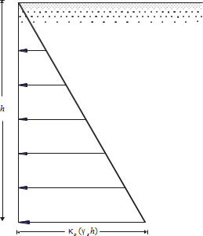

The ratio of the horizontal stress to the vertical stress is called the coefficient of earth pressure at rest,
κo , or
κo = σh
σv
Rearranging gives σh = κo⋅γs⋅h

h | = | depth of point of interest
γs | = | density of saturated or “moist” soil (Das, page 19)
For granular soils, the coefficient of earth pressure at rest can be represented by the empirical relation.

κo = 1 − sin(φ)
φ : soil friction angle

For select backfill material (conforming to the requirements of the Underground Horizontal Tank Installation Instructions Guidelines), we can assume φd := 30 deg for calculation proposes.

Therefore κ
⎛ φd ⎞
:= 1 − ⋅π = 0.5

sin⎜ ⎟
o
⎝ 180 ⎠

For the subject tank, we have the lateral earth pressure at rest as

Per_L := κo⋅ρws⋅LB

Lateral Water Load

Height of Water Table Above the Bot. of Shell
hw = 228 in

Lateral Pressure at Rest Below Ground Water Table
Phy := ρw⋅hw = 8.231⋅psi

Combined Lateral Load

Combined Pressure Due to Earth Load and Water
⎯⎯⎯⎯⎯→
Ps_ep := Phy + Per_L
( )

Ps_ep = 12.849⋅psi

Stress Analysis

- Hoop/Circumferential Crushing

If the tank is in a wet hole, the hydrostatic pressure on the outside of the cylinder produces compressive membrane stresses in the shell if the tank is empty.

The maximum compressive stress in the the cylindrical shell of the system occurs at the bottom of the tank. The expression for these stresses, for the cylinder are given by (Structural Plastics Design Manual, Vol. 2, 1984, ASCE, p. 928-930):

σs_c :=
⎯⎯⎯⎯→
Ps_ep⋅Rm ts

tsu ≡ ( 0.46 )

Shell Structure Thk.

σs_c = (2.018 × 103 )⋅psi
Compressive Strength of Shell σs_a_ep := 20000⋅psi

Safety Factor of Shell Under
⎯⎯⎯⎯→
⎛ σs_a_ep ⎞

Combined External Pressure SFs_ep := ⎜
⎝
⎠
σs_c ⎟
SFs_ep = ( 9.913 )

Buckling Analysis

The design for underground global buckling is performed according to the methodology detailed in [Moser,A.P.; Buried Pipe Design,1990, pages 65-68 ]. For this analysis, the cylindrical part of the tank is analyzed for overall buckling against soil and underground water loading, neglecting the constraining end effects of the bottom.

The critical buckling pressure in global buckling mode is given by the modified Luscher formula by Meyerhof and Baike.

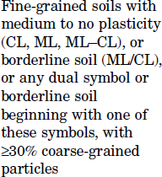
Modulus of Soil Reaction E' := 2000⋅psi SC3

Moment of Inertia of Tank per Unit Length
Is_un := Isu⋅in3

Buckling Safety Factor FSbu ≡ 2.5
Shell Hoop Flexural Modulus E = (3.077 × 106 )⋅psi
hf

Poisson's Ratio υ = 0.25

⎯⎯⎯⎯⎯⎯⎯⎯⎯⎯⎯→
⎡ E' ⎛ Ehf ⋅Is_un ⎞⎤

Critical Buckling Pressure Pcr := ⎢2⋅
⎢
⎣
⋅⎜
1 − υ2 ⎜
⎝
⎟⎥
3 ⎟⎥
R
m ⎠⎦

Pcr = ( 252.919 )⋅psi

⎯⎯⎯→

Actual Safety Factor Against
⎛ Pcr ⎞

Buckling FSbu_a := ⎜ P ⎟
FSbu_a = ( 19.684 )

⎝ s_ep ⎠

checkshellbucklingi := if ⎛FSbu_ai ≥ FSbu, "OK" , "Buckle" ⎞
⎝ ⎠

checkshellbuckling = ( "OK" )

Trapezoidal Shell Stiffener Design

Total Length for Vacuum Design Lvac := H +
2 ⋅0.162⋅D = 695.552⋅in
3

Stiffener Spacing on Shell
Lst := 36⋅in

Max. Design Unsupported Length (This includes 1/3 of head depth)
Lst_max := ⎛ 36 + 1 ⋅0.162⋅ D ⎞⋅in = ( 43.776 ) in
⎝
3
in ⎠

Required Moment of Inertia of Stiffener

Psti_q := (Ps_ep) = 12.849⋅psi

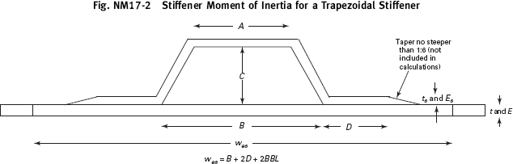

Stiffener Construction: Filament Wound

Stiffener Top Hoop Tensile Modulus:
Esri := 4200000⋅psi

Stiffener Side Hoop Tensile Modulus:
Esrli := 1500000⋅psi

Stiffener Top FW Thk.: tsr := ( 0.75 )⋅in
Stiffener Side Chop Thk.:
ts_sd := ( 0.25 )⋅in

⎯⎯⎯ →
( )
Shell Outside Diameter: Dsh_o := D + 2⋅ts

Stiffener Foam Dimensions:
Ast := 7⋅in
Cst := 3.5⋅in
Bst := 10⋅in

Stiffener Effective Dimensions:
A := 6⋅in
i
Ci := 3⋅in
Bi := 10⋅in
Dsri := 3⋅in

Shell Thk: tsh := ts = ( 0.46 ) in

Shell Hoop Tensile Modulus:

Esh

:= Eh
= (3.646 ×

10 ⋅psi
6 )

⎯⎯⎯⎯⎯⎯⎯⎯⎯⎯→

⎯⎯⎯⎯⎯→
⎯⎯⎯⎯⎯⎯⎯→

ϕ := acos⎡⎢ C ⎤⎥ ⎛ϕ 180 ⎞
⋅

⋅deg = ( 33.69 )⋅deg
⎢
⎢⎣
C +
⎝
2
⎛ B − A⎞2⎥
2
⎠ ⎥⎦
π
⎝ ⎠
Lsr :=

⎯⎯⎯⎯→
C +
2
⎛ B − A⎞2
⎝
2 ⎠
( )
Area of Sides: As := Lsr⋅ts_sd

⎯⎯⎯⎯→
( )
Effective Width of Cylinder: wes := B + 2⋅Dsr

⎯⎯⎯→
( )
Effective Area of Cylinder: Ac := wes⋅tsh

⎯⎯→
( )
Area of Top: At := A⋅tsr

⎯⎯⎯⎯⎯⎯⎯⎯⎯→
( )
Area of Base: Ad := ⎡⎣2⋅ Dsr − ts_sd ⋅ts_sd⎤⎦

Total Effective Area of
⎯⎯⎯⎯⎯⎯→

Stiffener Excluding Shell: Atot := (At + Ad + As)

Effective Hoop Modulus of Stiffener and Cylinder:

Esrh :=
⎯⎯⎯⎯⎯⎯⎯⎯⎯⎯⎯⎯⎯⎯→
Esh⋅Ac + Esr⋅ At + Ad + Esrl⋅As = (3.739 × 106 )⋅psi Ac + Atot
( )

Required MOI of Ring:

Isr_min :=
⎯⎯⎯⎯⎯⎯⎯⎯⎯→
Psti_q⋅Lst⋅Dsh_o3⋅Fvac 24⋅Esrh

= ( 39.22 )⋅ 4
in

⎯⎯⎯⎯⎯⎯⎯⎯⎯⎯⎯⎯⎯⎯⎯⎯⎯⎯⎯⎯⎯⎯⎯⎯⎯→
t

⎛ −tsh ⎞
c
tsr
Esr
C Esrl
⎛ tsr ⎞
Esr

Effective CG From CG :=
Outside of Shell:
A ⋅⎜
⎝
⎟ +
2 ⎠ 2
⋅
Esh
⋅Ad + As⋅
E
⋅
2 Esh
+ A ⋅⎜C +
⎝
E
⎟⋅
2 ⎠ Esh

Ac + As⋅ srl + (At + Ad)⋅ sr
Esh Esh

CG = ( 1.169 ) in

⎯⎯⎯⎯⎯⎯⎯⎯⎯⎯⎯⎯⎯⎯⎯⎯⎯ →

I of Each Side About the
⎛⎜ t
⋅L 3
L ⋅t 3 ⎞⎟

Centroid of the Sides: Iside := ⎜ s_sd sr ⋅cos(ϕ)2 + sr s_sd ⋅sin(ϕ)2⎟ =
4
( 0.677 ) in

⎝ 12 12 ⎠

About the Centroid:
⎯⎯⎯⎯⎯⎯⎯⎯⎯⎯⎯⎯⎯⎯⎯⎯⎯⎯⎯⎯⎯⎯⎯⎯⎯⎯⎯⎯→
⎛ Esrl 2 Esr 2 ⎞

⎜ 3
w ⋅t E
E ⋅Ad⋅ts_sd E
E ⋅At⋅tsr ⎟

⎜ es sh sh
⎟
srh
srl
srh ⎟

I1 := ⎜
⎝ 12
⋅ +
Esrh
+
12 E

srh
⋅2⋅Iside +

12 ⎠

⎯⎯⎯⎯⎯⎯⎯⎯⎯⎯⎯⎯⎯⎯⎯⎯⎯⎯⎯⎯⎯⎯⎯⎯⎯⎯⎯⎯⎯⎯⎯⎯⎯⎯⎯⎯⎯⎯⎯⎯⎯⎯⎯⎯⎯⎯→
⎤

⎡
I := ⎢
⎛ tsh ⎞2
Esh
Esrl ⎛
ts_sd ⎞2
Esrl ⎛ C
⎞2 Esr ⎛
2
tsr ⎥
⎞

2 ⎢tsh⋅wes⋅⎜CG + 2 ⎟ ⋅ E
- Ad⋅ E
⋅⎜CG −
2 ⎟ + As⋅ E
⋅ − CG
2
- At⋅ E
⋅⎜C +
2 − CG⎟ ⎥

⎣ ⎝ ⎠
srh
srh ⎝
⎠ srh ⎝ ⎠
srh ⎝ ⎠ ⎦

Effective MOI Considering Different Moduli of Shell and Stiffener: I
⎯
:= (
⎯⎯→ 4
= ( 40.192 )⋅
)
e I1 + I2
in

checkstiffenerMOIi := if ⎛Iei ≥ Isr_mini, "Adequate" , "Stiffener Inadequate" ⎞
⎝ ⎠

checkstiffenerMOI = ( "Adequate" )

⎯⎯⎯⎯→
n

Moment of Inertial of Shell per Inch ΣIu
⎛ Ie ⎞
:= ⎜ ⎟
L
⎝ st_max ⎠
ΣIu
= ( 0.918 )⋅i 3

Stiffener Unit Weight Isu ≡ ( 0.918 )

⎯⎯⎯⎯⎯⎯⎯⎯⎯⎯⎯⎯⎯⎯⎯⎯⎯⎯⎯⎯→
( ) ( )
Wstif := ⎡⎣π⋅ Do + 2CG ⋅⎡⎣A⋅tsr + Lsr + Dsr ⋅ts_sd⎤⎦⋅ρfrp⎤⎦

Number of Stiffeners on Each Shell Section Nsr := ( 18 )

⎯⎯⎯⎯→
( )
Wr := Nsr⋅Wstif

Wstif

= ( 185.278 ) lb
W = (3.335 ×

3
)
10 lb

ΣWr := ∑Wr = 3.335 × 103 lb
r

See FEA buckling analysis for shell w/ stiffeners.

Shell W/ Stiffeners Under External Pressure Finite Element Analysis
See external pressure calculation in section 2.2 IV. Tank is simply supported at the bot. 180 deg. surface.
Buckling analysis is run to investigate the safety factor against buckling for the shell and stiffeners assembl
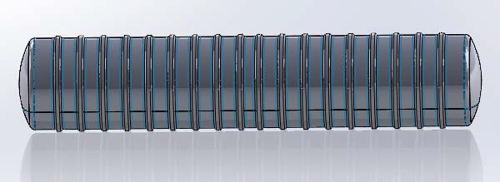

Solid Model
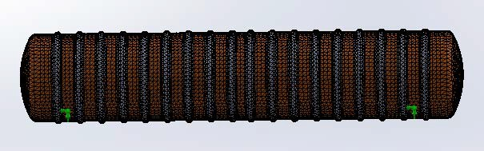

Meshed Model

Buckling Safety Factors For Shell + Stiffeners Assembly

⎛ "Mode No." "Buckling Factor of Safety" ⎞

⎜ 1 2.9794
⎜
⎜ 2 2.9847
⎜ 3 2.9916
⎜ 3.0033
4
⎜
⎝ 5 3.4152
⎟
⎟ Greater than min. buckling factor 2.5, OK.
⎟
⎟
⎟
⎟
⎠

Chapter 3 Dished Heads W/ Stiffener Design

Head Construction Hand Layup

Head Configuration ASME F & D w/ Stiffeners

Head Straight Flange Length
sfth := 1.5⋅in

Head Structural Thk. tth := 0.43⋅in

Head Total Thk. tth_tot := tth + tcb = 0.55⋅in

Tensile Modulus Eth := 1500⋅ksi

Tensile Strength Sth := 15⋅ksi

Flexural Modulus Eth_f := 1000⋅ksi

Ultimate Flexural Strength Sth_f := 22⋅ksi

Poisson's Ratio υ ≡ 0.25

Design Factor For Pressure Fs = 10

Design Factor For Vacuum and Combined Load

Fvac = 2.5

3.1 Head Design for Pressure

Head Construction: Hand Layup

Head Design Pressure: PH_ip := Ps_ip = 5.198⋅psi

Head Inside Dish Radius: Rc := 144⋅in

Head Inside Knuckle Radius: rc := 9⋅in

Minimum Required thk. For Pressure: t

h_ip :=
0.885PH_ip⋅Rc
Sth Fs

= 0.442 in

checkheadthkip := if (tth_tot ≥ th_ip, "OK" , "Increase head thk." ) = "OK"

Design of Head to Shell Joint

Joint Tensile Modulus: Ej := Eth

Secondary Bond Shear Strength: τj := 2000⋅psi

Left & Right Head to Shell Joint

PH_ip⋅⎛ D + ts ⎞

Min. Req'd Joint Thk.: tjH_min :=
⎝ 2
(0.001⋅Ej)
1⎠ = 0.251 in

Design Joint Thk.: tjH := tth = 0.43 in

PH_ip⋅⎛ D + ts ⎞
Min. Req'd Joint Length: LjH_min := ⎝ 2 1⎠
τ
j
2⋅
Fs

= 0.942 in

Design Joint length: See detail. in Appendix A

Head Design for External Loads

Design Max External Pressure PH_ep := Ps_ep = 12.849 psi

Finite Element Analysis of Dished Heads with Stiffeners

Applied Load : - Gravity
- External Water Pressure
- Soil Load

Boundary Condition: Fixed around the perimeter of the top head. (For simplicity of analysis.) Note : See Appendix A for stiffener size, location and FRP overlay thks.
Finite element analysis is performed based on the load and boundary conditions as stated above and material properties and thks specified in the previous sections of thie report. Solidworks 2012 Simulartion is used for this analysis.

FEA Solid Model
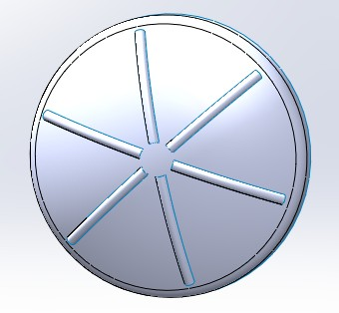
Meshed Model
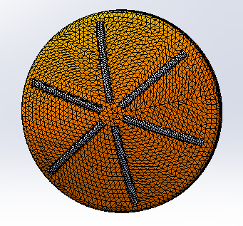

1st Principal Stress
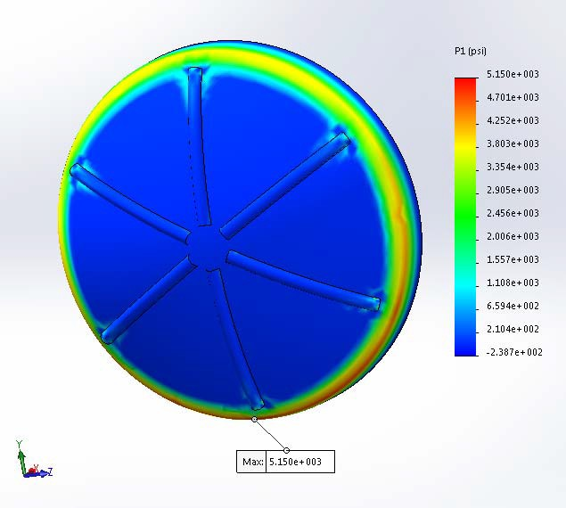

1st Principal Stress Detail
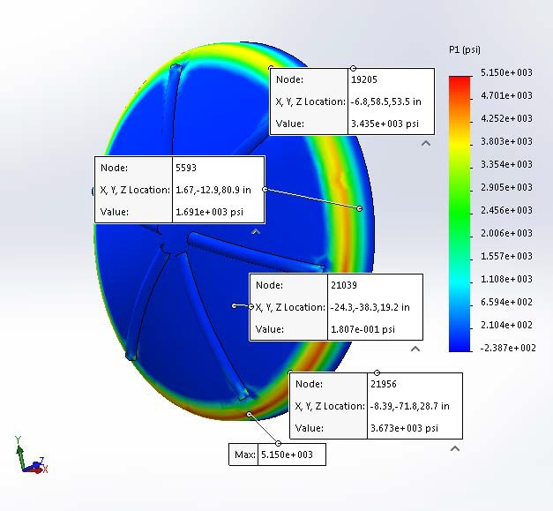

Tank head is under external pressure. Max. allowable compressive stress in type II hand layup laminate is 20,000 psi / 3 = 6,667 psi. Higher stress (5,150 psi) is observed in the knuckle region of the dished head. Knuckle is under compression. Buckling analysis is run to evaluate the head's stability under external loads. The max stress in the rest of the area in the top head is less than 4,000 psi, and is thus considered acceptable.

X - Stress

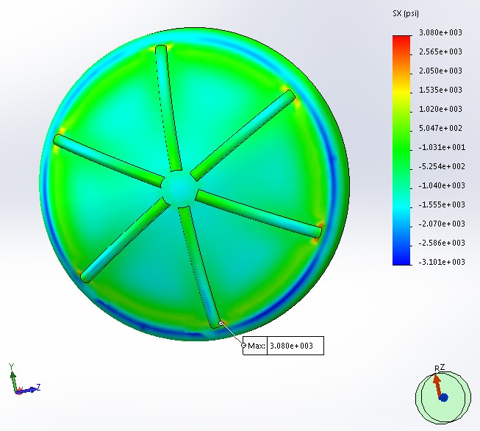

Y - Stress
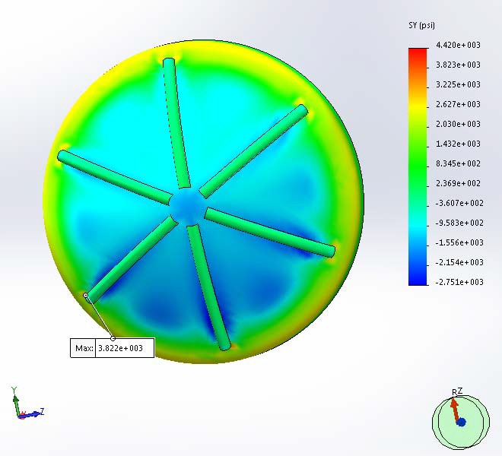

Z - Stress
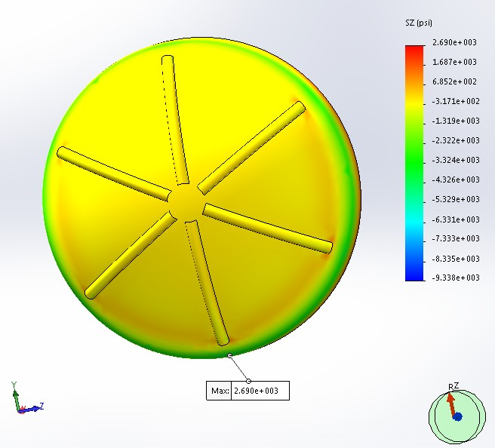

Resultant Displacement
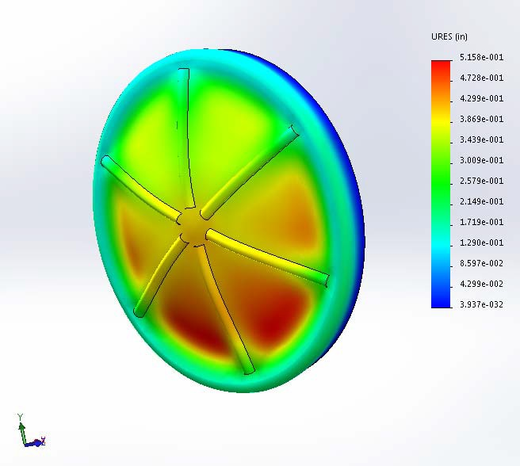

Less than 0.75", OK.
Note : Deflection is exaggerated by 20 times for clarity.

Buckling Safety Factor

⎛ "Mode No." "Buckling Factor of Safety" ⎞

⎜ 1 2.5383 ⎟
⎜ ⎟
⎜ 2 2.5459 ⎟
⎜ 3 2.5738 ⎟
⎜ 2.5922 ⎟
4
⎜
⎟
⎝ 5 2.8542 ⎠

Greater than 2.5. OK.

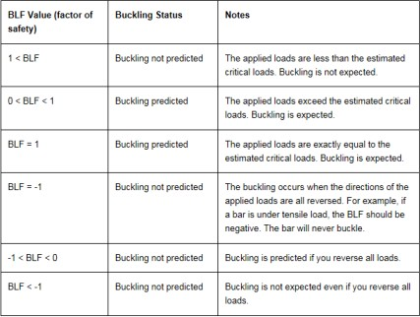

Chapter 4 Component Weight

Weight of Each Head: WH := Wttorihead(ρfrp, rc, R, Rc, 0 , tth)

WH = 545.939lb

Head Depth: h
⎡ ⎛
⎢ ⎜
:= R − R − r ⋅
⎛ D ⎞⎞⎤
⎜ 2 ⎟⎟⎥
- rc

H c ⎢( c
c) cos⎜asin⎜
⎟⎟⎥

⎣ ⎝ ⎝ Rc − rc ⎠⎠⎦

hH = 24.602 in

Weight of Shell: WS := ρfrp⋅π⋅D⋅H⋅

tstot
= 1.16 × 4

WS = 1.16 × 104 lb
10 lb

Top Head Volume: VL_H := f_volts(rc , R, Rc, 0) = 1.062 × 103⋅gal

Tank Volume (Flooded): VL := 2VL_H + π⋅R2⋅H

VL = 5.006 × 104 gal

Content Weight: WL := ρc⋅VL = 1.004 × 6
10 lb

Extra FRP Dead Weight (Covers joints, nozzles, and repads etc.)
Wad1 := 1200⋅lb

Total Weight Multiplication Factor: η := 1.15

Total FRP Tank Weight: WFRP :=
WS + 2⋅WH + Wad1 + Wr ⋅η = 1.981 × 4

Total FRP + Content Weight: WT := WFRP + WL = 1.024 × 106 lb
10 lb

Chapter 5 Buoyancy Design

- Buoyant force acting on the underground tank is equal to the weight of fluid which the tank displaces.

- Downward frictional resistance of the backfill material is neglected in this analysis to be conservative.

- Tank shell w/ stiffeners' weights, soil load directly above the tank, and the weight of the concrete deadman attached to the tank are used to resist buoyancy.

Buoyancy Design Safety Factor SFby ≡ 1.2

Saturated Backfill Material Density

Projected Area

Estimated Weight of Tank Used to Counteract Buoyancy
ρfil := 70⋅ lb
ft
3

Aprj := D⋅H = 9.792 × 104⋅in2 Wby_ww := WFRP = 1.981 × 104 lb

Total Volume of Water Displaced Vh2o := VL = 5.006 × 104 gal Total Weight of Water Displaced Wh2o := ρw⋅Vh2o = 4.175 × 105⋅lb Design Buoyancy Force Fby := Wh2o⋅SFby = 5.01 × 105⋅lb

Backfill Height dbk := 7⋅ft

Backfill Weight Reduction Factor χ := 0.7

Backfill Weight Wbk := D⋅H⋅dbk⋅ρfil⋅χ = 2.332 × 5
10 lb

Weight of Concrete Required To Hold Down the Tank When Totally Submerged
Wc_r := Fby − Wby_ww − Wbk = 2.479 × 105⋅lb

See concrete deadmen design sketch in Appendix A.

Chapter 6 Lifting Lug Design

Lifting Lug is Attached by Hoop Filament Wound Glass

A36 CS = Lifting Lug Material

WFRP = 19808 lb
= Total Empty Tank Weight

NL := 4
= Number of Lift Lugs

tlug := 0.5⋅in
= Thickness of Lift Lug

bL := 10⋅in
= Width of Lift Lug

hL := 12⋅in
= Height of Lift Lug

wL := 6⋅in
= of Lift Lug

x := 3.5⋅in
= Distance from back to hole center line

c := tlug ÷ 2

c = 0.25 in
σall := 36000⋅0.6⋅psi Sv := 2000⋅psi

DF := 2
= Distance to Neutral Axis

= Lug Allowable Stress

= FRP Shear Strength

= Design Factor

Cross-Sectional Area of Lug

AL := tlug⋅(bL) AL = 5.00 in
2.00

Lug Moment of Inertia (for Each Leg)

w 3⋅t

I := L lug
L
12
IL = 9 in4

Load per Lift Lug x 1.5 Shock Factor:

PL :=
1.5⋅WFRP NL

PL = 7428 lb

Moment in Lift Lug (for Each Leg)

Mlift :=
1 P ⋅(x)
2
L

Mlift = 12999 in⋅lb

Resulting Stress

σact :=
Mlift⋅(c) IL

σact = 361⋅psi where σall = 21600⋅psi

Lug_Stress := if (σact ≤ σall, "OK" , "Excessive" )

Lug_Stress = "OK"
for NL = 4

Lift Lugs

Shell Repad Thk. tpd := 0.043⋅8⋅in = 0.344 in

Shear Across Vessel Wall tst := ts + tpd + tcb tst = 0.924 in
1

Mean Radius RmL

:= R +
tst 2

Check Overwind:

Overwind Thickness

tLo := 0.5⋅in

Overwind to be continuous around the full circumference of the tank.

Unit Radial Load on Overwind

3(PL)⋅(x) lb

Wo :=
bL2
Wo = 779.9 in

Radial Load Due to Moment

⎛ bL ⎞
PrL := Wo⋅⎜ 2 ⎟
⎝
⎠

PrL = 3900 lb

Hoop Overwind Load

TrL :=

PrL⋅RmL hL

= 2.355 × 104 lb

Hoop Overwind Tensile Stress
σrL :=
TrL tLo⋅bL

= 4.71 ×

10 ⋅psi
3

checkoverlaytension := if ⎛σrL ≤ 40000 ⋅psi, "OK" , "Excessive Tension" ⎞ = "OK"

τwL :=
⎝ 5 ⎠
PrL tst⋅hL

τwL = 352⋅psi
Sv = 2000⋅psi

Wall_Shear := if ( τwL
≤ 1500⋅psi, "OK" , "Too High" )

Wall_Shear = "OK"

Shear on Lug Overlay

Coefficient of Bending on Vessel Wall βL :=

= 0.156 1
in
1.28
RmL⋅tst

Unit Radial Load p

stL :=
PrL hL

pstL
= 324.975 lb
in

Bending Moment M

axL :=
pstL 4⋅βL

= 519.363 lb

νL := 0.25

MhpL := νL⋅MaxL

Overlay Bending Stress: σaxL :=

σhpL :=
6⋅MaxL = 3.65 × 103⋅psi tst2
6⋅MhpL
= 912.469⋅psi
tst2
3

σaxL_al :=
15000⋅psi = 5 ×
3

10 ⋅psi

σhpL_al :=
40000⋅psi = 8 × 103⋅psi 5

checkoverlaybending := if (σaxL ≤ σaxL_al ∧ σhpL ≤ σhpL_al , "OK" , "Excessive Stress" ) = "OK"

See Appendix A for Lifting Lug Attachment Detail.

Chapter 7 Opening Reinforcement
Reference: RTP-1 3A-700 - 730

Pint = 0.0
= Design Pressure

dn = Nozzle Diameter
hn = Nozzle Elevation
Pn = Pressure at Nozzle Centerline
tr = Required Reinforcement Thickness
Dr = Required Reinforcement Diameter
tn = Nozzle Neck Thickness
ti = Inside Bond Thickness
to = Outside Bond Thickness

H = 680 in
Sr := Sth sg = 1.00
= Max Liquid Level
= Strength of Reinforcement Laminate
= Specific Gravity of Tank Contents

Shell Nozzle Opening Reinforcement

⎛ 4 ⎞

⎛ 144 ⎞
⎛⎜ 1.748 × 10− 14 ⎞⎟

d := ⎜ 24 ⎟⋅in
h := ⎜ 144 ⎟⋅in
Δh := (
⎯⎯→
Δh = ⎜
− 14 ⎟ in

n ⎜ ⎟
⎯
)
n ⎜ ⎟
D − hn
⎜ 1.748 × 10 ⎟

⎝ 30 ⎠
⎝ 144 ⎠
⎜ − 14 ⎟

k := 1 .. last(dn)
⎝ 1.748 × 10 ⎠

Calculate Pressure at Each Nozzle:

Pnk := Pint + Δhk⋅sg⋅ρws
⎛ 0.00 ⎞
Pn = ⎜ 0.00 ⎟⋅psi

⎜ ⎟
⎝ 0.00 ⎠

Calculate Reinforcement Diameter:
⎯⎯⎯⎯⎯⎯⎯⎯⎯⎯⎯⎯⎯⎯⎯⎯→
Drk := if ⎡⎛dn ⎞ > 6⋅in, ⎛2⋅dn ⎞ , ⎛dn + 6⋅in⎞⎤
⎣⎝ k⎠ ⎝ k⎠ ⎝ k ⎠⎦

⎛ 10 ⎞
Required Cutout Reinforcement Dia.: Dr = ⎜ 48 ⎟⋅in
⎜ ⎟
⎝ 60 ⎠

Calculate Coefficient "K":

⎡ ⎛ dn ⎞ ⎤
⎛ 0.67 ⎞

Kn := if ⎢dn < 6⋅in, ⎜ k ⎟ , 1.0⎥
Kn = ⎜ 1.00 ⎟

k ⎣ k
⎝ 6⋅in ⎠ ⎦ ⎜ ⎟

⎝ 1.00 ⎠

Calculate Coefficient "M":

Laminate type: type := "X" (X for filament wound, I and II for HLU)

Hoop tensile strength for shell: σuk := 0.01⋅Eh1

Factor M M :=
1 if type
σuk
15000⋅psi
r
k
= "I" ∨ type = "II"

otherwise

Calculated Structural Thk: T := t
c s
k 1
Theoretical Structural Wall Thk.: Tt := Tc

Factor V V := 1
k 2
(pressure governs V=1, vacuum governs V=1/2)

Calculate Reinforcement Thickness:

trk := V ⋅Mr ⋅Kn ⋅Ttk
k k k
− M ⋅⎛T − T ⎞
k ⎝ k k⎠
r c t

⎯⎯⎯⎯⎯⎯⎯⎯⎯⎯⎯→
trk := if ⎛trk ≥ 0.19⋅in, trk, 0.19⋅in⎞
⎝ ⎠

Required Reinforcement Thickness: Use Reinforcment Thickness:

⎛ 0.373 ⎞
tr = ⎜ 0.559 ⎟⋅in
⎛ 0.39 ⎞
trd := ⎜ 0.58 ⎟⋅in

⎜ ⎟ ⎜ ⎟
⎝ 0.559 ⎠ ⎝ 0.58 ⎠

Reinforcement should be made of type II laminate with mat and woven roving. Shell Nozzle Opening Reinforcement Summary

⎛ 4 ⎞
dn = ⎜ 24 ⎟⋅in
⎛ 10 ⎞
Dr = ⎜ 48 ⎟⋅in
⎛ 0.39 ⎞
trd = ⎜ 0.58 ⎟⋅in

⎜ ⎟ ⎜ ⎟ ⎜ ⎟

⎝ 30 ⎠
⎝ 60 ⎠
⎝ 0.58 ⎠

Head Nozzle Reinforcement

dnc := ( 4 )⋅in

m := 1 .. last(dnc)
hLc := ( 0 )⋅in

last(dnc) = 1
ΔhLc := D − hLc
ΔhLc = ( 144 ) in

Calculate Pressure At Each Nozzle:

Pncm := Pint + ρc⋅ΔhLcm

Pnc = ( 12.5 )⋅psi

Calculate Reinforcement Diameter:
⎯⎯⎯⎯⎯⎯⎯⎯⎯⎯⎯⎯⎯⎯⎯⎯⎯⎯→
Drcm := if ⎡⎛dnc ⎞ > 6⋅in, ⎛2⋅dnc ⎞ , ⎛dnc + 6⋅in⎞⎤
⎣⎝ m⎠ ⎝ m⎠ ⎝ m ⎠⎦

Calculate Coefficient "K":
⎡ ⎛ dncm ⎞ ⎤

Knc
:= if ⎢dnc < 6⋅in, ⎜ ⎟ , 1.0⎥
Knc = ( 0.667 )

m ⎣ m ⎝ 6⋅in ⎠ ⎦

Calculate Coefficient "M": Laminate type: typec := "II" Factor M Mrc := 1
m
Calculated structural thk: Tsc := tth
m

Theoretical structural thk: Ttc
m
:= Tscm

1
Vrcm := 2

(pressure governs V=1, vacuum/bending governs V=1/2)

Calculate Reinforcement Thickness:

trcm := Vrc
m
⋅Mrc
⋅Knc
⋅Ttc

⎯⎯⎯⎯⎯⎯⎯⎯⎯⎯⎯⎯ →
m
m
m
trcm := if ⎛trcm ≥ 0.19⋅in, trcm, 0.19⋅in⎞

trc = ( 0.19 )⋅in

⎝ ⎠

Design Repad Thk.: trc_d := ( 0.19 )⋅in

Drcm − dncm

Repad Width
wrcm :=
8⋅in if
- 8⋅in
2
wrc = ( 3 ) in

Drcm − dncm 2

otherwise

Design Repad Width wrc_d := wrc = ( 3 ) in

Top Head Nozzle Reinforcement Summary

dnc = ( 4 )⋅in
trc_d = ( 0.19 )⋅in
wrc_d = ( 3 )⋅in

Appendix A Design Summaries and Sketches

Tank Inside Diameter................................... D = 144⋅in

Straight Shell Length................................... H = 680⋅in

Shell Total Thk............................................ tstot = ( 0.58 )⋅in

Left/Right Head Combined Thk..................... tth_tot = 0.55⋅in
Tank Empty Weight..................................... WFRP = 1.981 × 104 lb

Lamination Sequence

Left & Right Heads 0.55" - V,C110-3(M,R)M,M,R,2M Shell 0.58" - V,C110-3(2FW,U),2FW

Nomenclature For Lamination Sequence:

FW = 0.05" @ 89 deg. winding angle, 1 cycle of filament wound glass c = 0.02", 1 layer interspersed chopped strand glass, 0.7 oz/ft2
C*** = 1 layer of chopped strand glass - *** indicates thk. of layer in mils (C025 = 0.025") C = 0.043", 1 layer chopped strand glass, 1.5 oz/ft2
M = 0.043", 1 layer chopped strand glass mat, 1.5 oz/ft2 R = 0.033", 1 layer woven roving, 24 oz/sq. yd.
U = 0.02", 1 layer unidirectional roving

Shell Stiffener Layout

Total Stiffener Weight ΣWr = 3.335 × 3
10 lb
Total # of Stiffeners Nsr = ( 18 )

Stiffener Spacing Lst = 36 in

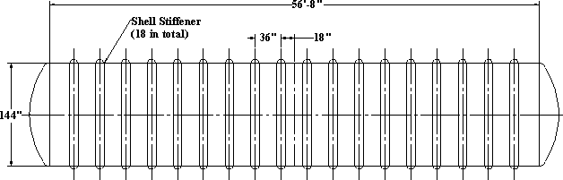
.

Note : Bottom 180 deg. section of the tank is fully supported. See customer installation manual.

Shell Stiffener Detail

A = ( 6 ) in

B = ( 10 ) in

C = ( 3 ) in
Dsr = ( 3 ) in

Stiffener Top FW Thk.: tsr = ( 0.75 ) in Stiffener Side Chop Thk.: ts_sd = ( 0.25 ) in

0.75" - 15 Hoop-Wound Glass

Winding stiffener top with hoop winding and apply chop for the side and base.

Shell to Shell Joint Detail

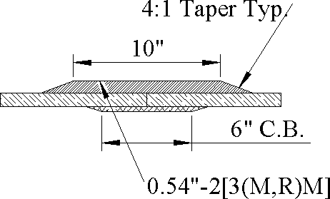

Head Reinforcement & Head to Shell Joint Detail

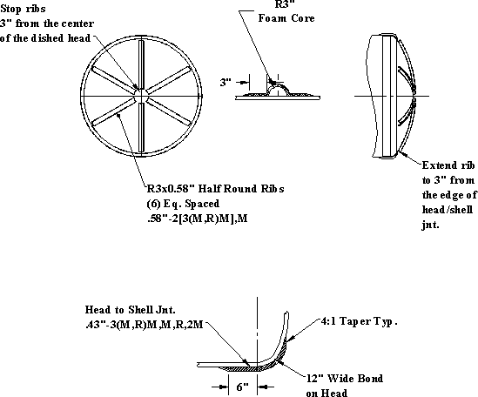

Lifting Lugs

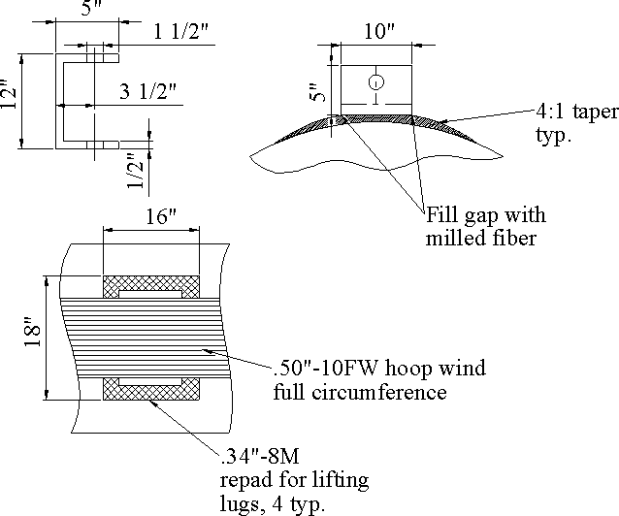

Nozzle Opening Reinforcement

Shell Nozzle Opening Reinforcement Summary

⎛ 4 ⎞
dn = ⎜ 24 ⎟⋅in
⎛ 10 ⎞
Dr = ⎜ 48 ⎟⋅in
⎛ 0.39 ⎞
trd = ⎜ 0.58 ⎟⋅in

⎜ ⎟ ⎜ ⎟ ⎜ ⎟

⎝ 30 ⎠
⎝ 60 ⎠
⎝ 0.58 ⎠

Top Head Nozzle Reinforcement Summary

dnc = ( 4 )⋅in
trc_d = ( 0.19 )⋅in
wrc_d = ( 3 )⋅in

Concrete Deadmen Design

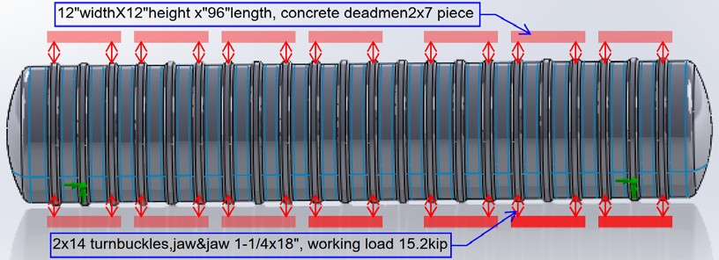

Deadmen dimensions:
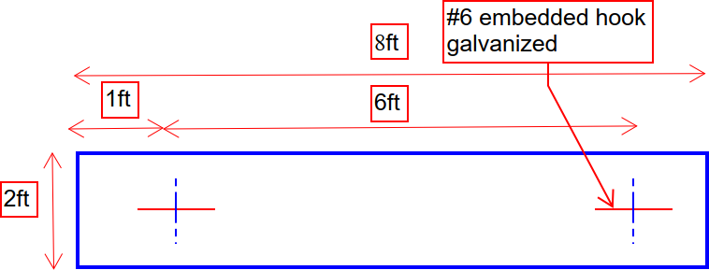

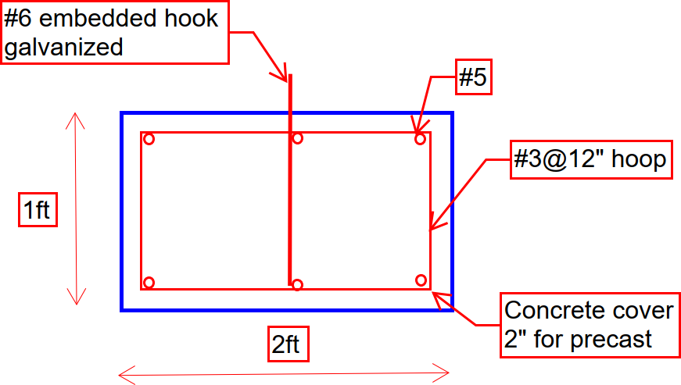

Turnbuckle Selection

1-1/4"x18", HG-228 Jaw & Jaw , working load is 15.2kip

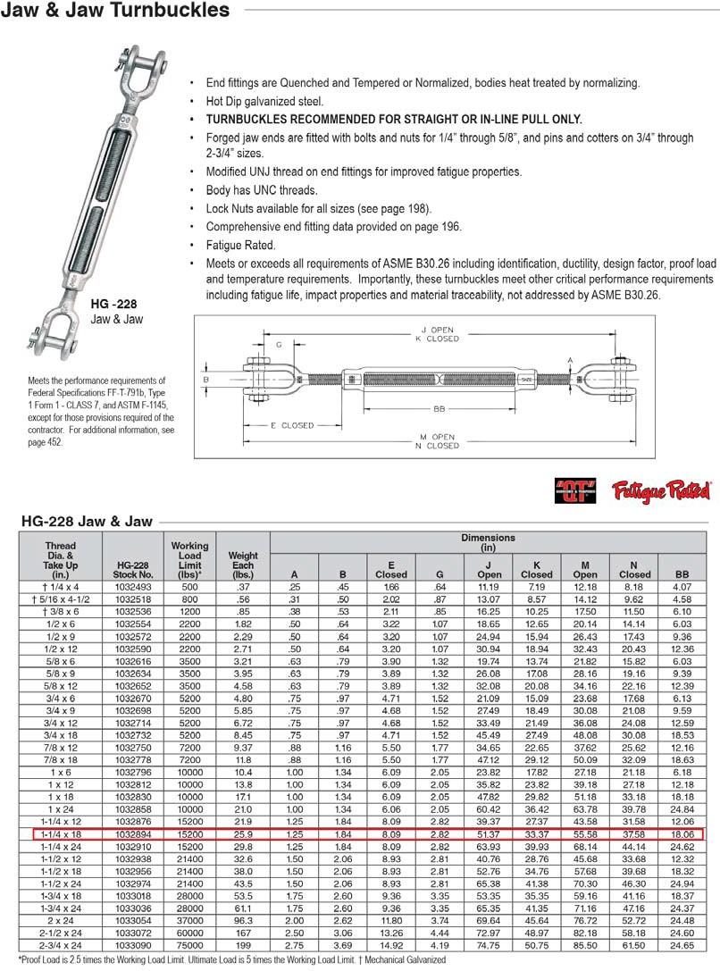

Appendix B Lamination Analysis Using Trilam

Stypol DCPD Resin used for construction of tank. Trilam analysis uses iso resin which has similar mechanical properties.

Laminate Sequence Shell
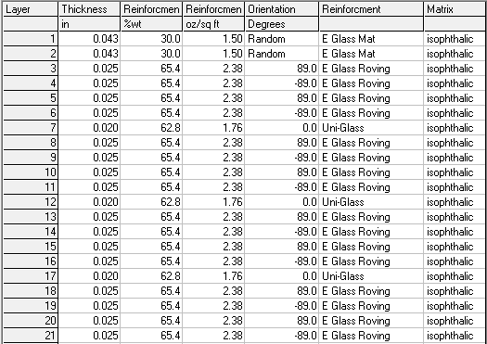

Laminate Properties Shell

