Table of Contents

Chapter 1 Design Inputs

Chapter 2 Design of Cylindrical Shell Chapter 3 Dished Heads Design Chapter 4 Component Weight Chapter 5 Buoyancy Design
Chapter 6 Lifting Lug Design Chapter 7 Opening Reinforcement

Appendix A Design Summaries and Sketches Appendix B Lamination Analysis

Chapter 1 Design Inputs

Shell Inside Diameter D := 8⋅ft = 96⋅in

Shell Inside Radius R :=
D = 48⋅in 2

Total Straight Shell Height H := 52⋅ft + 5⋅in = 629 in

Design Burial Depth to the Top of the Tank

hbu := 7⋅ft

Design Water Table Hwt := D + hbu = 180 in

Applied Internal Pressure Pint := 0⋅psi

Applied External Pressure Pext := 0⋅psi

Corrosion Barrier Thk. tcb := 0⋅in

Max. Design Temperature Tmax := 100⋅F

Content Specific Gravity sg := 1.0

Water Density: ρw := 0.0361⋅ lb in
3

FRP Density ρfrp := 0.065⋅ lb in
3

Submerged Soil Density ρws := 70⋅ lb ft
3

Concrete Desity
ρc := 150⋅ lb
ft
3

Design Safety Factor for Sustained Load Fs := 10

Design Safety Factor for Transient Load Ft := 5

Design Safety Factor for Vacuum Fvac := 2.5

Chapter 2 Design of Cylindrical Shell

  - Shell Properties

Shell Construction Filament Wound

Shell Structure Thk.: ts := tsu⋅in = ( 0.29 ) in

⎯⎯⎯→
( )
Shell Total Thk: tstot := ts + tcb

Shell & Head Thks, and Stiffener Design Work for Same Diameter Tank with Shorter Shell
Length

⎯⎯⎯→
s

Shell Mean Radius: Rm
⎛ t ⎞
:= ⎜R + ⎟
⎝ 2 ⎠
Rm = ( 48.145 )⋅in

tstot = ( 0.29 )⋅in

⎯⎯⎯⎯⎯→
( )
Shell Outer Diameter: Do := D + 2⋅tstot

Total Number of Shell Courses n ≡ 1
i ≡ 1 .. n

Shell Length: Ls := ( H )
∑Ls = 629 in
H = 629 in

Property Reduction Factor η := 0.98

Conservative properties are used. See lamination analysis in App. B

Axial Tensile Modulus Hoop Tensile Modulus

Ea := ( 1762000 )⋅η⋅psi = (1.727 × 106 )⋅psi Eh := ( 4402000 )⋅η⋅psi = (4.314 × 6 )⋅psi
10

Axial Flexural Modulus Hoop Flexural Modulus

Eaf := ( 1558000 )⋅η⋅psi = (1.527 × 106 )⋅psi Ehf := ( 4588000 )⋅η⋅psi = (4.496 × 6 )⋅psi
10

Axial Hoop Poisson's Ratio Hoop Axial Poisson's Ratio

υah := ( 0.09 ) υha := ( 0.22 )

⎯⎯⎯⎯⎯⎯⎯⎯⎯⎯→
Shell moment of inertia: Is := ⎡ π ⋅⎡(D + 2tstot)4 − 4⎤⎤
⎣64 ⎣
D ⎦⎦

Burial Depth to The Bot. of Shell
⎯⎯⎯ →
LB := D + hbu
( )

Height of Water Table Above the Bot. of Each Shell Section
hw := LB = 180 in

Loads Considered

The following loads will be considered for the structural analysis of the tank:

- Internal pressure

- Lateral earth loads

- Lateral water loads

Internal Pressure

Shell internal pressure is a combination of applied pressure and hydrostatic pressure.

⎯⎯⎯⎯⎯⎯→
( )
Internal Pressure on Shell Ps_ip := Pint + ρw⋅sg⋅D

Ps_ip = 3.466⋅psi

Shell Hoop Stress Due to Internal Pressure

σs_ip :=
⎯⎯⎯⎯→
Ps_ip⋅Rm ts

σs_ip = ( 575.349 )⋅psi

Shell Hoop Tensile Strength σh_al := 0.01⋅Eh

Shell Hoop Srain Due to Internal Pressure

εs_ip :=
⎯⎯→
σs_ip Eh
εs_ip = (1.334 × 10− 4 )

Safety Factor of Shell Under
⎯⎯⎯→
⎛ σh_al ⎞

Internal Pressure SFs_ip := ⎜ σ ⎟
⎝
s_ip ⎠
SFs_ip = ( 74.98 )

checkshellforinternalpressure := if ⎛SFs_ip ≥ 10, "OK" , "Inadequate" ⎞
i ⎝ i ⎠

checkshellforinternalpressure = ( "OK" )

Earth Load

Ref : Das B.M.; Fundamentals of Geotechnical Engineering, 2000, p.291-295.

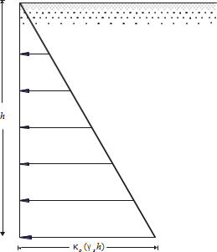

The ratio of the horizontal stress to the vertical stress is called the coefficient of earth pressure at rest,
κo , or
κo = σh
σv
Rearranging gives σh = κo⋅γs⋅h

h | = | depth of point of interest
γs | = | density of saturated or “moist” soil (Das, page 19)
For granular soils, the coefficient of earth pressure at rest can be represented by the empirical relation.

κo = 1 − sin(φ)
φ : soil friction angle

For select backfill material (conforming to the requirements of the Underground Horizontal Tank Installation Instructions Guidelines), we can assume φd := 30 deg for calculation proposes.

Therefore κ
⎛ φd ⎞
:= 1 − ⋅π = 0.5

sin⎜ ⎟
o
⎝ 180 ⎠

For the subject tank, we have the lateral earth pressure at rest as

Per_L := κo⋅ρws⋅LB

Lateral Water Load

Height of Water Table Above the Bot. of Shell
hw = 180 in

Lateral Pressure at Rest Below Ground Water Table
Phy := ρw⋅hw = 6.498⋅psi

Combined Lateral Load

Combined Pressure Due to Earth Load and Water
⎯⎯⎯⎯⎯→
Ps_ep := Phy + Per_L
( )

Ps_ep = 10.144⋅psi

Stress Analysis

- Hoop/Circumferential Crushing

If the tank is in a wet hole, the hydrostatic pressure on the outside of the cylinder produces compressive membrane stresses in the shell if the tank is empty.

The maximum compressive stress in the the cylindrical shell of the system occurs at the bottom of the tank. The expression for these stresses, for the cylinder are given by (Structural Plastics Design Manual, Vol. 2, 1984, ASCE, p. 928-930):

σs_c :=
⎯⎯⎯⎯→
Ps_ep⋅Rm ts

tsu ≡ ( 0.29 )

Shell Structure Thk.

σs_c = (1.684 × 103 )⋅psi
Compressive Strength of Shell σs_a_ep := 20000⋅psi

Safety Factor of Shell Under
⎯⎯⎯⎯→
⎛ σs_a_ep ⎞

Combined External Pressure SFs_ep := ⎜
⎝
⎠
σs_c ⎟
SFs_ep = ( 11.876 )

Buckling Analysis

The design for underground global buckling is performed according to the methodology detailed in [Moser,A.P.; Buried Pipe Design,1990, pages 65-68 ]. For this analysis, the cylindrical part of the tank is analyzed for overall buckling against soil and underground water loading, neglecting the constraining end effects of the bottom.

The critical buckling pressure in global buckling mode is given by the modified Luscher formula by Meyerhof and Baike.

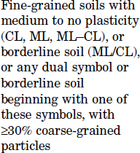
Modulus of Soil Reaction E' := 2000⋅psi SC3

Moment of Inertia of Tank per Unit Length
Is_un := Isu⋅in3

Buckling Safety Factor FSbu ≡ 2.5
Shell Hoop Flexural Modulus E = (4.496 × 106 )⋅psi
hf

Poisson's Ratio υ = 0.25

⎯⎯⎯⎯⎯⎯⎯⎯⎯⎯⎯→
⎡ E' ⎛ Ehf ⋅Is_un ⎞⎤

Critical Buckling Pressure Pcr := ⎢2⋅
⎢
⎣
⋅⎜
1 − υ2 ⎜
⎝
⎟⎥
3 ⎟⎥
R
m ⎠⎦

Pcr = ( 263.532 )⋅psi

⎯⎯⎯→

Actual Safety Factor Against
⎛ Pcr ⎞

Buckling FSbu_a := ⎜ P ⎟
FSbu_a = ( 25.98 )

⎝ s_ep ⎠

checkshellbucklingi := if ⎛FSbu_ai ≥ FSbu, "OK" , "Buckle" ⎞
⎝ ⎠

checkshellbuckling = ( "OK" )

Trapezoidal Shell Stiffener Design

Stiffener Spacing on Shell Lst := 24⋅in

Max. Design Unsupported Length (This includes 1/3 of head depth)
Lst_max := Lst − 4⋅in⋅2 = 16 in

Required Moment of Inertia of Stiffener

Psti_q := (Ps_ep) = 10.144⋅psi

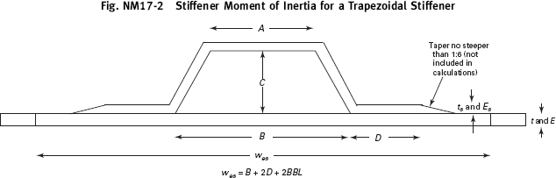

Stiffener Construction: Filament Wound

Stiffener Top Hoop Tensile Modulus:
Esri := 14000000⋅psi

Stiffener Side Hoop Tensile Modulus:
Esrli := 1400000⋅psi

Stiffener Top FW Thk.: tsr := ( 0.24 )⋅in

Stiffener Side Chop Thk.:
ts_sd := ( 0.24 )⋅in

⎯⎯⎯ →
( )
Shell Outside Diameter: Dsh_o := D + 2⋅ts

Stiffener Effective Dimensions:

A := 2⋅in
i
Ci := 2⋅in
Bi := 4⋅in
Dsri := 2⋅in

Shell Thk: tsh := tstot = ( 0.29 ) in

Shell Hoop Tensile Modulus:

Esh

:= Eh
= (4.314 ×

10 ⋅psi
6 )

⎯⎯⎯⎯⎯⎯⎯⎯⎯⎯→

⎯⎯⎯⎯⎯→
⎯⎯⎯⎯⎯⎯⎯→

ϕ := acos⎡⎢ C ⎤⎥ ⎛ϕ 180 ⎞
⋅

⋅deg = ( 26.565 )⋅deg
⎢
⎢⎣
C +
⎝
2
⎛ B − A⎞2⎥
2
⎠ ⎥⎦
π
⎝ ⎠
Lsr :=

⎯⎯⎯⎯→
C +
2
⎛ B − A⎞2
⎝
2 ⎠
( )
Area of Sides: As := Lsr⋅ts_sd

⎯⎯⎯⎯→
( )
Effective Width of Cylinder: wes := B + 2⋅Dsr

⎯⎯⎯→
( )
Effective Area of Cylinder: Ac := wes⋅tsh

⎯⎯→
( )
Area of Top: At := A⋅tsr

⎯⎯⎯⎯⎯⎯⎯⎯⎯→
( )
Area of Base: Ad := ⎡⎣2⋅ Dsr − ts_sd ⋅ts_sd⎤⎦

Total Effective Area of

⎯⎯⎯⎯⎯⎯→

Stiffener Excluding Shell: Atot := (At + Ad + As)

Effective Hoop Modulus of Stiffener and Cylinder:

Esrh :=
⎯⎯⎯⎯⎯⎯⎯⎯⎯⎯⎯⎯⎯⎯→
Esh⋅Ac + Esr⋅ At + Ad + Esrl⋅As = (7.009 × 106 )⋅psi Ac + Atot
( )

Required MOI of Ring:

Isr_min :=
⎯⎯⎯⎯⎯⎯⎯→
Psti_q⋅Lst⋅Dsh_o3 24⋅Esrh

= ( 1.304 )⋅ 4
in

⎯⎯⎯⎯⎯⎯⎯⎯⎯⎯⎯⎯⎯⎯⎯⎯⎯⎯⎯⎯⎯⎯⎯⎯⎯→
t

⎛ −tsh ⎞
c
tsr
Esr
C Esrl
⎛ tsr ⎞
Esr

Effective CG From CG :=
Outside of Shell:
A ⋅⎜
⎝
⎟ +
2 ⎠ 2
⋅
Esh
⋅Ad + As⋅
E
⋅
2 Esh
+ A ⋅⎜C +
⎝
E
⎟⋅
2 ⎠ Esh

Ac + As⋅ srl + (At + Ad)⋅ sr

CG = ( 0.511 ) in
Esh
Esh

⎯⎯⎯⎯⎯⎯⎯⎯⎯⎯⎯⎯⎯⎯⎯⎯⎯ →

⎛⎜ t
⋅L 3
L ⋅t 3 ⎞⎟

I of Each Side About the
Iside := ⎜ s_sd sr ⋅cos(ϕ)2 + sr s_sd ⋅sin(ϕ)2⎟ = 4

Centroid of the Sides:
⎝ 12
12 ⎠
( 0.179 ) in

About the Centroid:
⎯⎯⎯⎯⎯⎯⎯⎯⎯⎯⎯⎯⎯⎯⎯⎯⎯⎯⎯⎯⎯⎯⎯⎯⎯⎯⎯⎯→
⎛ Esrl 2 Esr 2 ⎞

⎜ 3
w ⋅t E
E ⋅Ad⋅ts_sd E
E ⋅At⋅tsr ⎟

⎜ es sh sh
⎟
srh
srl
srh ⎟

I1 := ⎜
⎝ 12
⋅ +
Esrh
+
12 E
srh
⋅2⋅Iside +
12 ⎠

⎯⎯⎯⎯⎯⎯⎯⎯⎯⎯⎯⎯⎯⎯⎯⎯⎯⎯⎯⎯⎯⎯⎯⎯⎯⎯⎯⎯⎯⎯⎯⎯⎯⎯⎯⎯⎯⎯⎯⎯⎯⎯⎯⎯⎯⎯→
⎤

⎡
I := ⎢
⎛ tsh ⎞2
Esh
Esrl ⎛
ts_sd ⎞2
Esrl ⎛ C
⎞2 Esr ⎛
2
tsr ⎥
⎞

2 ⎢tsh⋅wes⋅⎜CG + 2 ⎟ ⋅ E
- Ad⋅ E
⋅⎜CG −
- ⎟ + As⋅ E
⋅ − CG
2
- At⋅ E
⋅⎜C +
2 − CG⎟ ⎥

⎣ ⎝ ⎠
srh
srh ⎝
⎠ srh ⎝ ⎠
srh ⎝ ⎠ ⎦

Effective MOI Considering Different Moduli of Shell and Stiffener: I
⎯
:= (
⎯⎯→ 4
= ( 3.236 )⋅
)
e I1 + I2
in

checkstiffenerMOIi := if ⎛Iei ≥ Isr_mini, "Adequate" , "Stiffener Inadequate" ⎞
⎝ ⎠

checkstiffenerMOI = ( "Adequate" )

⎯⎯⎯⎯→
n

Moment of Inertial of Shell per Inch ΣIu
⎛ Ie ⎞
:= ⎜ ⎟
L
⎝ st_max ⎠
ΣIu
= ( 0.202 )⋅i 3

Stiffener Unit Weight Isu ≡ ( 0.202 )

⎯⎯⎯⎯⎯⎯⎯⎯⎯⎯⎯⎯⎯⎯⎯⎯⎯⎯⎯⎯→
( ) ( )
Wstif := ⎡⎣π⋅ Do + 2CG ⋅⎡⎣A⋅tsr + Lsr + Dsr ⋅ts_sd⎤⎦⋅ρfrp⎤⎦

Number of Stiffeners on Shell Nsr := ( 26 )

⎯⎯⎯⎯→
( )
Wr := Nsr⋅Wstif

Wstif = ( 29.829 ) lb

ΣWr := ∑Wr = 775.558 lb
Wr = ( 775.558 ) lb

See FEA buckling analysis for shell w/ stiffeners.

Shell W/ Stiffeners Under External Pressure Finite Element Analysis
See external pressure calculation in section 2.2 IV. Tank is simply supported at the bot. 180 deg. surface.
Buckling analysis is run to investigate the safety factor against buckling for the shell and stiffeners assembl

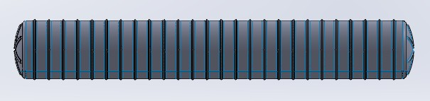

Solid Model

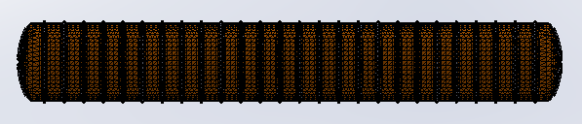

Meshed Model

Buckling Safety Factors For Shell + Stiffeners Assembly

⎛ "Mode No." "Buckling Factor of Safety" ⎞

⎜ 1 3.2011
⎜
⎜ 2 3.2071
⎜ 3 3.3664
⎜ 3.3731
4
⎜
⎝ 5 3.4237
⎟
⎟ Greater than min. buckling factor 2.5, OK.
⎟
⎟
⎟
⎟
⎠

Chapter 3 Dished Heads

Head Construction Hand Layup

Head Configuration ASME F & D

Head Straight Flange Length
sfth := 1.5⋅in

Head Structural Thk. tth := 0.31⋅in

Head Total Thk. tth_tot := tth + tcb = 0.31⋅in

Tensile Modulus Eth := 1500⋅ksi

Tensile Strength Sth := 15⋅ksi

Flexural Modulus Eth_f := 1000⋅ksi

Ultimate Flexural Strength Sth_f := 22⋅ksi

Poisson's Ratio υ ≡ 0.25

Design Factor For Pressure Fs = 10

Design Factor For Vacuum and Combined Load

Fvac = 2.5

3.1 Head Design for Pressure

Head Construction: Hand Layup

Head Design Pressure: PH_ip := Ps_ip = 3.466⋅psi

Head Inside Dish Radius: Rc := 96⋅in

Head Inside Knuckle Radius: rc := 6⋅in

Minimum Required thk. For Pressure: t

h_ip :=
0.885PH_ip⋅Rc
Sth Fs

= 0.196 in

checkheadthkip := if (tth_tot ≥ th_ip, "OK" , "Increase head thk." ) = "OK"

Design of Head to Shell Joint

Joint Tensile Modulus: Ej := Eth

Secondary Bond Shear Strength: τj := 2000⋅psi

Left & Right Head to Shell Joint

PH_ip⋅⎛ D + ts ⎞

Min. Req'd Joint Thk.: tjH_min :=
⎝ 2
(0.001⋅Ej)
1⎠ = 0.112 in

Design Joint Thk.: tjH := tth = 0.31 in

PH_ip⋅⎛ D + ts ⎞
Min. Req'd Joint Length: LjH_min := ⎝ 2 1⎠
τ
j
2⋅
Fs

= 0.418 in

Design Joint length: See detail. in Appendix A

Head Design for External Loads

Design Max External Pressure PH_ep := Ps_ep = 10.144⋅psi

Finite Element Analysis of Dished Heads

Applied Load : - Gravity
- External Water Pressure
- Soil Load

Boundary Condition: Fixed around the perimeter of the top head. (For simplicity of analysis.)

Finite element analysis is performed based on the load and boundary conditions as stated above and material properties and thks specified in the previous sections of thie report. Solidworks 2012 Simulation is used for this analysis.

FEA Solid Model
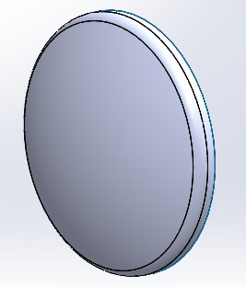
Meshed Model
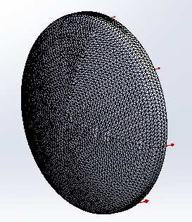

1st Principal Stress

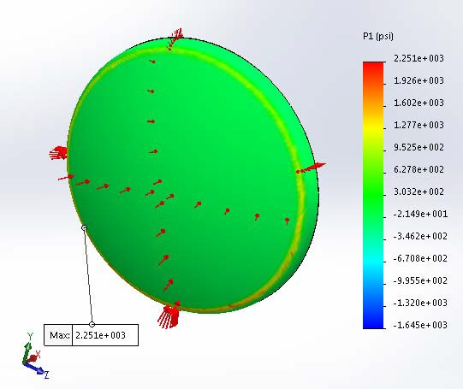

Tank head is under external pressure. Max. allowable compressive stress in type II hand layup laminate is 20,000 psi / 3 = 6,667 psi. Max. 1st principal stress in the head is 2,251 psi. Buckling analysis is run to evaluate the head's stability under external loads.

X - Stress
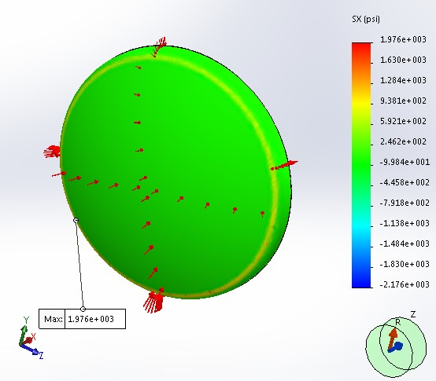

Y - Stress
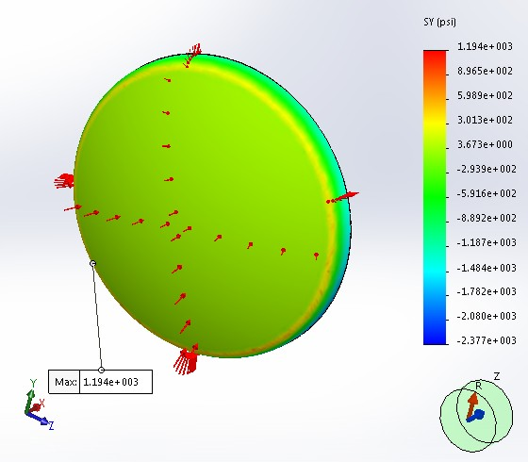

Z - Stress
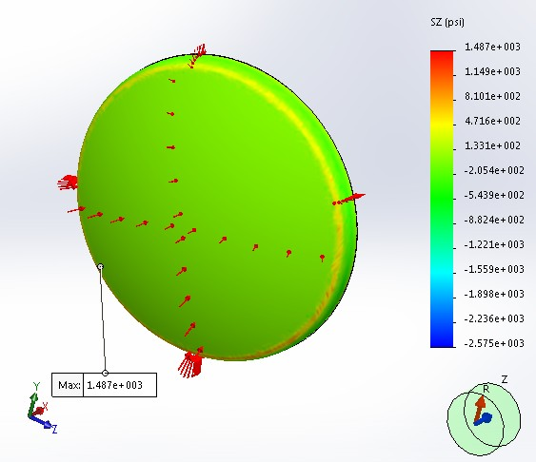

Resultant Displacement
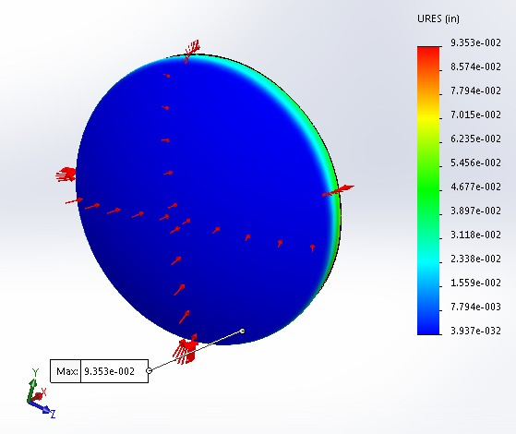

Less than 0.75", OK.
Note : Deflection is exaggerated by 50 times for clarity.

Buckling Safety Factor

⎛ "Mode No." "Buckling Factor of Safety" ⎞

⎜ 1 2.5228 ⎟
⎜ ⎟
⎜ 2 2.5326 ⎟
⎜ 3 2.5509 ⎟
⎜ 2.5731 ⎟
4
⎜
⎟
⎝ 5 2.7976 ⎠

Greater than 2.5. OK.

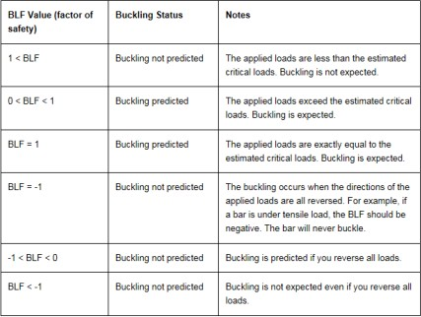

Chapter 4 Component Weight

Weight of Each Head: WH := Wttorihead(ρfrp, rc, R, Rc, 0 , tth)

WH = 175.043lb

Head Depth: h
⎡ ⎛
⎢ ⎜
:= R − R − r ⋅
⎛ D ⎞⎞⎤
⎜ 2 ⎟⎟⎥
- rc

H c ⎢( c
c) cos⎜asin⎜
⎟⎟⎥

⎣ ⎝ ⎝ Rc − rc ⎠⎠⎦

hH = 16.401 in

Weight of Shell: WS := ρfrp⋅π⋅D⋅H⋅

tstot
= 3.576 × 3

WS = 3.576 × 103 lb
10 lb

Top Head Volume: VL_H := f_volts(rc , R, Rc, 0) = 314.542⋅gal

Tank Volume (Flooded): VL := 2VL_H + π⋅R2⋅H

VL = 2.034 × 104 gal

Content Weight: WL := ρc⋅VL = 4.078 × 5
10 lb

Extra FRP Dead Weight (Covers joints, nozzles, and repads etc.)
Wad1 := 1000⋅lb

Total Weight Multiplication Factor: η := 1.15

Total FRP Tank Weight: WFRP :=
WS + 2⋅WH + Wad1 + Wr ⋅η = 6.557 × 3

Total FRP + Content Weight: WT := WFRP + WL = 4.144 × 105 lb
10 lb

Chapter 5 Buoyancy Design

- Buoyant force acting on the underground tank is equal to the weight of fluid which the tank displaces.

- Tank tank w/ stiffeners' weights, soil load above the tank within the friction angle, and the weight of the concrete deadman attached to the tank are used to resist buoyancy.

Buoyancy Design Safety Factor SFby ≡ 1.2

Saturated Backfill Material Density

Projected Area

Estimated Weight of Tank Used to Counteract Buoyancy
ρfil := 70⋅ lb
ft
3

Aprj := D⋅H = 6.038 × 104⋅in2 Wby_ww := WFRP = 6.557 × 103 lb

Total Volume of Water Displaced Vh2o := VL = 2.034 × 104 gal Total Weight of Water Displaced Wh2o := ρw⋅Vh2o = 1.696 × 5⋅lb Design Buoyancy Force Fby := Wh2o⋅SFby = 2.035 × 105⋅lb
10
Min. Backfill Height dbk := 3⋅ft

Soil Friction Angle (Estimated) ϕ := 20⋅deg

:= ϕ ⋅ = 0.349 180⋅deg
ϕ πr

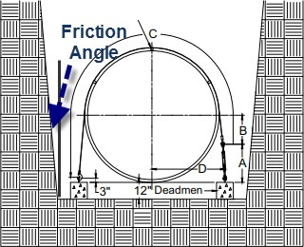

Soil friction angle must be verified by end user. Ecavate area must be greater than 20 degree area. All excavated in situ soil must be replaced with primary backfill material. Back fill soil must be even and uniform in every direction.

Base Area ab := D⋅H

Height h := dbk +

D = 7⋅ft 2

Δ := h⋅tan(ϕr) = 30.573 in

Top Area at := (D + 2⋅Δ)(H + 2⋅Δ) = 1.085 × 5 2
10 in

Concrete Deadmen Qty Nd := 6

Concrete Deadmen Length Ld := 16⋅ft

Unit Weight wd := 2400⋅lb

Concrete Deadmen Width bd := 18⋅in

Total Concrete Deadmen Weight
W := N ⋅w ⋅ ρc − ρw = 8.411 × 3

When Submerged
d d d ρc
10 lb

Soil Above Deadmen Below Tank C.L. Vd_sl := Nd⋅Ld⋅bd⋅ D = 576⋅ft3
2
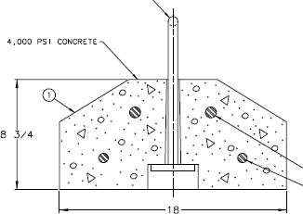

Volume of Backfill and Soil Above Vs := h ⋅(at + ab +
Tank Used to Counteract Buoyancy 3
at⋅ab) −
1 2 1
D
⋅π⋅ ⋅H⋅ =
4 2
2.73 × 103⋅ft3

Backfill Weight Wbk := (Vs + Vd_sl)⋅ρfil = 2.314 × 105 lb

Weight of Concrete Required To Hold Down the Tank When Totally Submerged
Wc_r := Fby − Wby_ww − Wbk = −3.443 × 104⋅lb

checkbuoyancy := if (Wd ≥ Wc_r, "Adequate" , "Additional Weight Req'd" ) = "Adequate"

See concrete deadmen design sketch in Appendix A.

Chapter 6 Lifting Lug Design

Lifting Lug are Attached by Hoop Filament Wound Glass

A36 C.S. = Lifting Lug Material

WFRP = 6557 lb
= Total Empty Tank Weight

NL := 4
= Number of Lift Lugs

tlug := 0.375⋅in
= Thickness of Backing Plate

wL := 8⋅in
= Width of Backing Plate

hL := 10⋅in
= Height of Backing Plate

elift := 1.5⋅in
= Eccentricity

Sv := 2000⋅psi

= FRP Shear Strength

Sa := 15000⋅psi
= FRP Axial Tensile Strength

Sh := 30000⋅psi
= FRP Hoop Tensile Strength

to1 := 0.40⋅in

λ := 1.5
= Hoop Overwind Thk.

= Design Factor

A36 C.S. = Lug Material

Material properties from ASME Section II part D for ambient temperature.

 | Es | Sy | Su
A36 | 29000 ksi | 36 ksi | 58 ksi
304 S.S. | 29000 ksi | 30 ksi | 75 ksi
316S.S. | 29000 ksi | 30 ksi | 75 ksi

Lug Eastic Modulus Ecs := 29000⋅ksi

Lug Yield Strength Fylug := 36⋅ksi

Lug Ultimate Tensile Strength Fulug := 58⋅ksi

CALCULATIONS

Reinforcement pad thickness tp := 0.043⋅in⋅5 = 0.215in
(All Mat Construction)

Reinforcement pad height Lp := hL + 6⋅in = 16 in

Reinforcement pad width wp := wL + 6⋅in = 14 in

Pad + shell thickness tps := tp + tsh = ( 0.505 ) in

Load per lug Flift :=
λ⋅WFRP = 2.459 × 3
NL
lb
10

Bending moment per lug ML := Flift⋅elift = 3.688 × 103 in⋅lb

Unit radial load on overwrap W
3⋅Flift⋅elift lb
:= = 172.883

max

wL2 in

Total radial load due to lug moment PL :=
Wmax⋅wL
= 691.533 lb
2

Overwind mean radius Ro := R + tps = ( 48.505 ) in

Hoop overwind load Ttl :=
PL⋅Ro = (3.354 × 103 ) lb hL

Hoop overwind tensile stress σo :=

Shear across vessel wall τo :=
Ttl hL⋅to1
PL

tps⋅hL

= ( 838.57 )⋅psi OK

= ( 136.937 )⋅psi OK

Coefficient of bending in vessel wall: βL :=

Poisson's ratio υ = 0.25
= 0.259 1
in
1.28
Ro⋅tps

PL lb
Unit radial loading P := = 69.153
star hL in

Bending loads:

Max.L :=
Pstar 4⋅βL

= 66.847 lb

Mhp.L := υ⋅Max.L = 16.712 lb

Loads due to pressure: Zero during lift

NaxL := 0

NhpL := 0

Bending stress on shell, psi: σ
6⋅Max.L
:= +
NaxL = (1.573 × 103 )⋅psi

ax.L
2
tps

tps

σ :=
6⋅Mhp.L
+
NhpL = ( 393.179 )⋅psi

hp.L
2
tps

tps

Safety factor for bending: Sa

σax.L Sh

σhp.L

= ( 9.538 )

= ( 76.301 )

- 3 OK

- 3 OK

LIFTING RING STRESS CHECK

Diameter of Ring Rod dbolt := 0.5⋅in

Ring Outside Diameter odring := 1.25⋅2⋅in = 2.5 in

Ring Inside Diameter idring := 1.5⋅in

Diameter of Pin dpin := 0.75⋅in

ϕgross := .90
ϕnet := .75
Ωgross := 1.67
Ωnet := 2

Shear lag factor U := 1 table D3.1

Net area An := 0.141⋅ 2
in

Tensile rupture in net area Ft

net :=

Fulug

Ωnet

Vcap1 := Ftnet⋅An⋅U
Vcap = 4.089 × 3
1
10 lb

AISC(13th ed.), sect. J7 bearing strength

ϕbrg := .75
Ωbrg := 2
LRFD

Allowmushrooming := "yes"

Allowable bearing stress: Fbrg
:= 1.8⋅ Fylug
Ωbrg

Projected bearing area: Abrg := dpin⋅dbolt

Allowable load for bearing: Vcap2 :=
Fbrg⋅Abrg
if Allowmushrooming = "no"
Vcap = 4.089 × 3
2
10 lb

Vcap1 if Allowmushrooming = "yes"

AISC(13th ed.), sect. J4-2 Strength of connecting elements in shear

shear yeilding
ϕsy := 1
Ωsy := 1.5

Net shear area: Anvsr := 2⋅ 1 ⋅π⋅d
4

2
bolt

shear rupture
ϕsr := .75
Ωsr := 2

Net area subject to shear: Anvsr := Anvsr
Rnsr := 0.6⋅Fulug⋅Anvsr

Vcap3 :=
Rnsr

Ωsr
Vcap = 6.833 × 3 lb
3
10

AISC(13th ed.), sect. J4-3 Block shear strength

Block Shear
ϕsb := .75
Ωsb := 2
Ubs := 1
tension is uniform

Net area subject to tension Ant := An
Net area subject to shear Anv := Anvsr

Rnsb := min(0.6⋅Fulug⋅Anv + Ubs⋅Fulug⋅Ant)
Rnsb 4

AISC(13th ed.), J4-5

Vcap4 :=

Ωsb
Vcap4 = 1.092 × 10 lb

AISC(13th ed.), sect. D5

tensile rupture
ϕtr := .75
Ωtr := 2
Pntr = 2⋅thk⋅beff⋅Fulug

⎛⎜ 4.089 × 103 ⎞⎟
beff := dbolt beff = 0.5 in
Vcap5 := 2⋅An⋅

Fulug

Ωtr

Vcap = 8.178 × 3 lb
5
10

⎜ 3 ⎟
⎜ 4.089 × 10 ⎟

Vcap = ⎜ 6.833 ×
- ⎟ lb
min(Vcap) = 1.663
must be greater than 1

⎜ 10 ⎟
Flift

⎜ 1.092 × 4 ⎟
⎜ 10 ⎟
⎜⎝ 8.178 × 103 ⎟⎠

Chapter 7 Opening Reinforcement
Reference: RTP-1 3A-700 - 730

Pint = 0.0
= Design Pressure

dn = Nozzle Diameter
hn = Nozzle Elevation
Pn = Pressure at Nozzle Centerline
tr = Required Reinforcement Thickness
Dr = Required Reinforcement Diameter
tn = Nozzle Neck Thickness
ti = Inside Bond Thickness
to = Outside Bond Thickness

H = 629 in
Sr := Sth sg = 1.00
= Max Liquid Level
= Strength of Reinforcement Laminate
= Specific Gravity of Tank Contents

Shell Nozzle Opening Reinforcement

⎛ 4 ⎞

⎛ 96 ⎞
⎛⎜ 1.748 × 10− 14 ⎞⎟

d := ⎜ 24 ⎟⋅in
h := ⎜ 96 ⎟⋅in
Δh := (
⎯⎯→
Δh = ⎜
− 14 ⎟ in

n ⎜ ⎟
⎯
)
n ⎜ ⎟
D − hn
⎜ 1.748 × 10 ⎟

⎝ 30 ⎠
⎝ 96 ⎠
⎜ − 14 ⎟

k := 1 .. last(dn)
⎝ 1.748 × 10 ⎠

Calculate Pressure at Each Nozzle:

Pnk := Pint + Δhk⋅sg⋅ρws

⎛ 0.00 ⎞
Pn = ⎜ 0.00 ⎟⋅psi

⎜ ⎟
⎝ 0.00 ⎠

Calculate Reinforcement Diameter:
⎯⎯⎯⎯⎯⎯⎯⎯⎯⎯⎯⎯⎯⎯⎯⎯→
Drk := if ⎡⎛dn ⎞ > 6⋅in, ⎛2⋅dn ⎞ , ⎛dn + 6⋅in⎞⎤
⎣⎝ k⎠ ⎝ k⎠ ⎝ k ⎠⎦

⎛ 10 ⎞
Required Cutout Reinforcement Dia.: Dr = ⎜ 48 ⎟⋅in
⎜ ⎟
⎝ 60 ⎠

Calculate Coefficient "K":

⎡ ⎛ dn ⎞ ⎤
⎛ 0.67 ⎞

Kn := if ⎢dn < 6⋅in, ⎜ k ⎟ , 1.0⎥
Kn = ⎜ 1.00 ⎟

k ⎣ k
⎝ 6⋅in ⎠ ⎦ ⎜ ⎟

⎝ 1.00 ⎠

Calculate Coefficient "M":

Laminate type: type := "X" (X for filament wound, I and II for HLU)

Hoop tensile strength for shell: σuk := 0.01⋅Eh1

Factor M M :=
1 if type
σuk
15000⋅psi
r
k
= "I" ∨ type = "II"

otherwise

Calculated Structural Thk: T := t
c s
k 1
Theoretical Structural Wall Thk.: Tt := Tc

Factor V V := 1
k 2
(pressure governs V=1, vacuum governs V=1/2)

Calculate Reinforcement Thickness:

trk := V ⋅Mr ⋅Kn ⋅Ttk
k k k
− M ⋅⎛T − T ⎞
k ⎝ k k⎠
r c t

⎯⎯⎯⎯⎯⎯⎯⎯⎯⎯⎯→
trk := if ⎛trk ≥ 0.19⋅in, trk, 0.19⋅in⎞
⎝ ⎠

Required Reinforcement Thickness: Use Reinforcment Thickness:

⎛ 0.278 ⎞
tr = ⎜ 0.417 ⎟⋅in
⎛ 0.31 ⎞
trd := ⎜ 0.43 ⎟⋅in

⎜ ⎟ ⎜ ⎟
⎝ 0.417 ⎠ ⎝ 0.43 ⎠

Reinforcement should be made of type II laminate with mat and woven roving. Shell Nozzle Opening Reinforcement Summary

⎛ 4 ⎞
dn = ⎜ 24 ⎟⋅in
⎛ 10 ⎞
Dr = ⎜ 48 ⎟⋅in
⎛ 0.31 ⎞
trd = ⎜ 0.43 ⎟⋅in

⎜ ⎟ ⎜ ⎟ ⎜ ⎟

⎝ 30 ⎠
⎝ 60 ⎠
⎝ 0.43 ⎠

Head Nozzle Reinforcement

dnc := ( 4 )⋅in

m := 1 .. last(dnc)
hLc := ( 0 )⋅in

last(dnc) = 1
ΔhLc := D − hLc
ΔhLc = ( 96 ) in

Calculate Pressure At Each Nozzle:

Pncm := Pint + ρc⋅ΔhLcm

Pnc = ( 8.333 )⋅psi

Calculate Reinforcement Diameter:
⎯⎯⎯⎯⎯⎯⎯⎯⎯⎯⎯⎯⎯⎯⎯⎯⎯⎯→
Drcm := if ⎡⎛dnc ⎞ > 6⋅in, ⎛2⋅dnc ⎞ , ⎛dnc + 6⋅in⎞⎤
⎣⎝ m⎠ ⎝ m⎠ ⎝ m ⎠⎦

Calculate Coefficient "K":
⎡ ⎛ dncm ⎞ ⎤

Knc
:= if ⎢dnc < 6⋅in, ⎜ ⎟ , 1.0⎥
Knc = ( 0.667 )

m ⎣ m ⎝ 6⋅in ⎠ ⎦

Calculate Coefficient "M": Laminate type: typec := "II" Factor M Mrc := 1
m
Calculated structural thk: Tsc := tth
m

Theoretical structural thk: Ttc
m
:= Tscm

1
Vrcm := 2

(pressure governs V=1, vacuum/bending governs V=1/2)

Calculate Reinforcement Thickness:

trcm := Vrc
m
⋅Mrc
⋅Knc
⋅Ttc

⎯⎯⎯⎯⎯⎯⎯⎯⎯⎯⎯⎯ →
m
m
m
trcm := if ⎛trcm ≥ 0.19⋅in, trcm, 0.19⋅in⎞

trc = ( 0.19 )⋅in

⎝ ⎠

Design Repad Thk.: trc_d := ( 0.19 )⋅in

Drcm − dncm

Repad Width
wrcm :=
8⋅in if
- 8⋅in
2
wrc = ( 3 ) in

Drcm − dncm 2

otherwise

Design Repad Width wrc_d := wrc = ( 3 ) in

Top Head Nozzle Reinforcement Summary

dnc = ( 4 )⋅in
trc_d = ( 0.19 )⋅in
wrc_d = ( 3 )⋅in

Appendix A Design Summaries and Sketches

Tank Inside Diameter................................... D = 96⋅in

Straight Shell Length................................... H = 629⋅in

Shell Total Thk............................................ tstot = ( 0.29 )⋅in

Left/Right Head Combined Thk..................... tth_tot = 0.31⋅in

Tank Empty Weight..................................... WFRP = 6.557 × 103 lb

Lamination Sequence

Left & Right Heads 0.31" -3(M,R)M,M Shell 0.29" - 2(2FW,U),FW

Nomenclature For Lamination Sequence:

FW = 0.05" @ 89 deg. winding angle, 1 cycle of filament wound glass c = 0.02", 1 layer interspersed chopped strand glass, 0.7 oz/ft2
C*** = 1 layer of chopped strand glass - *** indicates thk. of layer in mils (C025 = 0.025") C = 0.043", 1 layer chopped strand glass, 1.5 oz/ft2
M = 0.043", 1 layer chopped strand glass mat, 1.5 oz/ft2 R = 0.033", 1 layer woven roving, 24 oz/sq. yd.
U = 0.02", 1 layer unidirectional roving

Shell Stiffener Layout

Total Stiffener Weight ΣWr = 775.558 lb
Total # of Stiffeners Nsr = ( 26 )

Stiffener Spacing Lst = 24 in

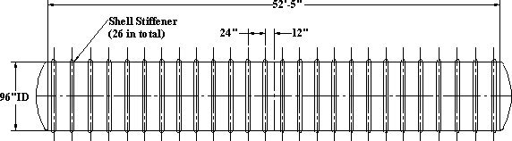

.

Note : Bottom 180 deg. section of the tank is fully supported. See customer installation manual.

Shell Stiffener Detail

A = ( 2 ) in
B = ( 4 ) in
C = ( 2 ) in
Dsr = ( 2 ) in

Stiffener Thk.: tsr = ( 0.24 ) in

0.24" - 3C,U,2C

Shell to Shell Joint Detail
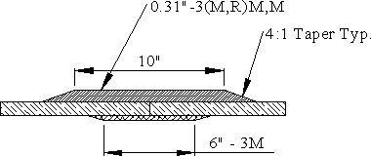

Head to Shell Joint Detail

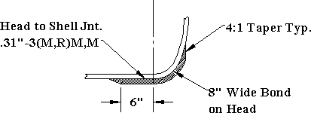

Lifting Lugs

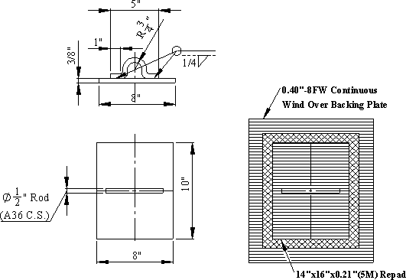

Nozzle Opening Reinforcement

Shell Nozzle Opening Reinforcement Summary

⎛ 4 ⎞
dn = ⎜ 24 ⎟⋅in
⎛ 10 ⎞
Dr = ⎜ 48 ⎟⋅in
⎛ 0.31 ⎞
trd = ⎜ 0.43 ⎟⋅in

⎜ ⎟ ⎜ ⎟ ⎜ ⎟

⎝ 30 ⎠
⎝ 60 ⎠
⎝ 0.43 ⎠

Top Head Nozzle Reinforcement Summary

dnc = ( 4 )⋅in
trc_d = ( 0.19 )⋅in
wrc_d = ( 3 )⋅in

Concrete Deadmen Design

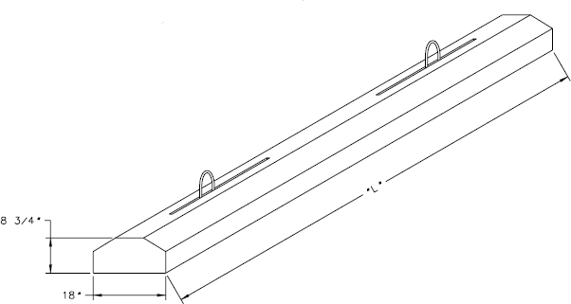

18" wide x 8 3/4" tall x 16' long; 6 req'd

Turnbuckle Selection

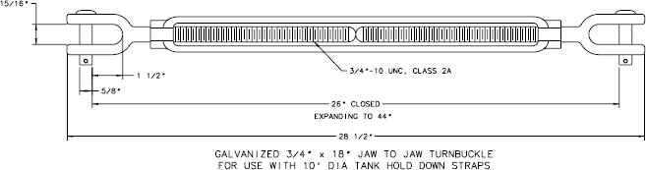

Appendix B Lamination Analysis Using Trilam

Stypol DCPD Resin used for construction of tank. Trilam analysis uses iso resin which has similar mechanical properties.

Laminate Sequence Shell

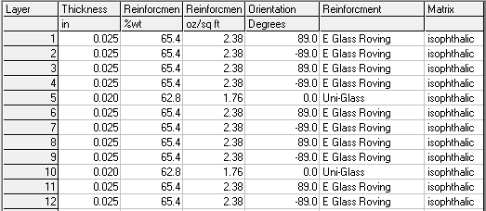

Laminate Properties Shell

