FRP Composite Services Composite Engineering Design Finite Element Analysis
D2020·02·04 jdu@frpcompositeservices.com (o) 417·708·6651 (c) 310·913·5502

ENGINEERING DESIGN REPORT
FIBERGLASS REINFORCED PLASTIC UNDERGROUND HORIZONTAL TANK BAFFLES

Customer: Fiberglass Tank Solutions, LLC Dimension: 8 ft, 10 ft, 12 ft O.D. baflles Construction: Hand Layup
Resin System: Stypol DCPD Resin w/ CoNAP/MEKP Corrosion Barrier: NA
Design Pressure: Atmospheric
Design Temperature: 100 deg. F max. Liquid Content: TBD.
Design Content Specific Gravity : 1.0 Seismic Load: NA
WmdLoad:NA
Equipment Service Location: TBD

Design Engineer: Joann Du, P.E. Revision: 0
Issue Date: 5/4/2020

Chapter 1 Design Inputs

⎛ 8 ⎞
Baffle Outside Diameter D := ⎜ 10 ⎟⋅ft
⎜ ⎟

Baffle Outside Radius R :=
⎝ 12 ⎠
D 2

Design Burial Depth to the Top of the Tank

Design Burial Depth to
hbu := 7⋅ft

⎯⎯⎯ →

the Bot. of the Tank LB := (D + hbu)

Design Water Table Hwt := LB

Applied Internal Pressure Pint := 0⋅psi

Applied External Pressure Pext := 0⋅psi

Corrosion Barrier Thk. tcb := 0⋅in

Max. Design Temperature Tmax := 100⋅F

Content Specific Gravity sg := 1.0

Water Density: ρw := 0.0361⋅ lb in
3

FRP Density ρfrp := 0.07⋅ lb in
3

Submerged Soil Density ρws := 70⋅ lb ft
3

Concrete Desity ρc := 150⋅ lb
3
ft

Type II Laminate Tensile Modulus Eth := 1500⋅ksi

Type II Laminate Tensile Strength Sth := 15⋅ksi

Type II Laminate Flexural Modulus Eth_f := 1000⋅ksi

Type II Laminate Flexural Strength Sth_f := 22⋅ksi

Poisson's Ratio υ ≡ 0.25

Design Safety Factor for Sustained Load Fs := 10

Design Safety Factor for Transient Load Ft := 5

Design Safety Factor for Vacuum Fvac := 2.5

Chapter 2 Dished Baffles W/ Stiffener Design

Baffle Construction Hand Layup

Baffle Configuration ASME F & D w/ Stiffeners

Baffle Structural Thk.
⎛ "3(M,R)M"
⎜ "3(M,R)M,2M"
td := ⎜ 0.36 ⎟⋅in
⎛ 0.27 ⎞
⎜ ⎟
⎝ 0.47 ⎠
⎜
⎞ Bond w/ the same thk.
⎟ secondary overlay on each
⎟ side. Min. 6" bond each

Baffle Total Thk.
⎝"3(M,R)M,2(M,R)M" ⎠

⎛ 0.27 ⎞
td_tot := td + 2⋅tcb = ⎜ 0.36 ⎟⋅in
side plus 4:1 taper.

⎜ ⎟
⎝ 0.47 ⎠

2.1 Baffle Design for Pressure

Baffle Construction: Hand Layup
⎯⎯⎯⎯⎯→
( )
Baffle Design Pressure: PH_ip := Pint + ρw⋅D
Baffle Inside Dish Radius: Rc := D
Baffle Inside Knuckle Radius: rc := 0.06⋅D
⎯⎯⎯⎯⎯⎯→

⎛ 0.196 ⎞

Minimum Required thk. For Pressure: t
0.885PH_ip⋅Rc
:=
= ⎜ 0.307 ⎟ in

h_ip

Sth ⎜ ⎟

Fs

⎛ 1.44 ⎞
Allowable Deflection δ := 0.015⋅D = ⎜ 1.8 ⎟ in
⎝ 0.442 ⎠

⎜ ⎟
⎝ 2.16 ⎠

  - Baffle Design for External Pressure

⎛ 3.466 ⎞
Design Max External Pressure PH_ep := PH_ip = ⎜ 4.332 ⎟⋅psi
⎜ ⎟
⎝ 5.198 ⎠

  - Finite Element Analysis of Dished Baffles
Applied Load : - Gravity
- External Water Pressure

Boundary Condition: Fixed around the perimeter of the baffle. (For simplicity of analysis.) Note : See Appendix A for stiffener size, location and FRP overlay thks.

Finite element analysis is performed based on the load and boundary conditions as stated above and material properties and thks specified in the previous sections of thie report. Solidworks 2012 Simulation is used for this analysis.

FEA Solid Model
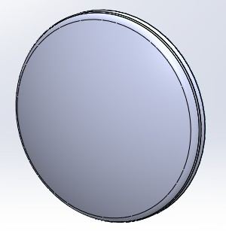
Meshed Model
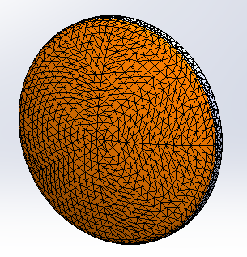

8 ft O.D Baffle

1st Principal Stress
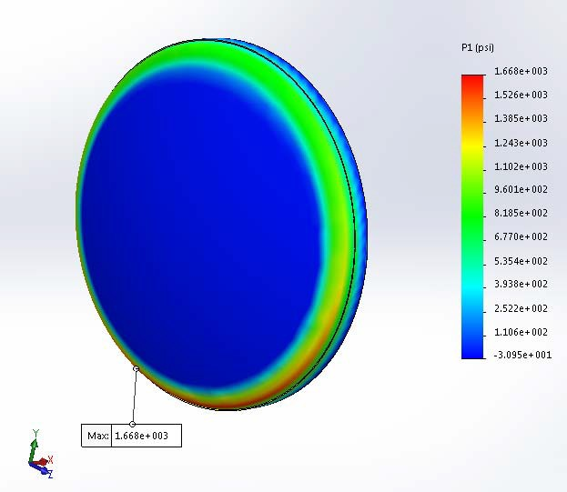
Tank baffle is under external pressure. Max. allowable tensile stress in type II hand layup laminate is 15,000 ps
/ 3 = 5,000 psi. Higher stress (1,668 psi) is observed in the knuckle region of the dished baffle. Knuckle is under compression. Buckling analysis is run to evaluate the baffle's stability under external loads.
The max stress in the rest of the area in the baffle is less than 3,000 psi, and is thus considered acceptable.

X - Stress
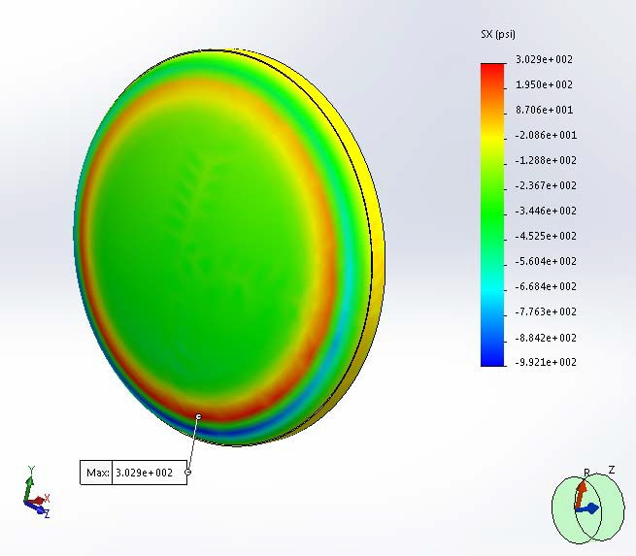

Y - Stress
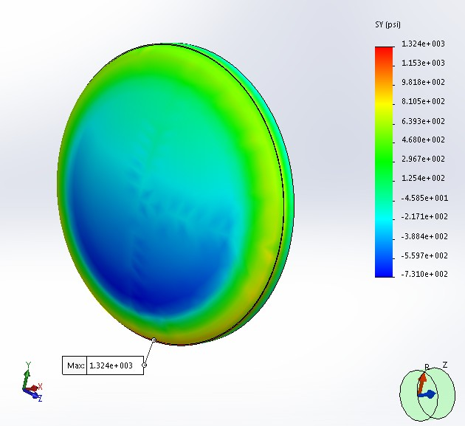

Z - Stress
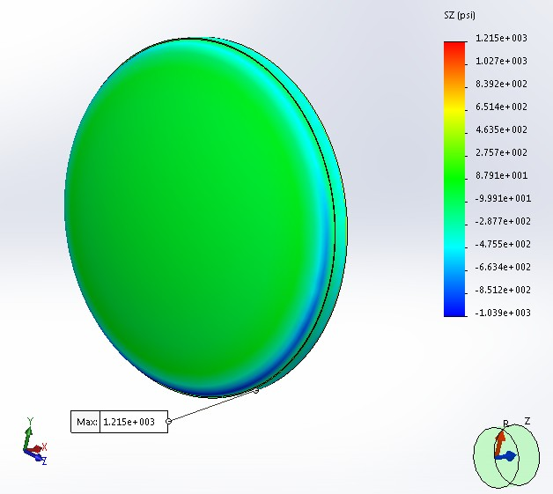

Resultant Displacement
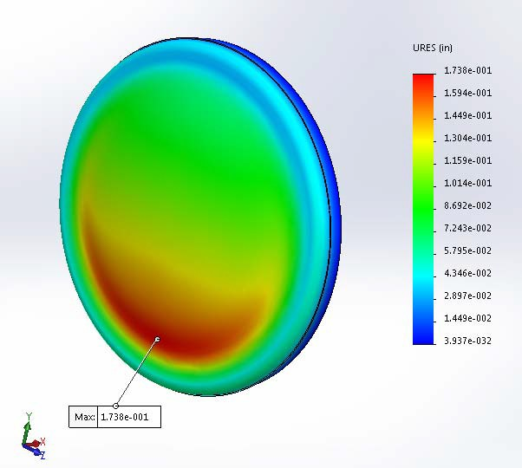

Less than 1.44", OK.
Note : Deflection is exaggerated by 20 times for clarity.

Buckling Safety Factor

⎛"Mode No." "Buckling Factor of Safety" ⎞

⎜ 1 2.9715 ⎟
⎜ ⎟
⎜ 2 2.9827 ⎟
⎜ 3 3.2635 ⎟
⎜ 3.2691 ⎟
4
⎜
⎟
⎝ 5 3.5343 ⎠

Greater than 2.5. OK.

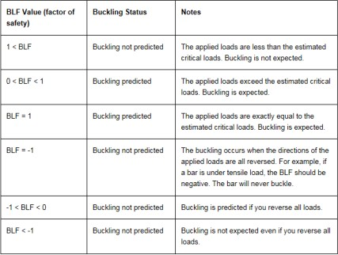

10 ft O.D Baffle 1st Principal Stress
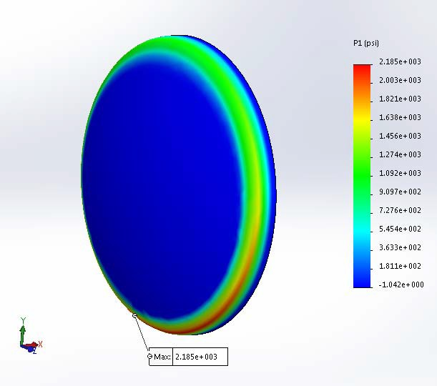

Tank baffle is under external pressure. Max. allowable tensile stress in type II hand layup laminate is 15,000 ps
/ 3 = 5,000 psi. Higher stress (2,185 psi) is observed in the knuckle region of the dished baffle. Knuckle is under compression. Buckling analysis is run to evaluate the baffle's stability under external loads.
The max stress in the rest of the area in the baffle is less than 3,000 psi, and is thus considered acceptable.

X - Stress
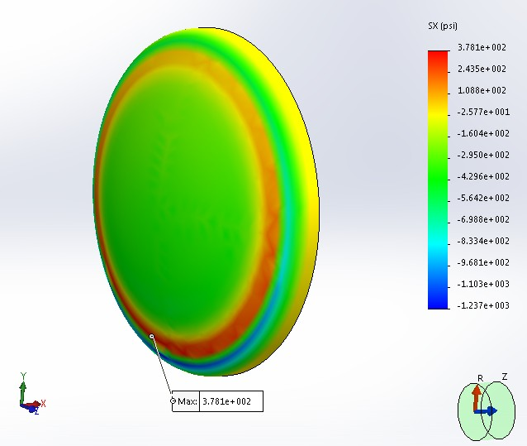

Y - Stress

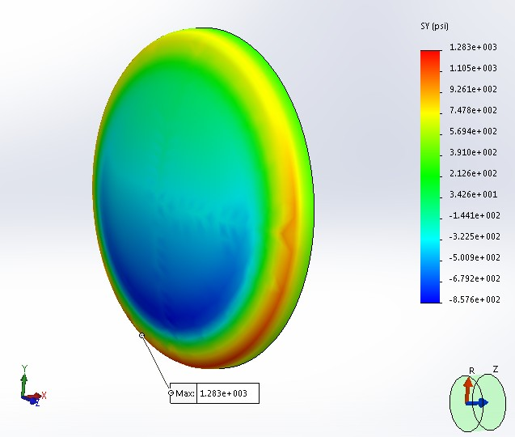

Z - Stress

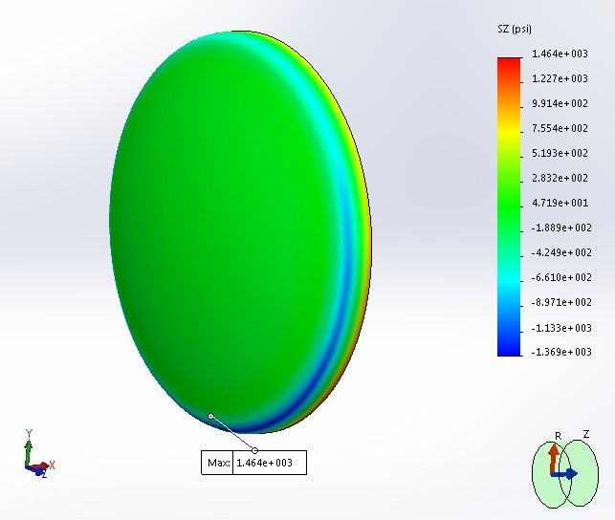

Resultant Displacement

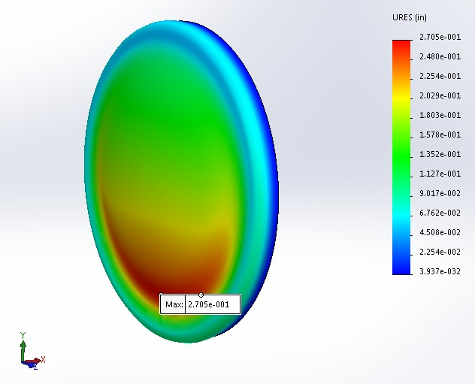

Less than 1.8", OK.
Note : Deflection is exaggerated by 20 times for clarity.

Buckling Safety Factor

⎛"Mode No." "Buckling Factor of Safety" ⎞

⎜ 1 2.6688 ⎟
⎜ ⎟
⎜ 2 2.6749 ⎟
⎜ 3 2.9395 ⎟
⎜ 2.942 ⎟
4
⎜
⎟
⎝ 5 3.2007 ⎠

Greater than 2.5. OK.

12 ft O.D Baffle

1st Principal Stress
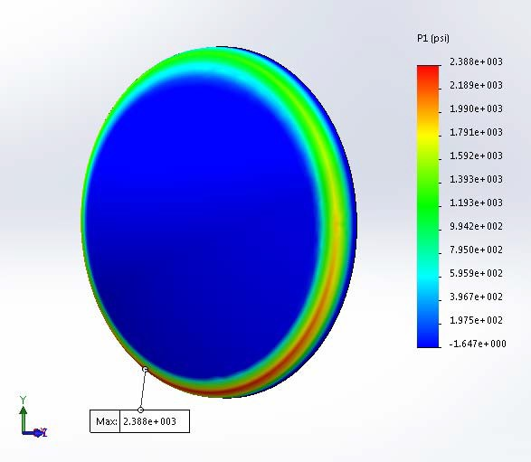

Tank baffle is under external pressure. Max. allowable tensile stress in type II hand layup laminate is 15,000 ps
/ 3 = 5,000 psi. Higher stress (2,388 psi) is observed in the knuckle region of the dished baffle. Knuckle is under compression. Buckling analysis is run to evaluate the baffle's stability under external loads.
The max stress in the rest of the area in the baffle is less than 3,000 psi, and is thus considered acceptable.

X - Stress
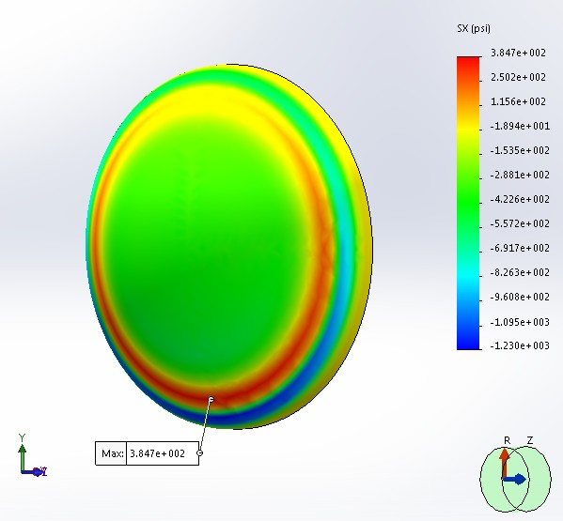

Y - Stress

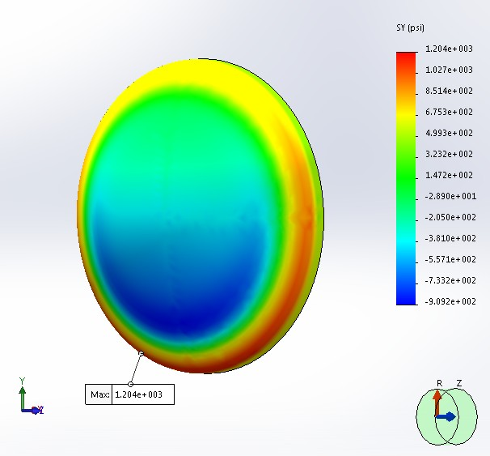

Z - Stress
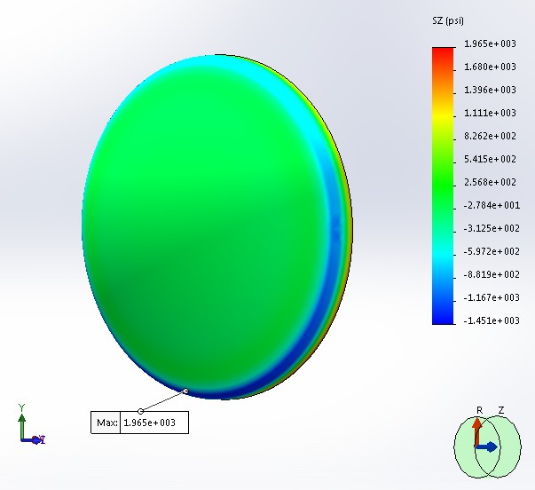

Resultant Displacement
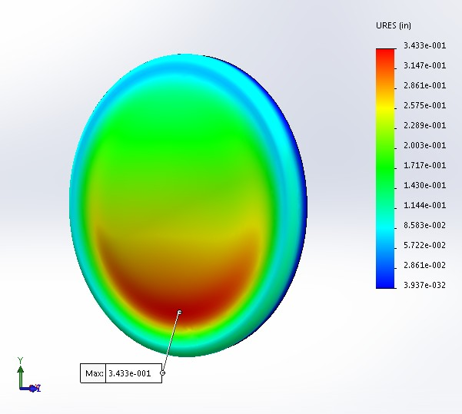

Less than 2.16", OK.
Note : Deflection is exaggerated by 20 times for clarity.

Buckling Safety Factor

⎛"Mode No." "Buckling Factor of Safety" ⎞

⎜ 1 2.653 ⎟
⎜ ⎟
⎜ 2 2.6538 ⎟
⎜ 3 2.9229 ⎟
⎜ 2.9234 ⎟
4
⎜
⎟
⎝ 5 3.2008 ⎠

Greater than 2.5. OK.

Chapter 3 Flat Baffles W/ Stiffener Design

  - Flat Baffle Dimensions and Design Load

⎛ 96 ⎞
Baffle Diameter D = ⎜ 120 ⎟ in
⎜ ⎟
⎝ 144 ⎠

Baffle Height Hbf :=
⎛ 84 ⎞
7 ⋅D = ⎜ 105 ⎟ in

8 ⎜ ⎟
⎝ 126 ⎠

⎛ 0.36 ⎞ ⎛ "3(M,R)M,2M" ⎞
Design Baffle Plate Thk. tbf := ⎜ 0.58 ⎟⋅in ⎜ "2[3(M,R)M],M" ⎟
⎜ ⎟ ⎜ ⎟
⎝ 0.9 ⎠ ⎝"3[3(M,R)M],2M" ⎠

⎛ 0.36 ⎞
Baffle Plate Total Thk. tbf_tot := tbf + tcb = ⎜ 0.58 ⎟ in
⎜ ⎟
⎝ 0.9 ⎠

⎛ 7.292 ⎞
Max. Design Pressure Pbf := ρc⋅Hbf = ⎜ 9.115 ⎟⋅psi
⎜ ⎟
⎝ 10.938 ⎠

See baffle stiffener details in Appendix A.

  - Finite Element Analysis of Flat Baffles with Stiffeners

Applied Load : - Gravity
- External Water Pressure

Boundary Condition: Fixed around the perimeter of the baffle. (For simplicity of analysis.) Note : See Appendix A for stiffener size, location and FRP overlay thks.

8 ft OD Baffle FEA Analysis

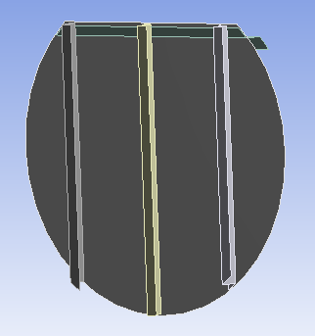
FEA Solid Model

Meshed Model
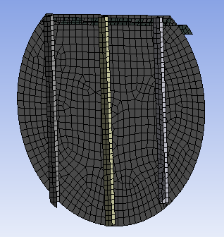

1st Principal Stress
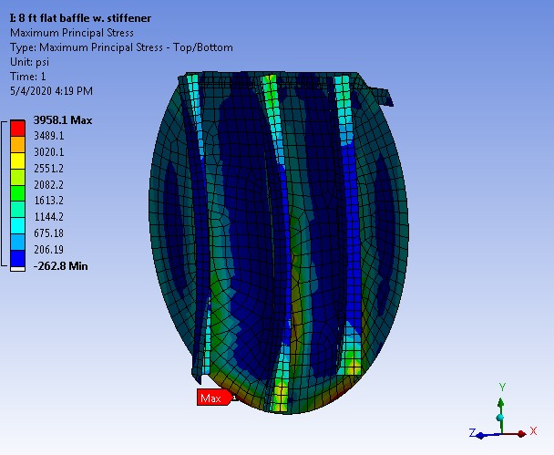

Tank baffle is under external pressure. Max. allowable bending stress in type II hand layup laminate is 15,000 psi / 3 = 5,000 psi. Higher stress (3,958 psi) is observed at the edge of the baffle which is fixed. Attachment bond is not included in the FEA for simplicity. Actual stress with the attachment bond will be less than 4,000 psi. Buckling analysis is run to evaluate the baffle's stability under external loads.
The max stress in the rest of the area in the baffle is less than 3,000 psi, and is thus considered acceptable.

X - Stress
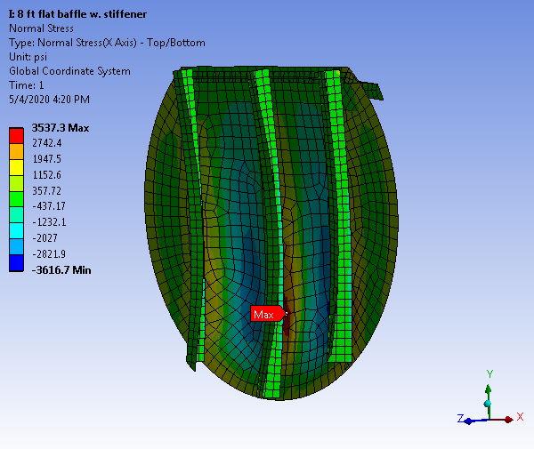

Y - Stress
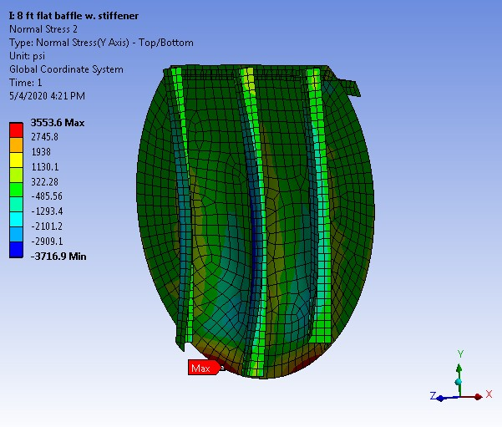

Z - Stress
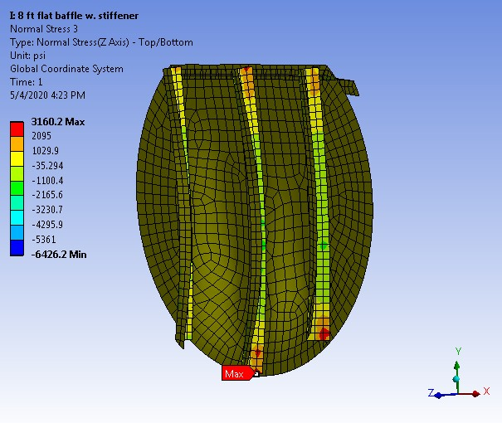

Resultant Displacement
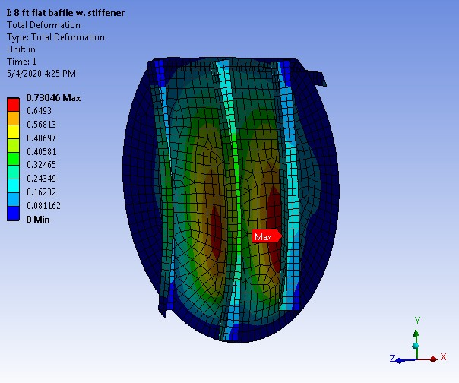

Less than 1.44 in. OK.

Buckling Safety Factor

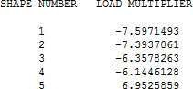

Buckling safety factors are greater than 2.5. It's adequate.

10 ft OD Baffle FEA Analysis

FEA Solid Model
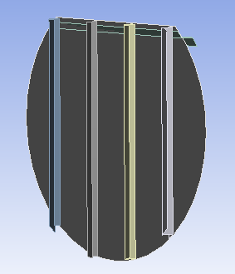
Meshed Model
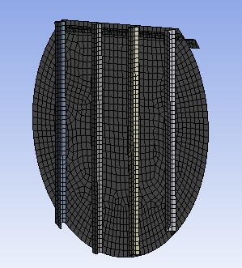

1st Principal Stress
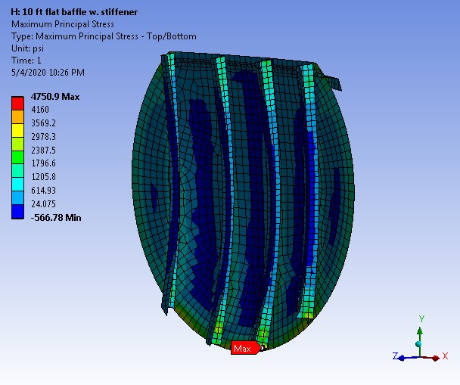

Tank baffle is under external pressure. Max. allowable bending stress in type II hand layup laminate is 15,000 psi / 3 = 5,000 psi. Higher stress (4,751 psi) is observed at the edge of the baffle which is fixed. Attachment bond is not included in the FEA for simplicity. Actual stress with the attachment bond will be less than 4,000 psi. Buckling analysis is run to evaluate the baffle's stability under external loads.
The max stress in the rest of the area in the baffle is less than 3,000 psi, and is thus considered acceptable.

X - Stress
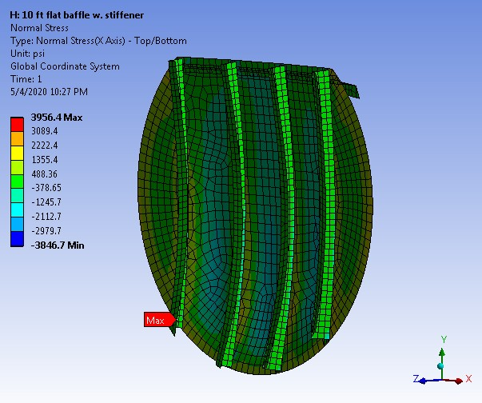

Y - Stress
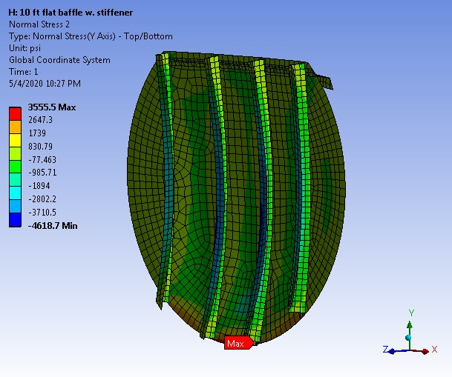

Z - Stress
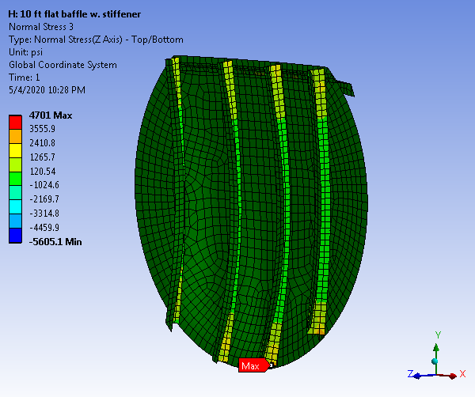

Resultant Displacement
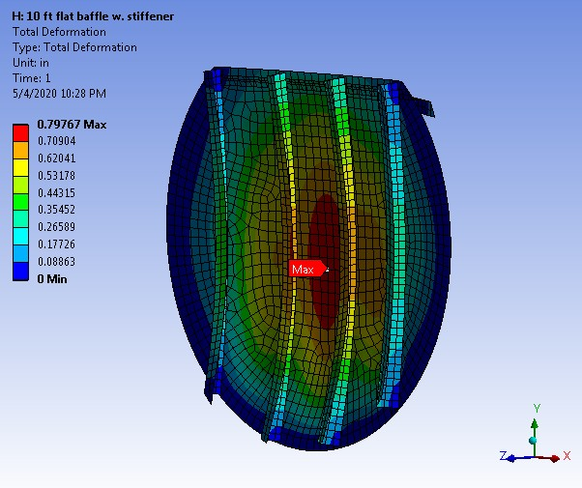

Less than 1.8". OK.

Buckling Safety Factor

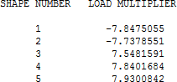

Buckling safety factors are greater than 2.5. It's adequate.

12 ft OD Baffle FEA Analysis

FEA Solid Model
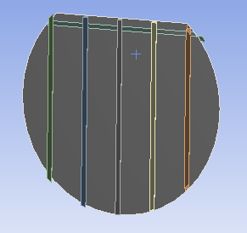

Meshed Model

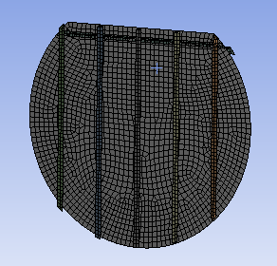

1st Principal Stress
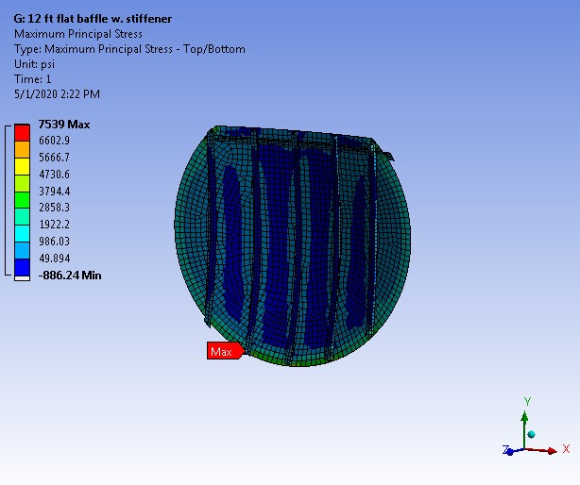

Tank baffle is under external pressure. Max. allowable bending stress in type II hand layup laminate is 15,000 psi / 3 = 5,000 psi. Higher stress (7,539 psi) is observed at the edge of the baffle which is fixed. Attachment bond is not included in the FEA for simplicity. Actual stress with the attachment bond will be less than 4,000 psi. Buckling analysis is run to evaluate the baffle's stability under external loads.
The max stress in the rest of the area in the baffle is less than 4,000 psi, and is thus considered acceptable.

1st Principal Stress (Detail)
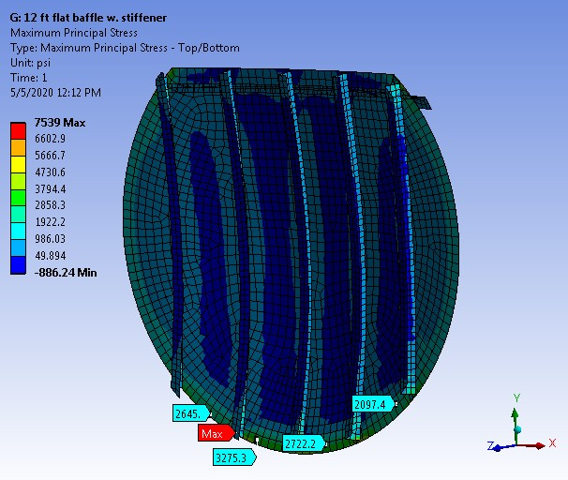

X - Stress
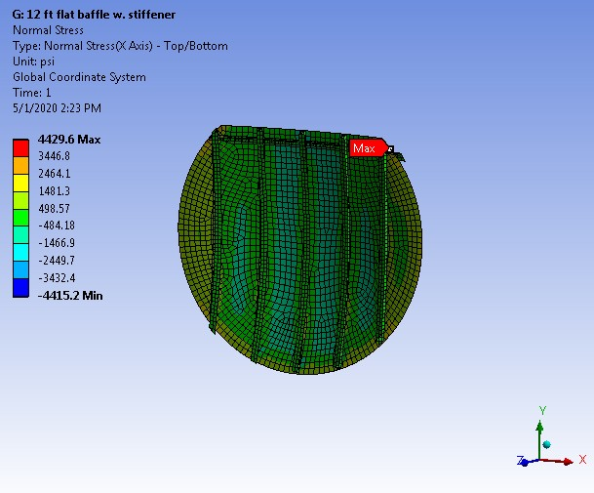

Y - Stress
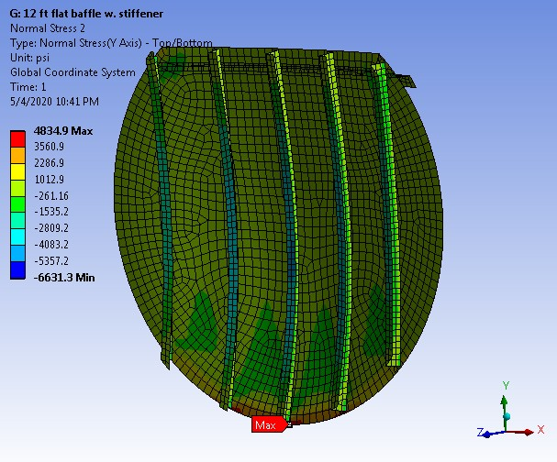

Z - Stress
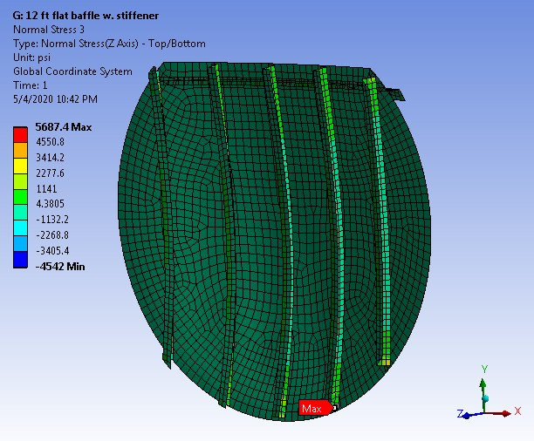

Resultant Displacement
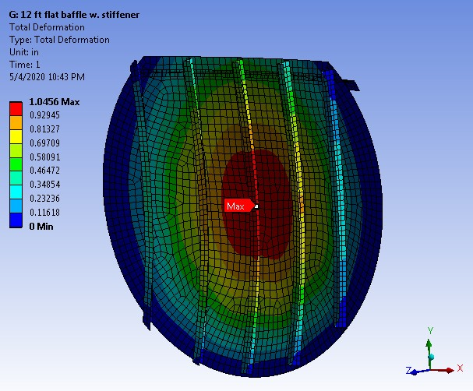

Less than 2.16". OK.

Buckling Safety Factor

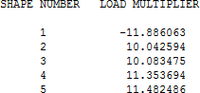

Buckling safety factors are greater than 2.5. It's adequate.

Appendix A Design Sketches

Top and side stiffeners detail

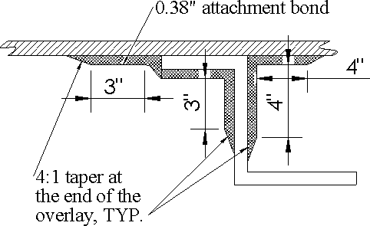

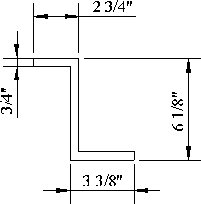
Attachment Bond

.38" - 3(M,R)M,M,R,M

Note: It is OK to install top stiffener on the same side as the vertical stiffeners.

8 ft ID Flat Baffle w/ Stiffeners

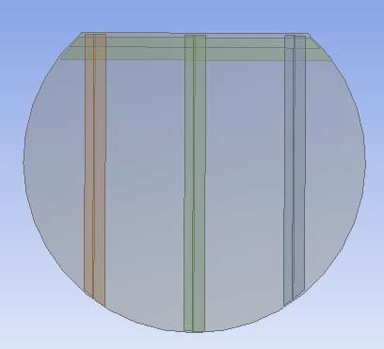

Stiffener spacing : 28"

10 ft ID Flat Baffle w/ Stiffeners

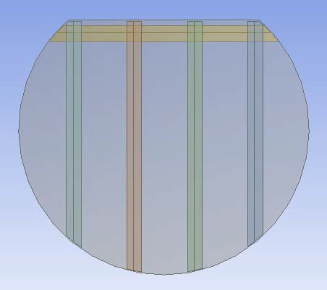

Stiffener spacing : 25"

12 ft ID Flat Baffle w/ Stiffeners
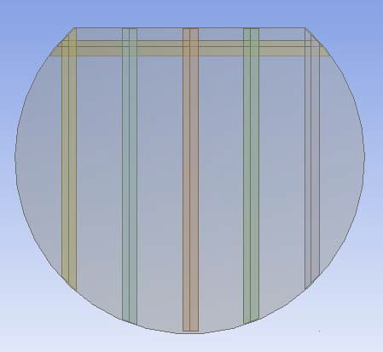

Stiffener spacing : 25"

⎛ 0.36 ⎞ ⎛ "3(M,R)M,2M" ⎞
Design Baffle Plate Thk. tbf := ⎜ 0.58 ⎟⋅in ⎜ "2[3(M,R)M],M" ⎟
⎜ ⎟ ⎜ ⎟
⎝ 0.9 ⎠ ⎝"3[3(M,R)M],2M" ⎠

Bond Thk. & Sequence (on each side)
⎛ 0.27 ⎞
tj := ⎜ 0.36 ⎟⋅in
⎜ ⎟
0.47
⎛ "3(M,R)M" ⎞
⎜ "3(M,R)M,2M" ⎟
⎜ ⎟
"3(M,R)M,2(M,R)M"

⎝ ⎠ ⎝ ⎠

Joint Length on Baffle & Shell

⎛ 6 ⎞
Lj := ⎜ 8 ⎟⋅in
⎜ ⎟
10

Joint doesn't include 4:1 taper.

⎝ ⎠

