FRP Composite Services Composite Engineering Design Finite Element Analysis
D2020·02·08·02 jdu@frpcompositeservices.com (c) 310·913·5502

ENGINEERING DESIGN REPORT
UNDERGROUND HORIZONTAL TANK DEADMEN DESIGN

Project Name: Underground FRP Storage Tank Anchoring Deadrnen Customer: Fiberglass Tank Solutions, LLC
Tank Dimension: 12'-0" Inside Diameter X 56'-8" Straight Shell Length 10'-0" Inside Diameter X 65'-2" Straight Shell Length 8'-0" Inside Diameter X 52'-5" Straight Shell Length
6'-0" Inside Diameter X 46'-9" Straight Shell Length 5'-0" Inside Diameter X 53'-10" Straight Shell Length 4'-0" Inside Diameter X 53'-10" Straight Shell Length
Design Water Table: Flooded to Grade
Tank Configuration: Dished Heads, Cylindrical Shell, Horizontal Tank Construction: Filament Wound & Hand Layup
Deadmen Construction: Hand Layup & A36 C.S.

Design Engineer: Joann Du, P.E. Revision: 1
Issue Date: 11/4/2020

Chapter 1 Design Inputs

Max. Design Burial Depth to the Top of the Tank

hbu := 7⋅ft

Water Density: ρ := 0.0361⋅ lb
w
3
in

FRP Density ρfrp := 0.065⋅ lb in
3

Content Specific Gravity sg := 1.0

Buoyancy Design Safety Factor SFby ≡ 1.2

Saturated Backfill Material Density
ρfil := 60⋅ lb
ft3

⎛ 12 ⎞
⎜ 10 ⎟
⎛ 144 ⎞
⎜ 120 ⎟

⎜ ⎟ ⎜ ⎟
Tank Inside Diameter D := ⎜ 8 ⎟⋅ft = ⎜ 96 ⎟⋅in

⎜ 6 ⎟
⎜ 5 ⎟
⎜ 72 ⎟
⎜ 60 ⎟

⎜ ⎟ ⎜ ⎟

i := 1 .. last(D)
⎝ 4 ⎠
⎝ 48 ⎠

Tank Radius R := D
2

⎛ 56⋅ft + 8⋅in ⎞
⎜ 65⋅ft + 2⋅in ⎟
⎛ 680 ⎞
⎜ 782 ⎟

⎜ ⎟ ⎜ ⎟
Total Straight Shell Length H := ⎜ 52⋅ft + 5⋅in ⎟ = ⎜ 629 ⎟ in

⎜ 46⋅ft + 9⋅in ⎟
⎜ 53⋅ft + 10⋅in ⎟
⎜ 561 ⎟
⎜ 646 ⎟

⎜ ⎟ ⎜ ⎟
⎝ 53⋅ft + 10⋅in ⎠ ⎝ 646 ⎠

⎛ 228 ⎞
⎜ 204 ⎟
⎜ ⎟

Design Water Table Hwt
:= D + hbu
= ⎜ 180 ⎟ in
⎜ 156 ⎟
⎜ 144 ⎟

⎜ ⎟
⎝ 132 ⎠

Dished Head Radius Rc := D
Dished Head Knuckle Radius rc := 0.06⋅D

⎛ 1.047 × 3 ⎞

Top Head Volume: V
⎜
⎜
⎯⎯⎯⎯⎯⎯⎯→ ⎜
:= =
10
605.915
310.228
⎟
⎟
⎟
⋅gal

L_H f_volts(rc , R, Rc, 0)
⎜ ⎟
⎜ 130.878 ⎟
⎜ 75.739 ⎟
⎜ ⎟
⎝ 38.779 ⎠

⎛ 5.004 × 4 ⎞
⎜ 10 ⎟
⎜ 3.95 × 104 ⎟
⎯⎯⎯⎯⎯⎯⎯⎯→ ⎜ 4 ⎟

Tank Volume (Flooded): V
:= ⎛2V
+ π⋅R2⋅H⎞ = ⎜ 2.033 × 10
⎟
gal

L ⎝ L_H ⎠ ⎜ 4 ⎟
⎜ 1.015 × 10 ⎟
⎜ 3 ⎟
⎜ 8.058 × 10 ⎟
⎜ 3 ⎟
⎝ 5.138 × 10 ⎠

⎛ 16000 ⎞
⎜ 11000 ⎟
⎜ ⎟

Tank Estimated Empty Weight WFRP
:= ⎜ 6600 ⎟⋅lb
⎜ 4200 ⎟
⎜ 3900 ⎟

⎜ ⎟
⎝ 3600 ⎠

Chapter 2 Buoyancy Design

Buoyant force acting on the underground tank is equal to the weight of fluid which the tank displaces.

- Tank tank w/ stiffeners' weights, soil load above the tank within the friction angle specified, and the weight of the soil above the FRP deadmen are used to resist buoyancy.

Projected Area Aprj := D⋅H

⎛ 1.6 × 104 ⎞
⎜ ⎟
⎜ 1.1 × 104 ⎟
⎜ ⎟
⎜ 6.6 × 103 ⎟

Estimated Weight of Tank
Wbu_FRP := WFRP = ⎜
⎟ lb

Used to Counteract Buoyancy
⎜ 4.2 × 103 ⎟

⎜ ⎟
⎜ 3.9 × 103 ⎟
⎜ ⎟
⎝ 3.6 × 103 ⎠

⎛ 5.004 × 4 ⎞
⎜ 10 ⎟
⎜ 3.95 × 4 ⎟
⎜ 10 ⎟
⎜ 2.033 × 4 ⎟

Total Volume of Water Displaced V
:= V = ⎜
10
⎟ gal
⎟

h2o
L
⎜ 1.015 × 4
⎜ 3 ⎟
10

⎜ 8.058 × 10 ⎟
⎜ 3 ⎟
⎝ 5.138 × 10 ⎠

⎛ 4.173 × 105 ⎞
⎜ ⎟
⎜ 3.294 × 105 ⎟
⎜ ⎟
⎜ 1.695 × 105 ⎟

Total Weight of Water Displaced Wh2o := ρw⋅Vh2o = ⎜
⎟⋅lb

⎜ 8.464 × 104 ⎟
⎜ 4 ⎟
⎜ 6.72 × 10 ⎟
⎜ ⎟
⎝ 4.285 × 104 ⎠

⎛ 1.001 × 6 ⎞
⎜ 10 ⎟
⎜ 7.905 × 5 ⎟
⎜ 10 ⎟
⎜ 4.069 × 5 ⎟

Design Buoyancy Force
F := 2⋅W
⋅SF = ⎜
10
⎟⋅lb

(For Two Tanks)
by h2o
by
⎜ 2.031 × 10
⎟
5
⎜ 5 ⎟

⎜ 1.613 × 10 ⎟
⎜ 5 ⎟
⎝ 1.028 × 10 ⎠

⎛ 4 ⎞
⎜ 3 ⎟
⎛ 12 ⎞
⎜ 10 ⎟

⎜ ⎟ ⎜ ⎟

Min. Backfill Height dbk
:= ⎜ 3 ⎟⋅ft
⎜ 2 ⎟
⎜ 2 ⎟
D = ⎜ 8 ⎟⋅ft
⎜ 6 ⎟
⎜ 5 ⎟

⎜ ⎟ ⎜ ⎟
⎝ 2 ⎠ ⎝ 4 ⎠

Soil Friction Angle (Estimated) ϕ := 25⋅deg

conservative friction angle selected.

ϕ := ϕ ⋅π = 0.436 180⋅deg
r

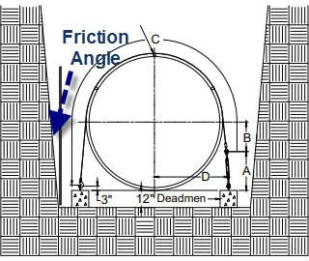

FRP deadmen need to be placed outside the tank shadow.

Double Tank Design

Soil Above Tank Centerline

⎯⎯→

Base Area ab := (D⋅H)

⎛ 10 ⎞

⎯⎯⎯⎯→
⎜ 8 ⎟
⎜ ⎟

Height h := ⎛d
+ D⎞ = ⎜ 7
⎟⋅ft

⎝ bk

2 ⎠ ⎜ 5 ⎟

⎜ 4.5 ⎟
⎜ ⎟
⎝ 4 ⎠

⎛ 55.957 ⎞
⎜ 44.766 ⎟
⎜ ⎟
Δh := h⋅tan(ϕ ) = ⎜ 39.17 ⎟ in
r ⎜ 27.978 ⎟
⎜ 25.181 ⎟
⎜ ⎟
⎝ 22.383 ⎠

⎛ 2.027 × 5 ⎞
⎜ 10 ⎟
⎜ 1.826 × 5 ⎟
⎜ 10 ⎟

⎯⎯⎯⎯⎯⎯⎯⎯⎯⎯→
⎜ 1.233 × 5 ⎟ 2

Top Area at := [(D + 2⋅Δh)(H + 2⋅Δh)] = ⎜
10
⎜ 7.894 ×
⎜
⎟ in
4
⎟
10
4 ⎟

⎜ 7.685 × 10 ⎟
⎜ 4 ⎟
⎝ 6.408 × 10 ⎠

⎛ 3.357 × 103 ⎞

⎯⎯⎯⎯→
⎜ ⎟
⎜ 3 ⎟
⎜ 2.149 × 10 ⎟

Cross Section of Friction Zone
Acr := ⎛ 1 ⋅Δh⋅h⎞ = ⎜ 1.645 × 103 ⎟ in2

On Each Side of Tank Directly Above Tank C.L.
⎝ 2 ⎠
⎜ ⎟
⎜ 839.354 ⎟
⎜ 679.877 ⎟
⎜ ⎟
⎝ 537.186 ⎠

Soil Above Deadmen

⎛ 24 ⎞
⎜ 24 ⎟

⎛ 12 ⎞
⎜ 10 ⎟

⎜ ⎟ ⎜ ⎟

FRP Deadmen Width bd
:= ⎜ 18 ⎟⋅in
⎜ 12 ⎟
⎜ 12 ⎟
D = ⎜ 8 ⎟⋅ft
⎜ 6 ⎟
⎜ 5 ⎟

⎜ ⎟ ⎜ ⎟

⎝ 12 ⎠
⎝ 4 ⎠

FRP Deadmen Length Ld := 8⋅ft + 6⋅in = 102 in

⎛ 10 ⎞
⎜ 14 ⎟
⎛ 12 ⎞
⎜ 10 ⎟

⎜ ⎟ ⎜ ⎟

FRP Deadmen Qty. (Per Tank)
N := ⎜ 6 ⎟
d ⎜ 8 ⎟
⎜ 2 ⎟
D = ⎜ 8 ⎟⋅ft
⎜ 6 ⎟
⎜ 5 ⎟

⎜ ⎟ ⎜ ⎟
⎝ 0 ⎠ ⎝ 4 ⎠

⎯⎯⎯ →
( )
Soil Column Height Above Deadmen hd_fr := D + dbk

⎛ 1.02 × 103 ⎞
⎜ ⎟

⎯⎯⎯⎯⎯⎯→
⎜
⎜ 1.19 × 103 ⎟

Soil Directly Above Deadmen V
:= ⎛N ⋅L ⋅b
⋅ D⎞ = ⎜

306
⎟ 3
⋅ft

d_sl
⎝ d d
d 2 ⎠ ⎜
⎜
⎜
⎝
⎟
204 ⎟
42.5 ⎟
⎟
0 ⎠

⎯⎯⎯⎯⎯⎯⎯⎯⎯⎯→
⎛ 713.451 ⎞
⎜ 693.633 ⎟

⎡ 1 ⎛ D⎞2
⎤
⎜ ⎟
190.254 3
⋅Ld = ⋅ft

Soil in Friction Zone Above Deadmen
⎣ 2 ⎝ 2 ⎠
Vd_fr := ⎢Nd⋅ ⋅tan(ϕr)⋅
⎥ ⎜ ⎟
⎦ ⎜ 142.69 ⎟
⎜ 24.773 ⎟

⎜ ⎟
⎝ 0 ⎠

⎯⎯⎯⎯⎯⎯⎯⎯⎯⎯⎯⎯⎯⎯⎯⎯→
⎣3
4
2 ⎤

Volume of Backfill Above Tank
C.L. Used to Counteract Buoyancy
Vs_t := ⎡h ⋅(at + ab +

⎛ 7.014 × 103 ⎞
at⋅ab) − 1 ⋅π⋅
1
D ⋅H⋅
2⎦

⎜ ⎟
⎜ 3 ⎟
⎜ 4.985 × 10 ⎟
⎜ 3.058 × 103 ⎟ 3

Vs_t = ⎜
⎟⋅ft

⎜ 1.374 × 103 ⎟
⎜ ⎟
⎜ 1.244 × 103 ⎟
⎜ ⎟
⎝ 954.928 ⎠

Spacing Between Adjacent Tanks ΔL := 3⋅ft

Overlapping Soil Zone

⎯⎯⎯⎯⎯→

⎛ 75.914 ⎞
⎜ 53.531 ⎟
⎜ ⎟
42.34

Overlapping Length Lov := (2⋅Δh − ΔL) = ⎜ ⎟ in
⎜ 19.957 ⎟
⎜ 14.361 ⎟
⎜ ⎟
⎝ 8.766 ⎠

Overlapping Area Height H
⎯⎯⎯⎯⎯⎯→
⎛ Lov 1 ⎞
:= ⋅

ov ⎜
⎠
⎝ 2
tan(ϕr) ⎟

⎯⎯⎯⎯⎯→

Overlapping Area Aov := ⎛ 1 ⋅Lov
⎝ 2
⋅H ⎞
ov⎠

Overlapping Soil Volume

Total Volume of Backfill Used to Counteract Buoyancy
(For Two Tanks)
⎯⎯⎯→
Vov := Aov⋅H
( )
⎯⎯⎯⎯⎯⎯⎯⎯⎯⎯⎯⎯⎯⎯→
( )
Vs := ⎡⎣2⋅ Vs_t + Vd_sl + Vd_fr − Vov⎤

⎛ 9.768 × 5 ⎞
⎜ 10 ⎟
⎜ 7.825 × 5 ⎟
⎜ 10 ⎟

⎯⎯⎯→
⎜ 4.055 × 5 ⎟

Backfill Saturated Weight
W := (V ⋅ρ
) = ⎜
10
⎟ lb
⎟

(For Two Tanks)
bk s
fil
⎜ 2.023 × 5
⎜ 5 ⎟
10

⎜ 1.549 × 10 ⎟
⎜ 5 ⎟

⎝ 1.137 × 10
⎠

⎛ 9.694 × 5 ⎞

⎜ 10 ⎟
⎜ 7.685 × 5 ⎟
⎜ 10 ⎟
10

Weight of Backfill Required
⎯⎯⎯⎯⎯⎯⎯⎯→
⎜ 3.937 × 5 ⎟

To Hold Down the Tank
Wc_r := (Fby − 2⋅Wbu_FRP) = ⎜
⎟⋅lb
5

When Totally Submerged (For Two Tanks)
⎜ 1.947 × 10 ⎟
⎜ ⎟
1.535 × 5

⎜ 10 ⎟
⎜ 4 ⎟

⎯⎯⎯⎯⎯→
( )
Δ := Wbk − Wc_r
⎝ 9.563 × 10 ⎠

⎛ 7.387 × 3 ⎞
⎜ 10 ⎟
⎜ 1.396 × 4 ⎟
⎜ 10 ⎟

⎜ 1.179 ×
⎟
Δ = ⎜
⎜ 7.573 ×
⎜
4
10
⎟ lb
⎟
3
10
3 ⎟

⎜ 1.427 × 10 ⎟
⎜ 4 ⎟
⎝ 1.804 × 10 ⎠

checkbackfill := if (Δ ≥ 0⋅lb, "Adequate" , "Additional Weight Req'd" )
i i
⎛ "Adequate" ⎞
⎜ "Adequate" ⎟
⎜ ⎟
checkbackfill = ⎜ "Adequate" ⎟
⎜ "Adequate" ⎟
⎜ "Adequate" ⎟
⎜ ⎟
⎝ "Adequate" ⎠

Downard Force on All Deadmen for Each Tank

⎛ 1.003 × 5 ⎞

⎯⎯⎯⎯⎯⎯⎯⎯⎯⎯⎯⎯→
⎜ 10 ⎟
⎜ 1.06 × 105 ⎟

⎡ ⎯⎯⎯⎯⎯⎯→⎤ ⎜ 4 ⎟

⎢Wc_r − ρfil⋅(2⋅Vs_t − Vov)⎥
⎜ 2.388 × 10 ⎟

Pd := ⎢⎣
2 ⎥⎦ = ⎜
⎟ lb
4

⎜ 1.702 × 10 ⎟
⎜ 3 ⎟
⎜ 3.323 × 10 ⎟
⎜ 3 ⎟
⎝−9.018 × 10 ⎠

Ndui := if ⎛Ndi = 0 , 1 , Nd ⎞
⎝ i⎠

Downard Force on Single Deadman for Each Tank

Pd_ui := if Pdi ≤ 0⋅lb
0⋅lb
Pdi Ndui

otherwise

Qty of Turnbuckle Per Deadmen Ntb ≡ 2

Vertical Load Taken by Each Turnbuckle

Tv :=
Pd_u Ntb

⎛ 5.016 × 3 ⎞
⎜ 10 ⎟
⎜ 3.787 × 3 ⎟
⎜ 10 ⎟
Tv = ⎜ 1.99 × 103 ⎟ lb
⎜ ⎟
⎟
⎜ 1.063 × 3
10
⎜ 830.761 ⎟
⎜ ⎟
⎝ 0 ⎠

Anchor Plate Dimensions

wa := 12⋅in La := 12⋅in

FRP Overlay Thk.

tov := 0.5⋅in

Shear Stress in FRP Overlay

⎛ 208.987 ⎞
⎜ 157.797 ⎟
⎜ ⎟

τ :=
Tv = ⎜ 82.923 ⎟⋅psi

p 2⋅(wa + La)⋅tov
⎜ 44.31 ⎟

⎜ 34.615 ⎟
⎜ ⎟
⎝ 0 ⎠

Allowable Shear Stress in FRP Overlay

τal :=
2000⋅psi = 666.667⋅psi 3

Compressive Stress in FRP Overlay

⎛ 34.831 ⎞
⎜ 26.3 ⎟
⎜ ⎟

σp :=
Tv wa⋅La
= ⎜ 13.82 ⎟⋅psi
⎜ 7.385 ⎟
⎜ 5.769 ⎟

⎜ ⎟
⎝ 0 ⎠

Allowable Compressive Stress in FRP Overlay

σp_al := 20000⋅ psi = 6.667 × 103⋅psi
3

checkcompsheari := if ⎛τpi ≤ τal ∧ σpi ≤ σp_al, "OK" , "Inadequate" ⎞
⎝ ⎠

⎛ "OK" ⎞
⎜ "OK" ⎟
⎜ ⎟
checkcompshear = ⎜ "OK" ⎟
⎜ "OK" ⎟
⎜ "OK" ⎟
⎜ ⎟
⎝ "OK" ⎠

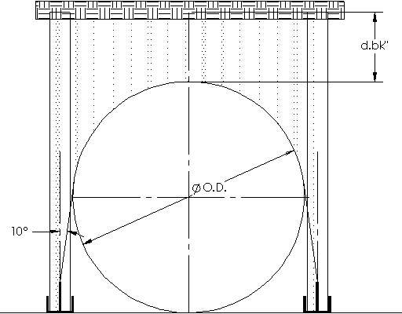

Considering strap angle at 10 deg.

Max. Tensile Force on Each Turnbuckle

⎛ 5.093 × 3 ⎞
⎜ 10 ⎟
⎟

⎯⎯⎯⎯ →
⎜ 3.846 ×
⎜
3
10 ⎟

T :=
Tv = ⎜ 2.021 × 103 ⎟ lb

cos(10⋅deg)
⎜ ⎟
⎜ 1.08 × 3
⎟
10
⎜ 843.577 ⎟
⎜ ⎟
⎝ 0 ⎠

Turnbuckle must be rated for loads higher than "T" shown above. Use 3/4"x18" turnbuckle with rated capacity of 5,200 lbs.
Hold Down Strap Width

⎛ 4 ⎞
⎜ 4 ⎟
⎜ ⎟

wstr
:= ⎜ 3 ⎟⋅in
⎜ 2 ⎟
⎜ 2 ⎟

⎜ ⎟

⎝ 1 ⎠

Load in Strap Tstr := T

Pressure Under Each Strap p

str :=

⎯⎯⎯⎯⎯→
Tstr 0.9π⋅D⋅wstr
2

⎛ 5.093 × 3 ⎞

⎜ 10 ⎟
⎛ 6.255 ⎞

⎜ 3.846 × 3 ⎟ ⎜ 5.667 ⎟
⎜ 10 ⎟ ⎜ ⎟

T = ⎜ 2.021 × 103 ⎟ lb
p = ⎜ 4.963 ⎟ psi OK

str ⎜ ⎟
str ⎜ 5.304 ⎟

⎜ 1.08 × 3 ⎟
10
⎜ 4.973 ⎟

⎜ 843.577 ⎟
⎜ ⎟
⎝ 0 ⎠
⎜ ⎟
⎝ 0 ⎠

LUG STRESS CHECK

Material A36 C.S. Galv. Tensile Strength Fulug := 58⋅ksi
Yield Strength Fylug := 36⋅ksi

Allowable Bending Stress
σalb := 0.66⋅Fylug = 2.376 × 104⋅psi

Hole Diameter dhole := 1.25⋅in

Diameter of Pin dpin := dhole − 0.25⋅in = 1 in

Lug Height hlug := 17⋅in

Lug Width
wlug := 6⋅in

Lug Thk.
thk := 0.25⋅in

Lug Radius radius :=

Vertical Uplift
wlug = 3 in 2

AISC(13th ed.), sect. D2 and sect. J4-1 table D3.1

ϕgross := .90

ϕnet := .75
Ωgross := 1.67

Ωnet := 2

Shear lag factor U := 1
An := thk⋅(2⋅radius − dhole) Fylug

Ftgross :=

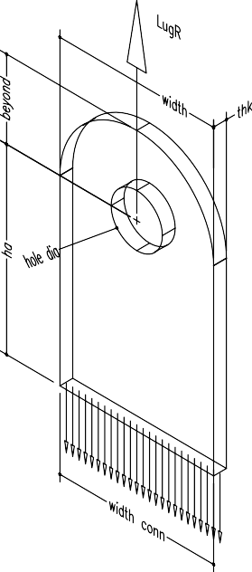
Ωgross

Vcap
1

:= Ftgross⋅thk⋅2⋅radius

Vcap
1
= 3.234 × 4

Ftnet :=
10 lb
Fulug

Ω
10 lb

Vcap
2
net

:= Ftnet⋅An⋅U

Vcap
2

= 3.444 × 4

AISC(13th ed.), sect. J7
ϕbrg := .75
Ωbrg := 2

Allow permanent deformation around hole due to bearing (mushrooming of hole)? Allowmushrooming := "yes"

Allowable Bearing Stress: Fbrg
:= 1.8⋅ Fylug
Ωbrg

Allowable Load for Bearing:

Vcap :=
3

Fbrg⋅thk⋅dpin

if Allowmushrooming = "no"

Vcap
1
if Allowmushrooming = "yes"

AISC(13th ed.), sect. J4-2
lb
10

Vcap
3
= 3.234 × 4

shear yeilding
ϕsy := 1
Ωsy := 1.5

Rnsy = 0.6⋅Fylug⋅Ag

Vnsy := 0.6⋅Fylug⋅thk⋅2⋅radius
10

Vcap :=
4
Vnsy

Ωsy

Vcap
4

= 2.16 × 4 lb

shear rupture
ϕsr := .75
Ωsr := 2

Rnsr = 0.6⋅Fulug⋅Anvsr

Anvsr := thk⋅(2⋅radius − dhole)

Vnsr := 0.6⋅Fulug⋅Anvsr

Vnsr
Vcap := Vcap

= 2.066 × 4 lb

- Ωsr 5
10

AISC(13th ed.), sect. J4-3

Block Shear ϕsb := .75
Ωsb := 2
Ubs := 1

tension is uniform

⎛ dhole ⎞ ⎛ dhole ⎞
⎝
⎝

Agv := (radius)⋅thk
Anv := ⎜radius −
⎟⋅thk
2 ⎠
Ant := ⎜radius −
⎟⋅thk
2 ⎠

Rnsb := min(0.6⋅Fulug⋅Anv + Ubs⋅Fulug⋅Ant, 0.6⋅Fylug⋅Agv + Ubs⋅Fulug⋅Ant)

Rnsb
Vcap := Vcap

= 2.532 × 4 lb

- Ωsb 6
10

AISC(13th ed.), sect. D5 tensile rupture ϕtr := .75

Ωtr := 2

Pntr = 2⋅thk⋅beff⋅Fulug

b'eff :=
2⋅radius − dhole
if
(2⋅thk + 0.63⋅in)

2⋅radius − dhole 2
2

- 2⋅thk + 0.63⋅in

otherwise

⎡3 ⎛
dhole ⎞⎤ 4
dhole

beff :=
⎢ ⋅⎜radius −
4
⎟⎥ if
2
3 ⋅b'eff > radius − 2
= 1.13⋅in

⎣ ⎝ ⎠⎦
b'eff otherwise
10

Vcap
7

:= 2⋅thk⋅beff⋅
Fulug

Ωtr

Vcap
7
= 1.638 × 4 lb

shear rupture ϕsr = 0.75 Ωsr = 2

Pnsr = 0.6⋅Fulug⋅Asf

a := radius −

dhole 2

= 2.375⋅in

amin := 1.333⋅beff = 1.506⋅in
⎟

⎛
Asf := 2⋅thk⋅⎜a +
dpin ⎞

⎝ 2 ⎠

Vcap
8
:= 0.6⋅Fulug⋅ Asf
Ωsr
lb
10

Vcap
8
= 2.501 × 4

AISC(13th ed.), sect. J2.4
Weld Strength
ϕfw := 0.75
Ωfw := 2.0
FEXX := 70⋅ksi

Allowable weld stress and load for bottom weld, 100% transverse to load
θ := 90⋅deg

weld :=
1 ⋅in 4

dw :=
weld

Swt :=
2
0.6⋅FEXX⋅(1 + 0.5⋅sin(θ)1.5)
Ωfw

Swt

= 31.5⋅ksi

Vcap8

:= Swt

⋅wlug

⋅dw⋅2

Vcap8 = 6.682 × 104 lb

⎛ 3.234 × 4 ⎞
⎜ 10 ⎟
⎜ 3.444 × 4 ⎟
⎜ 10 ⎟
⎜ 3.234 × 4 ⎟
⎜ 10 ⎟
⎜ 2.16 × 104 ⎟

Vcap = ⎜
⎜ 2.066 ×
⎜
⎟ lb
4
⎟
10
4 ⎟

⎜ 2.532 × 10 ⎟
⎜ 4 ⎟
⎜ 1.638 × 10 ⎟

⎜ ₄ ⎟
⎝ 2.501 × 10 ⎠

Lug Lateral Bending Section Modulus
Zlug :=
1 ⋅thk⋅wlug2

Max. Lateral Load
6

Bending Moment
Flt := 10000⋅lb⋅sin(10⋅deg) = 1.736 × 103 lb

Mlt := Flt⋅(hlug − radius) = 2.431 × 104 in⋅lb

Bending Stress σlt_b :=
Mlt Zlug
= 1.621 × 104⋅psi

σalb σlt_b

= 1.466

greater than 1, OK

Turnbuckle Selection

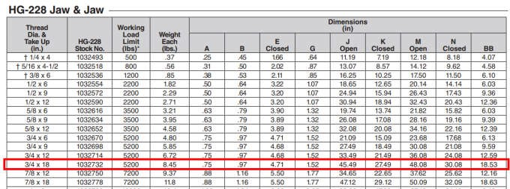

Appendix A Design Sketches

Anchor Plate Detail

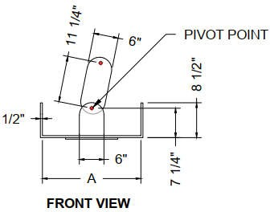

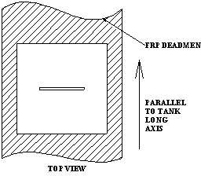
.

FRP Deadmen Detail

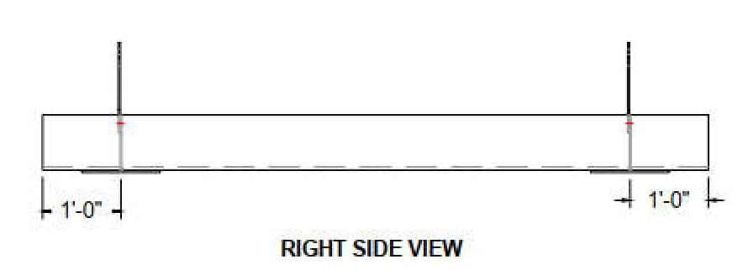

FRP Overlay : .51" - 3(M,R)M,2(M,R),2M

Tank ID Min. Burial Depth
Deadmen Width
Deadmen Qty. (For Two Tanks)
Qty. of Turnbuckles (For Two Tanks))

⎛ 12 ⎞
⎜ 10 ⎟
⎛ 4 ⎞
⎜ 3 ⎟
⎛ 24 ⎞
⎜ 24 ⎟
⎛ 20 ⎞
⎜ 28 ⎟
⎛ 40 ⎞
⎜ 56 ⎟

⎜ ⎟ ⎜ ⎟ ⎜ ⎟ ⎜ ⎟ ⎜ ⎟

D = ⎜ 8 ⎟⋅ft
d = ⎜ 3 ⎟⋅ft
b = ⎜ 18 ⎟ in
2N = ⎜ 12 ⎟
N ⋅2⋅N
= ⎜ 24 ⎟

⎜ 6 ⎟
⎜ 5 ⎟
bk ⎜ 2 ⎟
⎜ 2 ⎟
d ⎜ 12 ⎟
⎜ 12 ⎟
d ⎜ 16 ⎟
⎜ 4 ⎟
tb d
⎜ 32 ⎟
⎜ 8 ⎟

⎜ ⎟ ⎜ ⎟ ⎜ ⎟ ⎜ ⎟ ⎜ ⎟

⎝ 4 ⎠
⎝ 2 ⎠
⎝ 12 ⎠
⎝ 0 ⎠
⎝ 0 ⎠

Two Tank Backfill Zone Detail

