Double Tank Uplift Protection Reference Table
Tank Diameter (ft) | Tank Weight per Unit Length (lb/ft) | Trench Side Slope (degrees) | Minimum Soil Cover Thickness Required (ft.) | Tank Spacing (ft.) | Bottom of Trench Width (ft.) | Recommended TankAnchor® Material | Length of Material per Unit Length of Tank (ft) | Rated Safety Factor
5 | 66 | 34 | 2.0 | 3.0 | 16.0 | Type A | 104.4 | 2.24
 |  | 45 | 2.0 | 3.0 | 16.0 | Type A | 89.2 | 1.96
 |  | 53 | 2.0 | 3.0 | 16.0 | Type A | 81.6 | 1.82
6 | 88 | 34 | 2.0 | 3.0 | 18.0 | Type B | 120.8 | 1.93
 |  | 45 | 2.0 | 3.0 | 18.0 | Type B | 102.7 | 1.67
 |  | 53 | 2.0 | 3.0 | 18.0 | Type B | 93.7 | 1.54
8 | 102 | 34 | 2.0 | 3.0 | 22.0 | Type C | 153.5 | 1.55
 |  | 45 | 3.0 | 3.0 | 22.0 | Type C | 129.8 | 1.62
 |  | 53 | 3.0 | 3.0 | 22.0 | Type C | 118.1 | 1.48
10 | 144 | 34 | 3.0 | 4.0 | 27.0 | Type D | 189.3 | 1.66
 |  | 45 | 3.0 | 4.0 | 27.0 | Type D | 160.1 | 1.41
 |  | 53 | 3.0 | 4.0 | 27.0 | Type D | 145.5 | 1.29
12 | 270 | 34 | 3.0 | 4.0 | 31.0 | Type E | 222.0 | 1.48
 |  | 45 | 3.0 | 4.0 | 31.0 | Type E | 187.2 | 1.25
 |  | 53 | 3.5 | 4.0 | 31.0 | Type E | 169.8 | 1.22
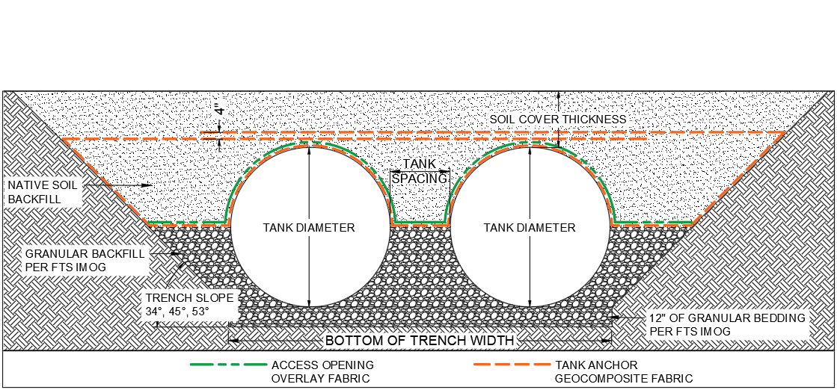
TankAnchor® is engineered and calculated for a minimum 1.2 rated safety factor.
the values presented on this table are for estimate purposes and only valid for the listed soil conditions, tank sizes/ weights and trench geometries.
TankAnchor® is utilized for an open cut trench excavation with a trench slope of 34°, 45°, or 53°.
**cannot be used with a shored hole excavation**

TankAnchor®

