SIDE WALL NOZZLES
BOTTOM FULL DRAIN NOZZLE

L

BOTTOM SUPPORT

TOP AND BOTTOM NOZZLES
NOZZLE PLACEMENT
NOZZLE DIA. NOZZLE
HEIGHT "L"
2" 3"
4" 5"
6" 6"
8" 7"
10" 8"
12" 10"
14" 11"
16" 12"

SHEET TITLE:
PLACEMENT
PROJECT:
FIBERGLASS NOZZLES

L 18"

13"
DRAWN DATE:
01/06/20
DRAWN BY:
JACK
REV.
00

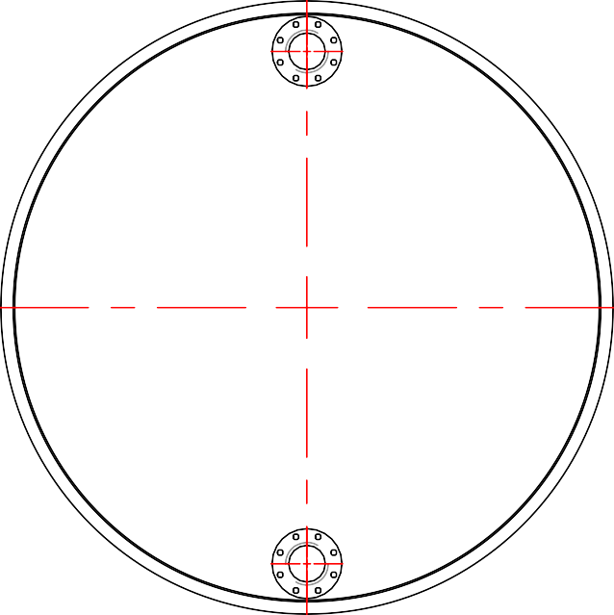
P.O. BOX 326, Montreal, MO 65591 P: 573-317-9620

