024" FRP RISER 030" FRP RISER

LID TOP VIEW
LID TOP VIEW

RISER TOP VIEW

DURAFIBER LID

ISOMETRIC VIEW

RISER TOP VIEW

DURAFIBER LID

ISOMETRIC VIEW

RISER TO LID ADAPTER (TYP 4)
RISER TO LID ADAPTER (TYP 4)

24 1/2" O.D. 30 1/2" O.D.
A

24" I.D.
30" I.D.

SHEET TITLE:

FRP RISER PIPES W/ BOLT ON LIDS

DRAWN DATE:
3"
11/17/20
DRAWN BY:
JACK
REV.
00

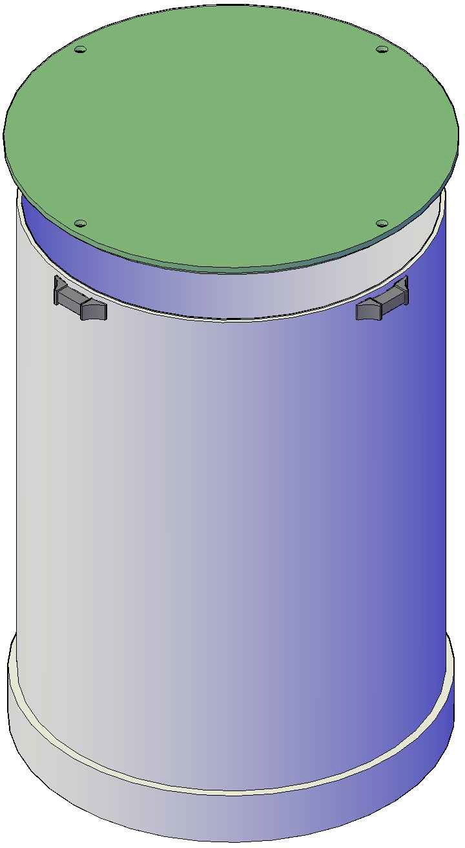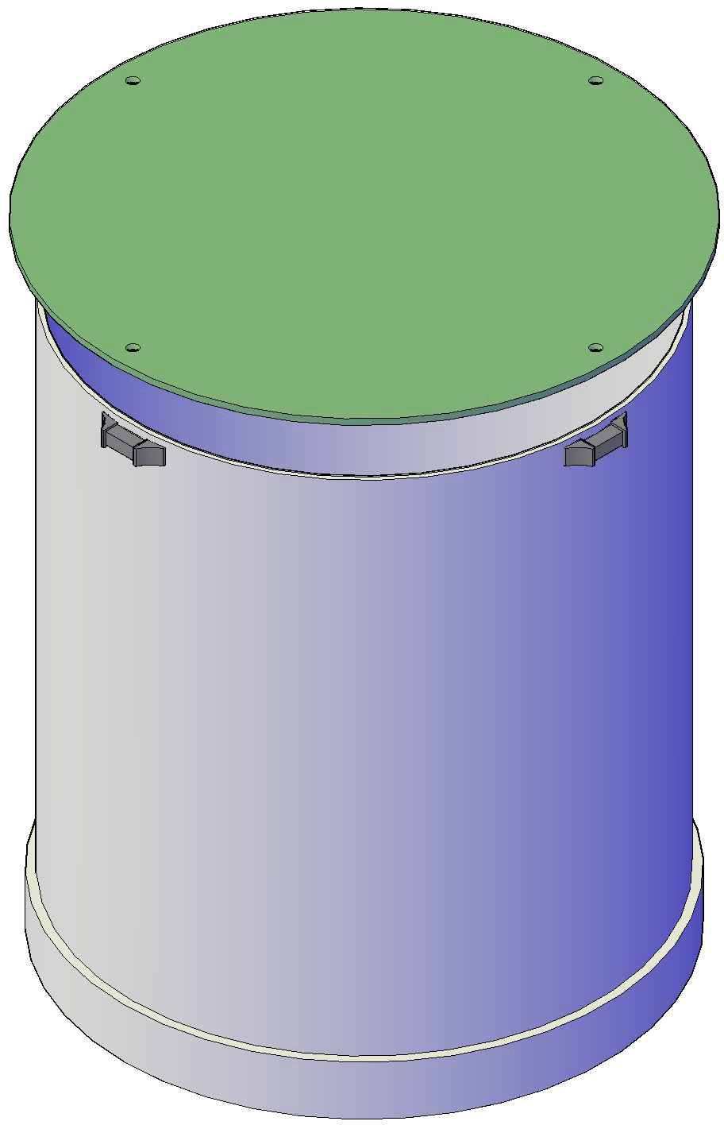25"
A
3"
25 1/2"

FRONT VIEW
31"
31 1/2"

FRONT VIEW

Mailing: P.O. BOX 326, Montreal, MO 65591 MFG: 147 Camdenton Bus. Prk. Dr., Camdenton, MO 65020
P: 573-317-9620

