ISOMETRIC VIEW

TOP VIEW

STEEL OR FRP COVER 1/8" THICK GASKET

MANWAY DIMENSIONS

SIZE 22" 24" 30"
O.D. 28" 32" 38 3/4"
I.D. 22" 24" 30"

BOLT CIRCLE
6"
HOLE Ø
26"

3/4"
29 1/2"

1/2"
36"

3/4"

SHEET TITLE:
FIBERGLASS MANWAYS

HOLE QTY 24
20 28
DRAWN DATE:
11/12/20
DRAWN BY:
JACK
REV.
00

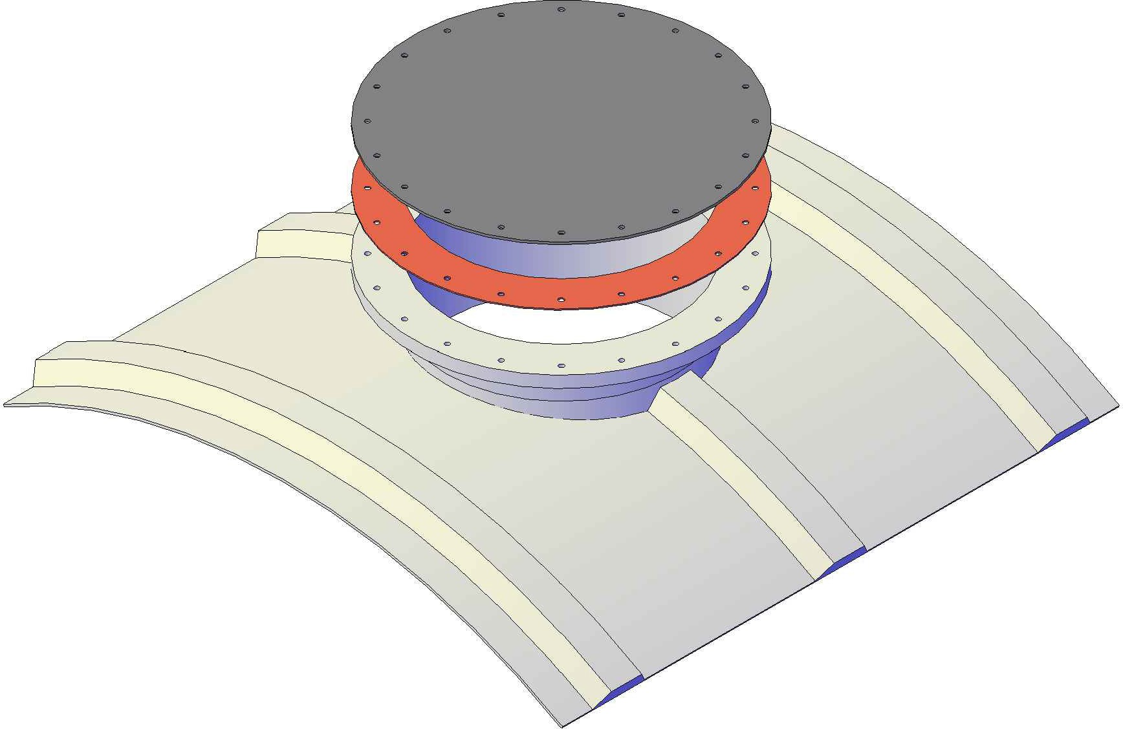FRONT VIEW
12"
Mailing: P.O. BOX 326, Montreal, MO 65591 MFG: 147 Camdenton Bus. Prk. Dr., Camdenton, MO 65020
P: 573-317-9620

