24" FLG X FLG MW EXTENSION

30" FLG X FLG MW EXTENSION

# TOP VIEW

**ISOMETRIC VIEW**

# TOP VIEW

**ISOMETRIC VIEW**

STEEL OR FRP COVER

STEEL OR FRP COVER

1/8" THICK GASKET

1/8" THICK GASKET

Ø24 1/2" O.D.

30 1/2" O.D.

A

A

SHEET TITLE:

FLANGE X FLANGE FRP MANWAY EXTENSIONS

Ø24" I.D.

30" I.D.

DRAWN DATE:

11/17/20

DRAWN BY:

JACK

REV.

00

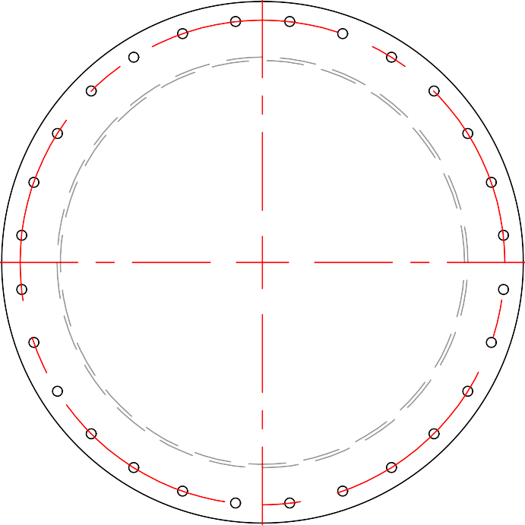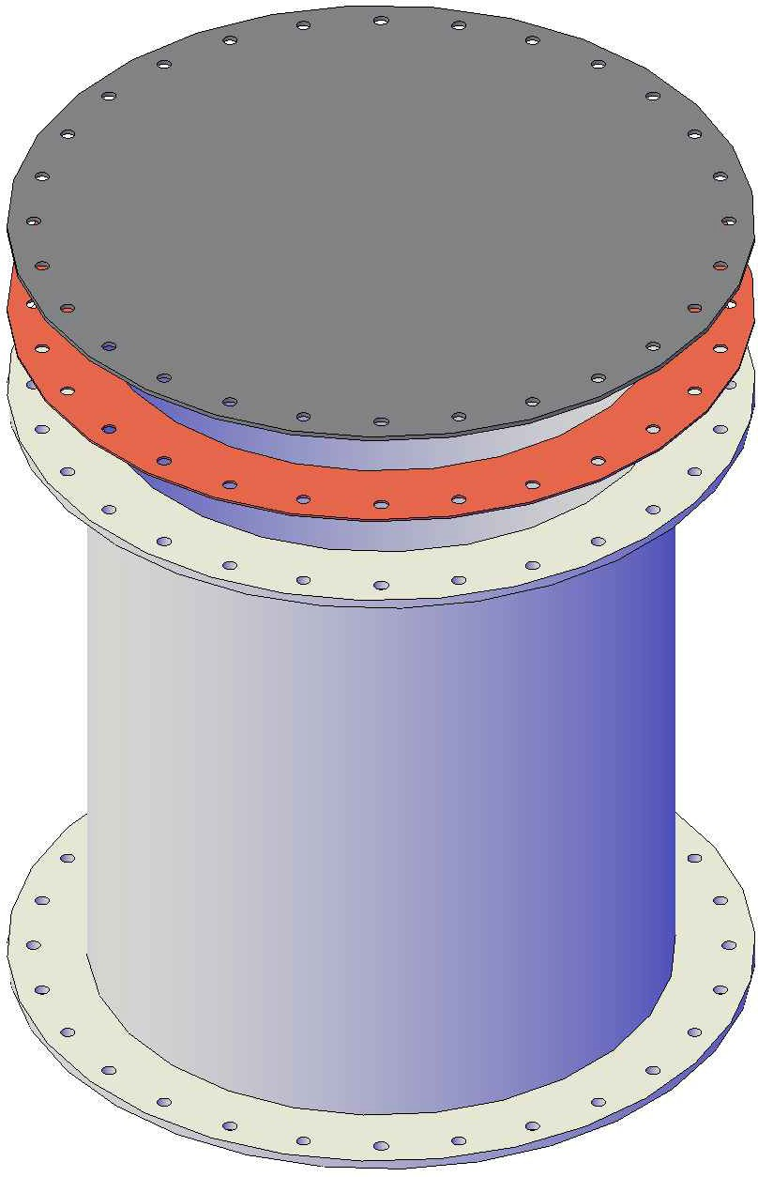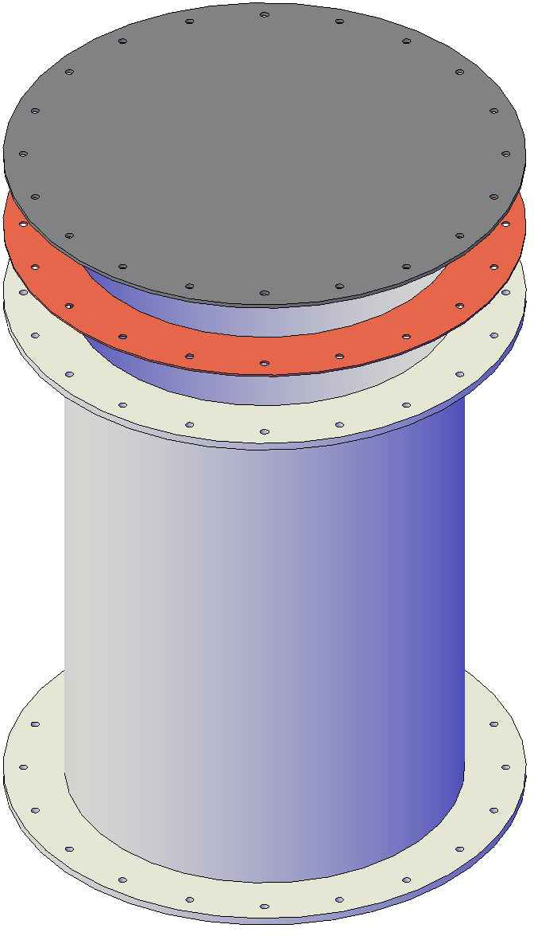

# FRONT VIEW

# FRONT VIEW

Mailing: P.O. BOX 326, Montreal, MO 65591 MFG: 147 Camdenton Bus. Prk. Dr., Camdenton, MO 65020

P: 573-317-9620