1 1/2"
15/16"

3/4"-10 UNC, CLASS 2A

5/8"

26" CLOSED EXPANDING TO 44"
28 1/2"

3/4" X 18" JAW TO JAW TURNBUCKLE

5/8"
15/16"
1 1/2"

3/4"-10 UNC, CLASS 2A

20" CLOSED EXPANDING TO 32"
22 1/2"

3/4" X 12" JAW TO JAW TURNBUCKLE

5/8"
3/4"
1 1/4"
15/16"
1 1/2"

3/4"-10 UNC, CLASS 2A

17" CLOSED EXPANDING TO 26"
1'-7 1/2"

3/4"
5 1/2"

3/4" X 9" JAW TO JAW TURNBUCKLE

1 1/4"
PROJECT NAME:
JAW TO JAW TURNBUCKLES
TURNBUCKLE SELECTION GUIDE
TANK SIZE & APPLICATION | TURNBUCKLE SIZE
Ø4' TANK W/ CONCRETE DEADMEN ABOVE BEDDING | N/A
Ø4' TANK W/ CONCRETE DEADMEN BELOW BEDDING | 3/4" X 9"
Ø4' TANK W/ FRP DEADMEN | 3/4" X 6"
Ø5' TANK W/ CONCRETE DEADMEN ABOVE BEDDING | N/A
Ø5' TANK W/ CONCRETE DEADMEN BELOW BEDDING | 3/4" X 9"
Ø5' TANK W/ FRP DEADMEN | 3/4" X 6"
Ø6' TANK W/ CONCRETE DEADMEN ABOVE BEDDING | N/A
Ø6' TANK W/ CONCRETE DEADMEN BELOW BEDDING | 3/4" X 9"
Ø6' TANK W/ FRP DEADMEN | 3/4" X 6"
Ø8' TANK W/ CONCRETE DEADMEN ABOVE BEDDING | 3/4" X 12"
Ø8' TANK W/ CONCRETE DEADMEN BELOW BEDDING | 3/4" X 12" & 3/4" CONN. LINK
Ø8' TANK W/ FRP DEADMEN | 3/4" X 12"
Ø10' TANK W/ CONCRETE DEADMEN ABOVE BEDDING | 3/4" X 18"
Ø10' TANK W/ CONCRETE DEADMEN BELOW BEDDING | 3/4" X 18"
Ø10' TANK W/ FRP DEADMEN | 3/4" X 18"
Ø12' TANK W/ CONCRETE DEADMEN ABOVE BEDDING | 3/4" X 18"
Ø12' TANK W/ CONCRETE DEADMEN BELOW BEDDING | 3/4" X 18"
Ø12' TANK W/ FRP DEADMEN | 3/4" X 18"

3/4" CONNECTING LINK
15/16"

5/8"
1 1/2"

3/4"-10 UNC, CLASS 2A
DRAWN DATE: DRAWN BY: REV.

08/31/21 JACK 01

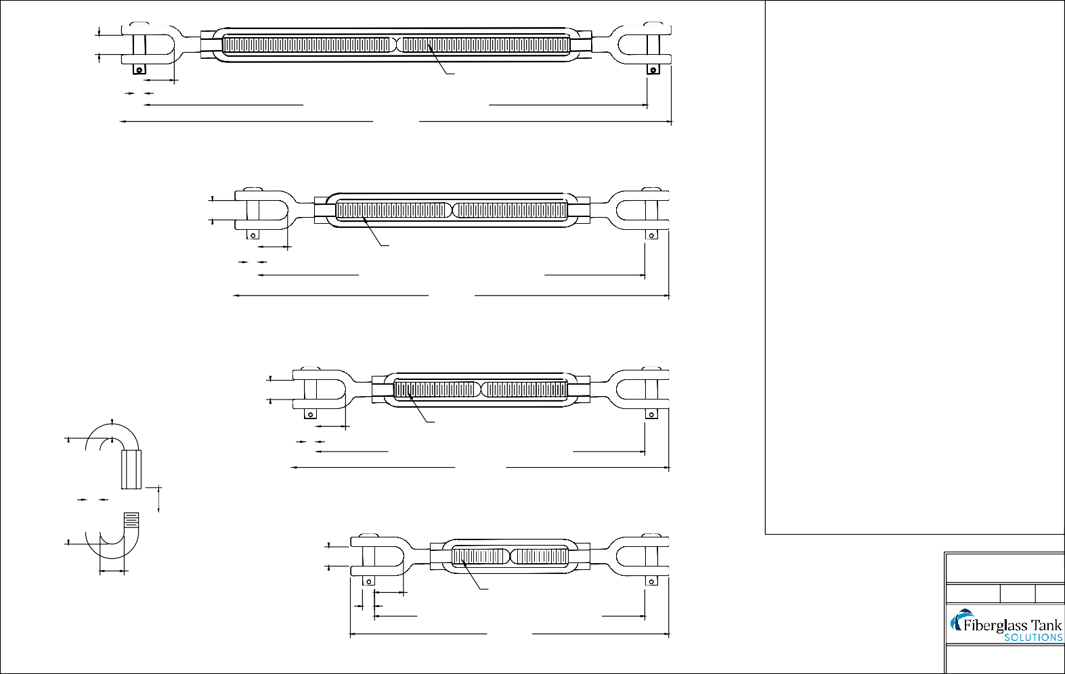14" CLOSED EXPANDING TO 21"
16 1/2"

3/4" X 6" JAW TO JAW TURNBUCKLE

Mailing: P.O. BOX 326, Montreal, MO 65591 MFG: 147 Camdenton Bus. Prk. Dr., Camdenton, MO 65020
P: 573-317-9620

