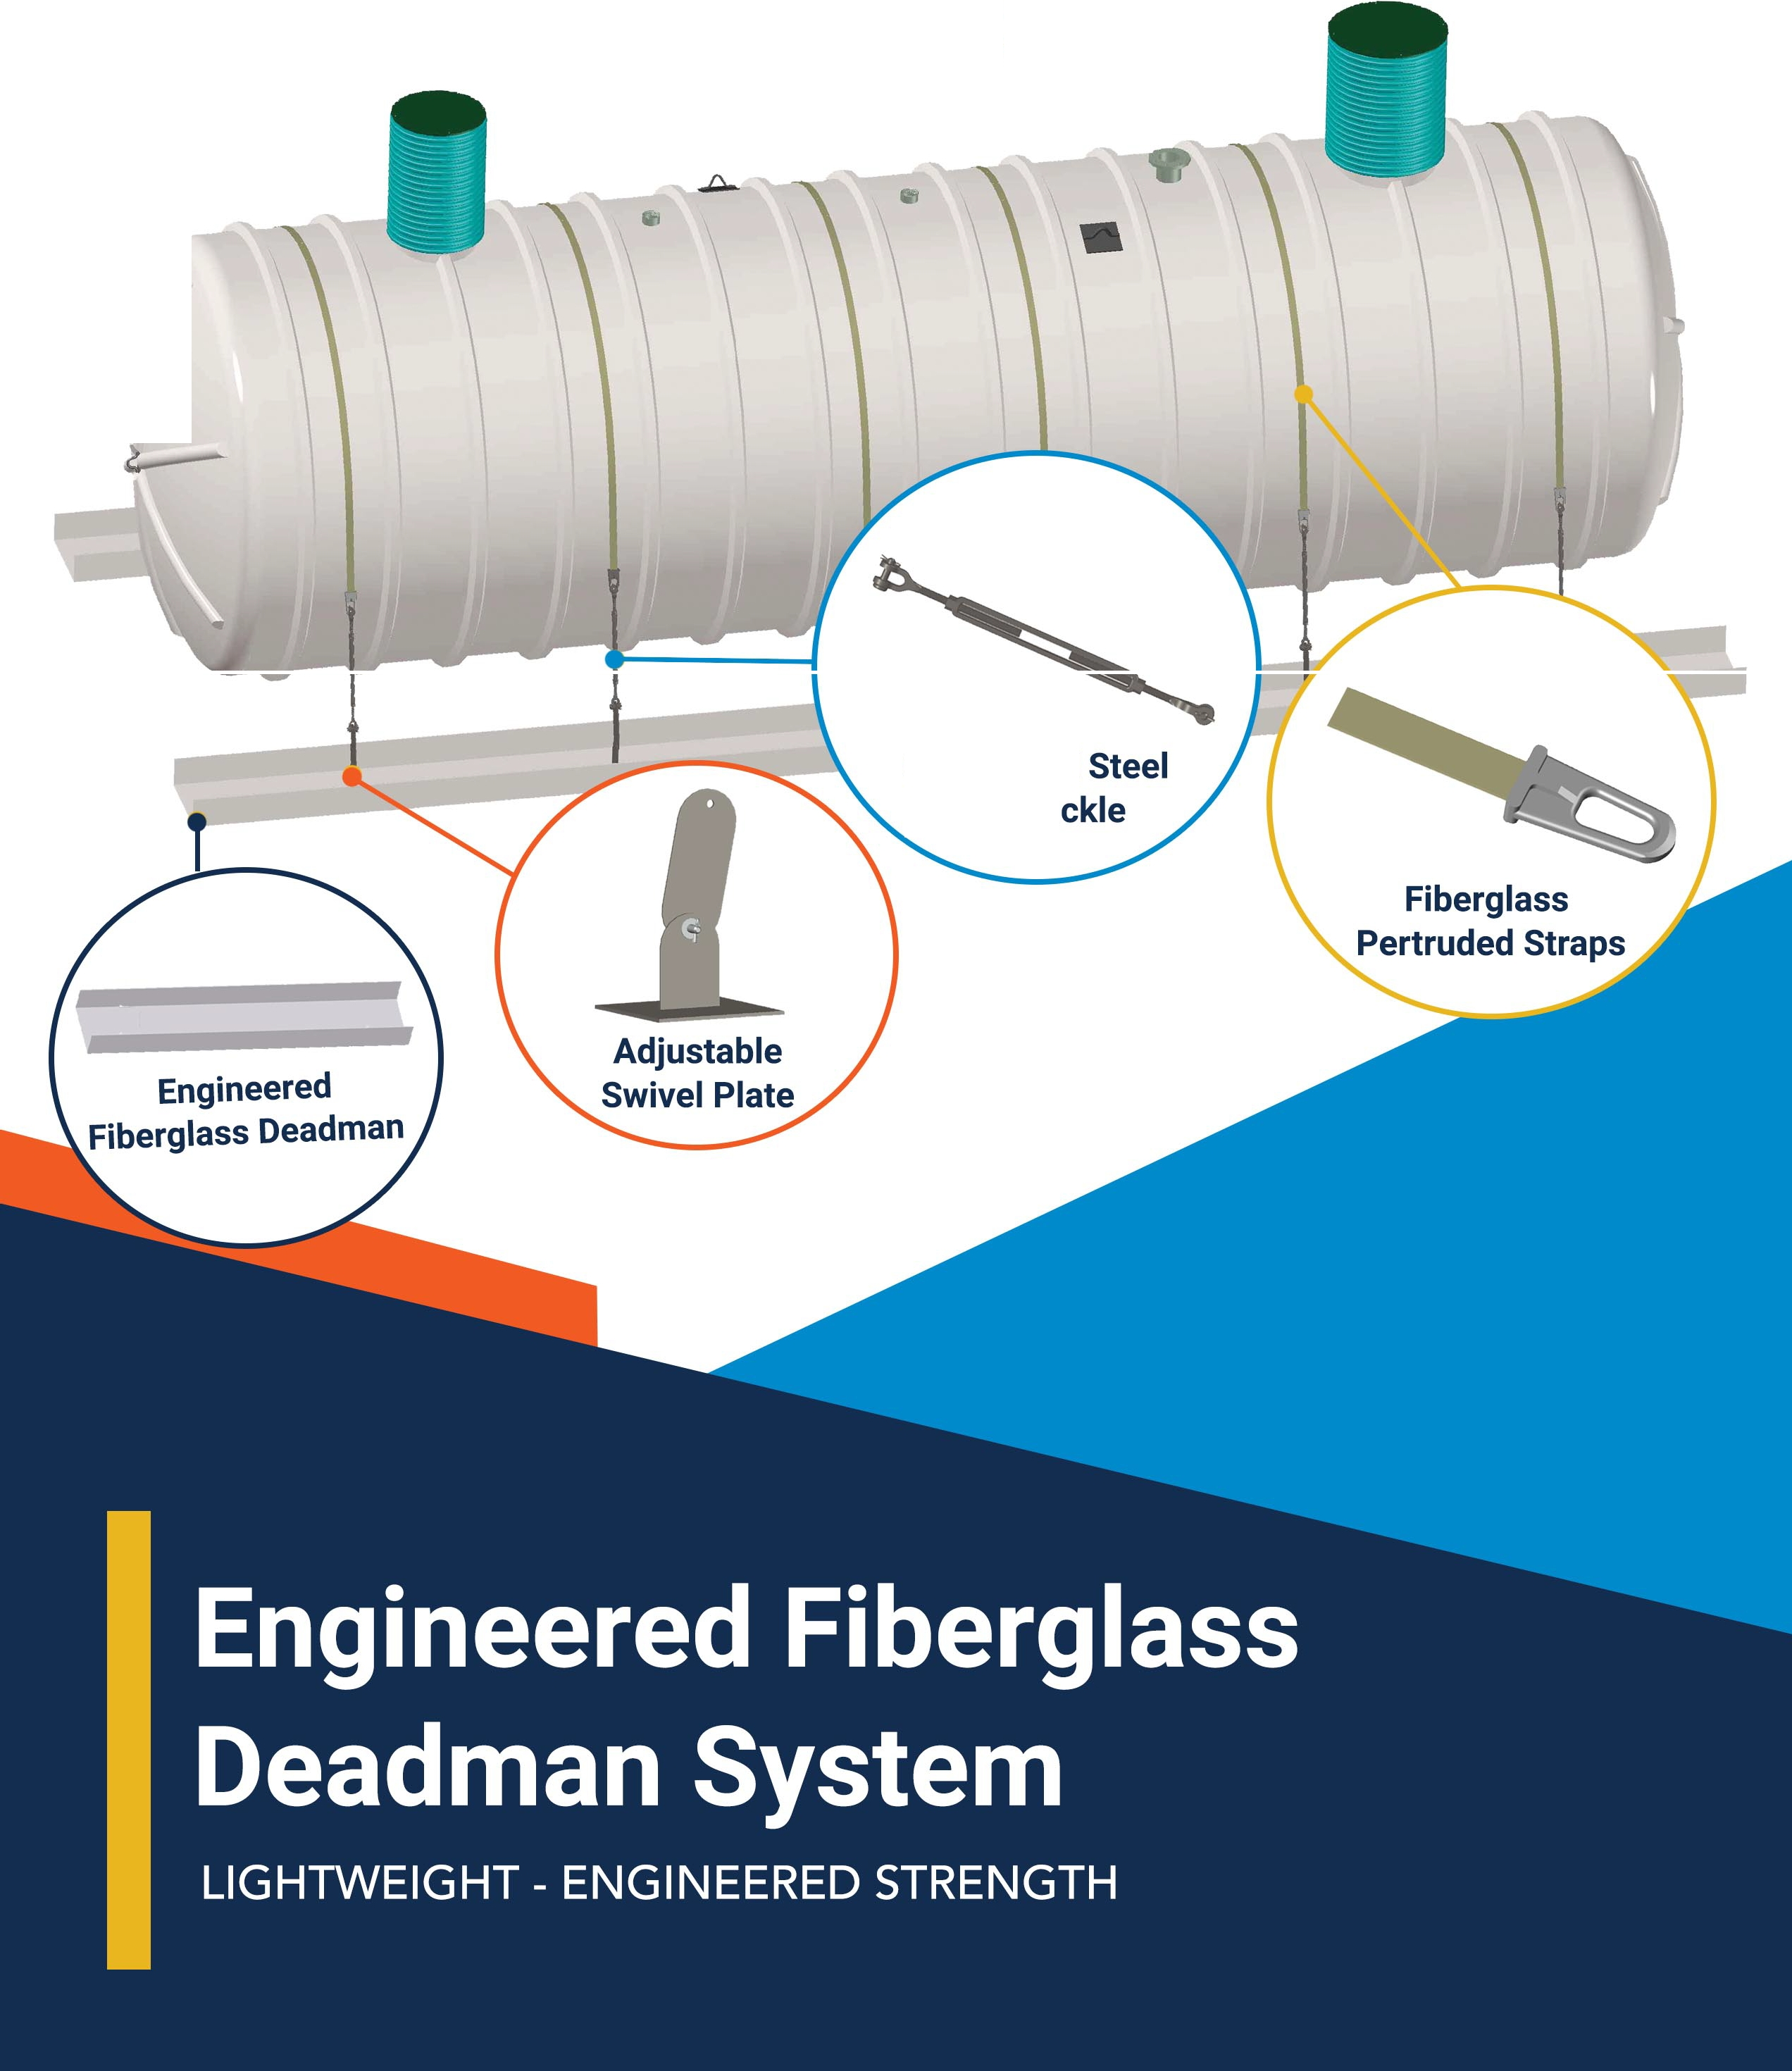
r a A

(C'Fiberglass Tank
SOLUTIONS

Galvanized
Turnbu

ENGINEERED FIBERGLASS DEADMEN

TANK DIA. | "A" | "B" | "C" | "D" | "E" | "F"
 | 4'- 4" | 85" | 12" | 2'-9" | 1'- 10" | 0'- 4"
 | 5'- 4" | 112" | 12" | 3'-3" | 2'- 1" | 0'- 7"
6' | 6'- 4" | 145" | 12" | 3'- 9" | 1 '- 11" | 1'- 3"
8' | 8'- 4" | 181" | 18" | 4'- 12" | 3'- 1" | 1'- 2"
10' | 10'- 4" | 236" | 24" | 6'- 4" | 3'- 4" | 1'- 10"
12' | 12'- 4" | 288" | 24" | 7'- 3" | 3'- 9" | 2'- 6"

- NO EXTRA FREIGHT COSTS
- LIGHTWEIGHT
- FLEXIBLE DESIGN

,���Fiberglass Tank •.J (573) 317-9620
mlf�a
147 Opportunity Rd.
1•

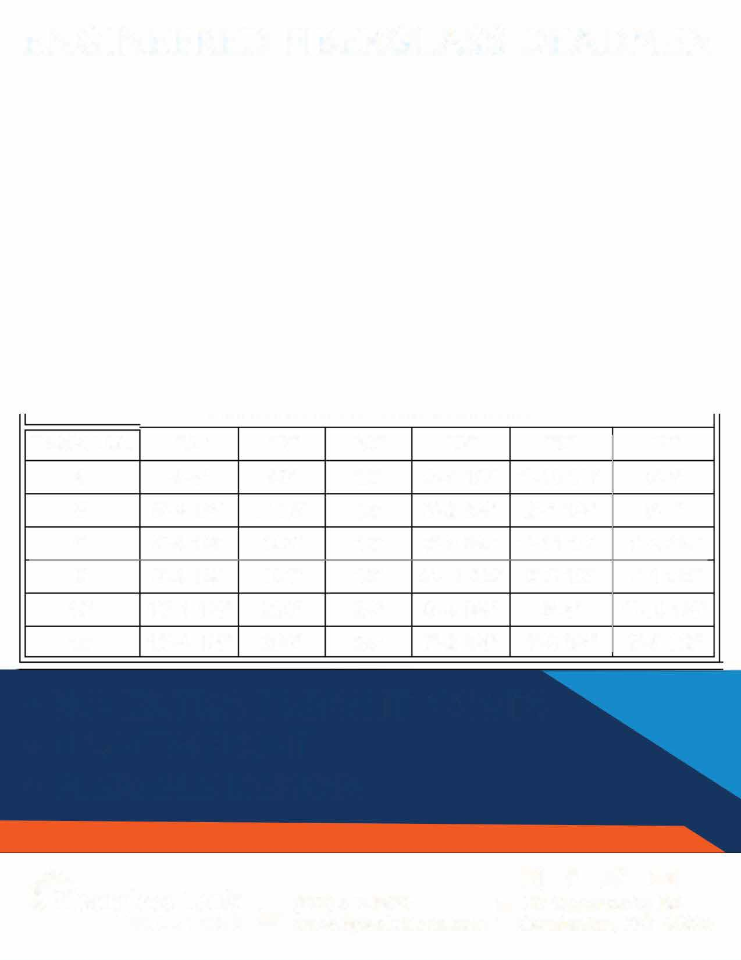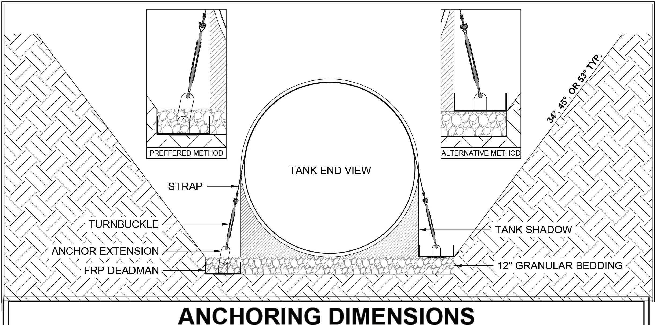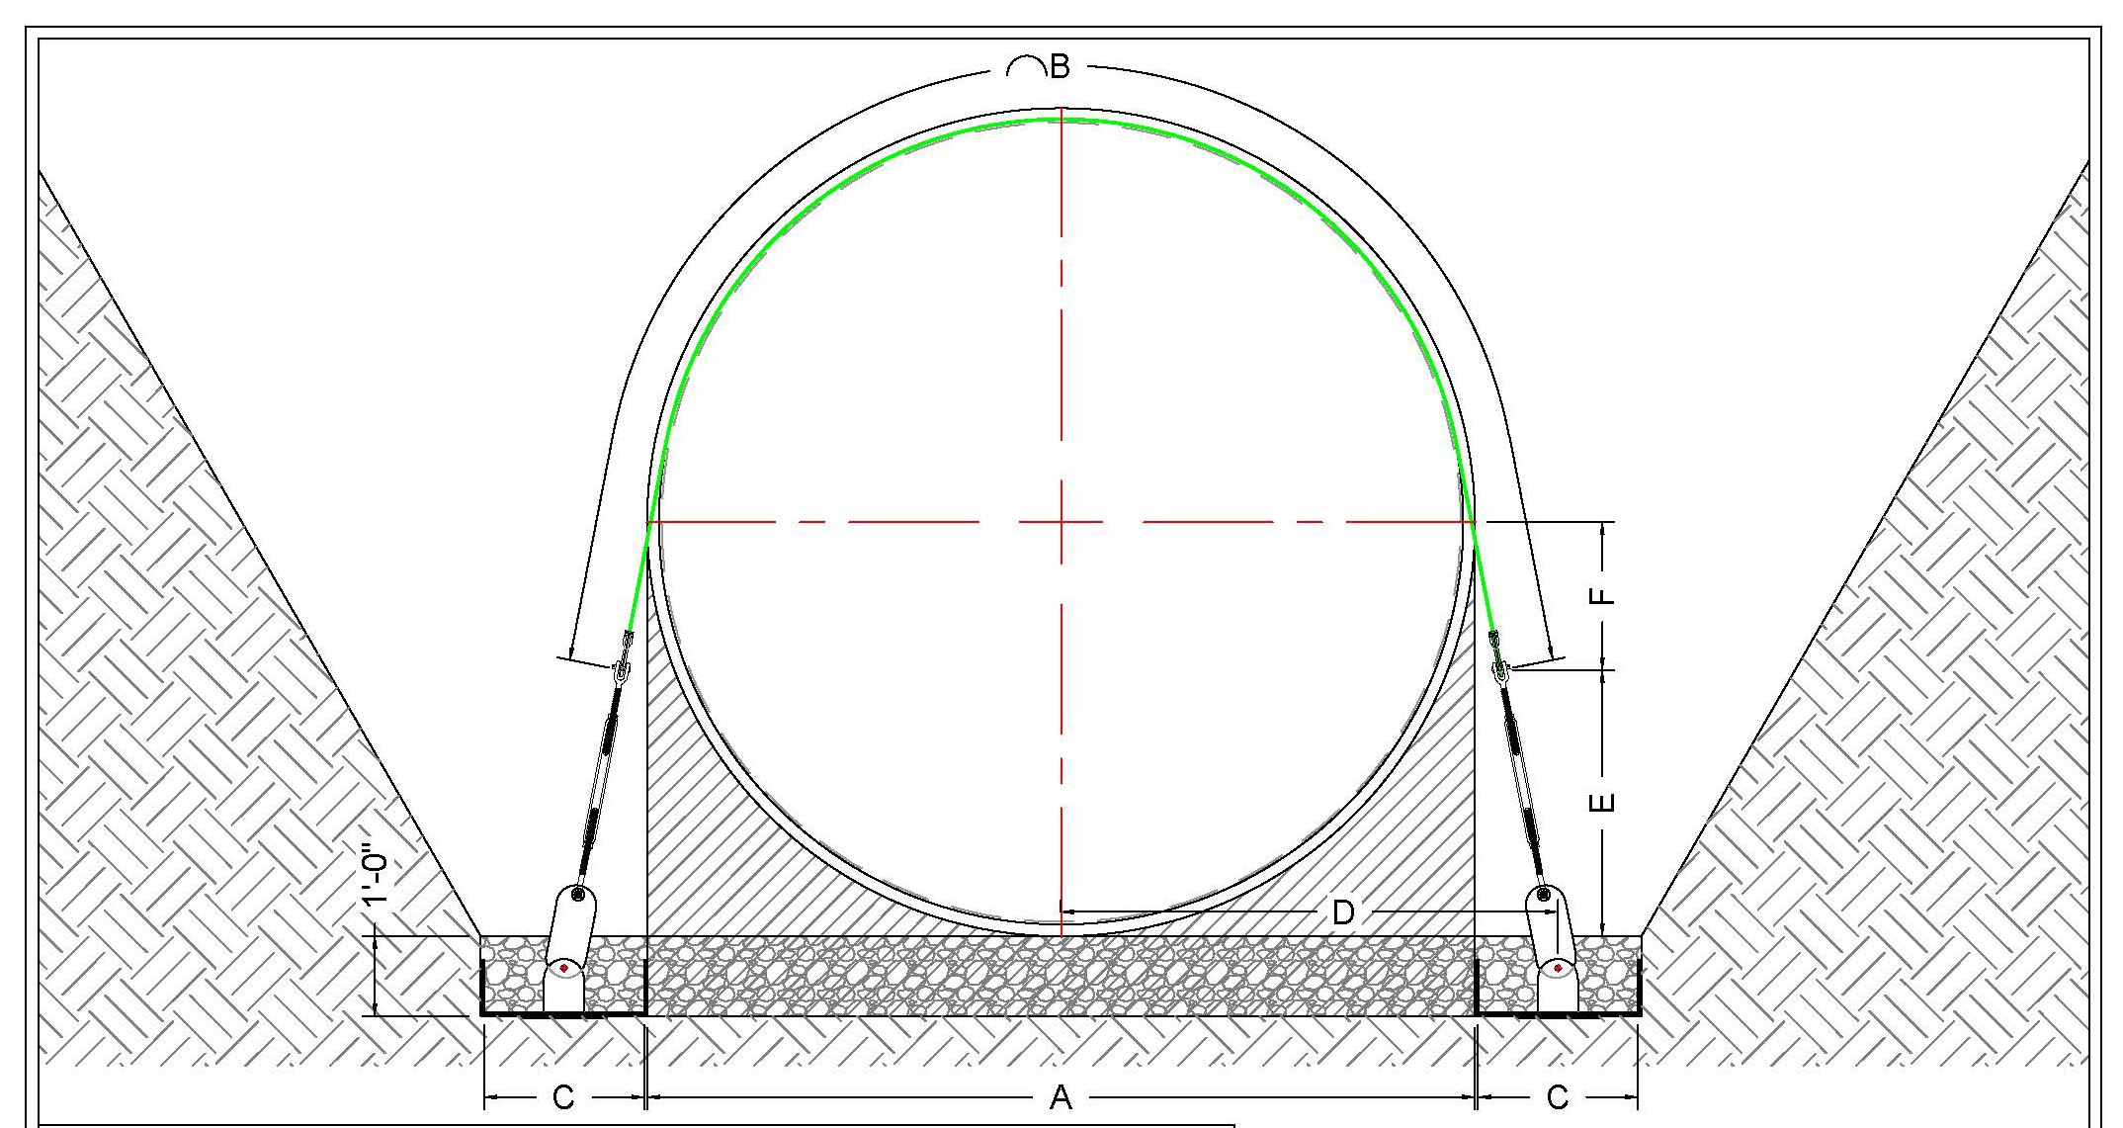SOLUTIONS .t' www.fgtsolutions.com Camdenton, MO 65020
4'
5'

