C D

B
G
L F I

J
K A M M K

E H

AQUEOUS FILM FORMING
FOAM COLLECTION TANK
 |  | www.fgtsolutions.com Phone: 573-317-9620 | DATE:  8/17/2021
MFG: 147 Opportunity Rd., Camdenton, MO 65020
Mailing: P.O. BOX 326, Montreal, MO 65591
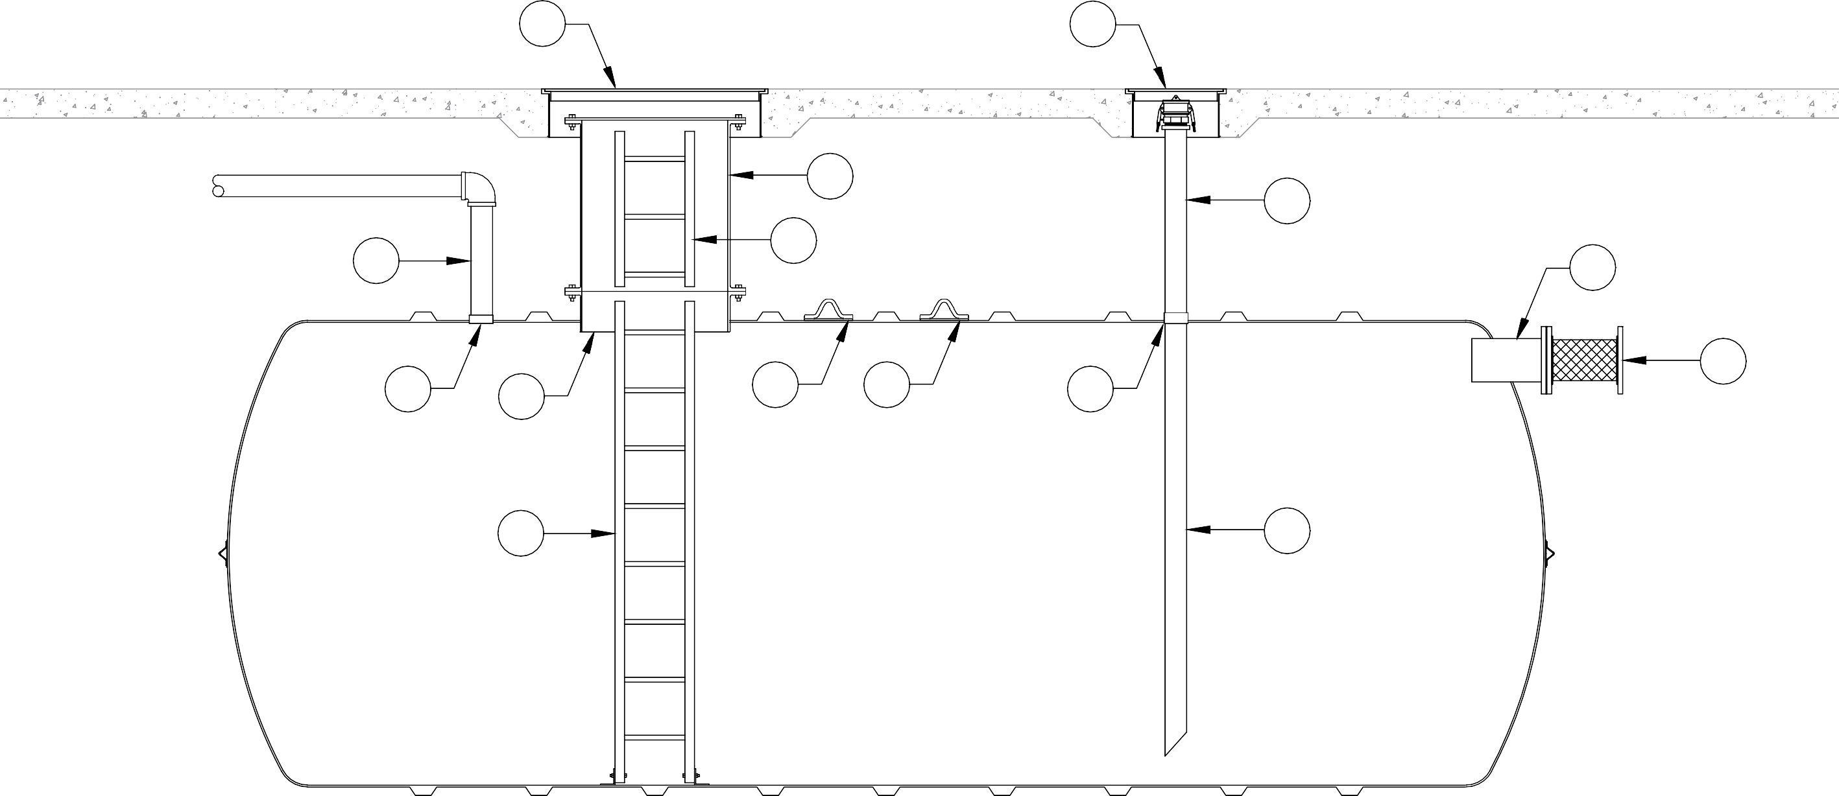
BILL OF MATERIALS
ITEM | DESCRIPTION | ITEM | DESCRIPTION
A | Ø30" MANWAY W/ STEEL COVER | H | FIBERGLASS DROP PIPE
B | Ø30" MANWAY EXTENSION W/ GASKET & HARDWARE | I | 8" FLANGE NOZZLE INLET
C | Ø42" H-20 RATED STEEL MANHOLE RING & COVER | J | 8" FLANGE X FLANGE FLEXIBLE CONNECTOR
D | Ø16" H-20 RATED STEEL MANHOLE RING & COVER | K | 4" HALF COUPLING, NPT
E | 16" WIDE FIBERGLASS LADDER | L | 4" VENT LINE
F | 16" WIDE FIBERGLASS LADDER EXTENSION | M | STEEL LIFTING LUGS
G | 4" PUMP OUT CONNECTION W/ CAM-LOCK QUICK CONNECT

