F E F

C
K
B O
G L
M
D A P P N

I
J

H

INDUSTRIAL WASTEWATER/ CHEMICAL WASH DOWN TANK (DOUBLE WALL TANK)

www.fgtsolutions.com Phone: 573-317-9620
BILL OF MATERIALS
ITEM | DESCRIPTION | ITEM | DESCRIPTION
A | Ø24" MANWAY W/ STEEL COVER | I | LEVEL SENSORS
B | Ø42" CONTAINMENT COLLAR W/ EPOXY SOCKET | J | 4" FLANGE NOZZLE W/ FIBERGLASS DROP PIPE
C | Ø42" CONT. SUMP W/ Ø37" WATERTIGHT TWIST LOCK LID | K | 4" PUMP OUT CONNECTION W/ CAM-LOCK QUICK CONNECT
D | 4" HALF COUPLING, NPT MANWAY COVER FITTING | L | 6" FLANGE NOZZLE INLET
E | Ø42" H-20 RATED STEEL MANHOLE RING & COVER | M | 6" FLANGE X FLANGE FLEXIBLE CONNECTOR
F | Ø16" H-20 RATED STEEL MANHOLE RING & COVER | N | 4" HALF COUPLING, NPT
G | 4" HALF COUPLING, NPT INTERSTITIAL MONITOR FITTING | O | 4" VENT LINE
H | LEAK DETECTION SENSOR | P | STEEL LIFTING LUGS

MFG: 147 Opportunity Rd., Camdenton, MO 65020

DATE:
8/18/2021

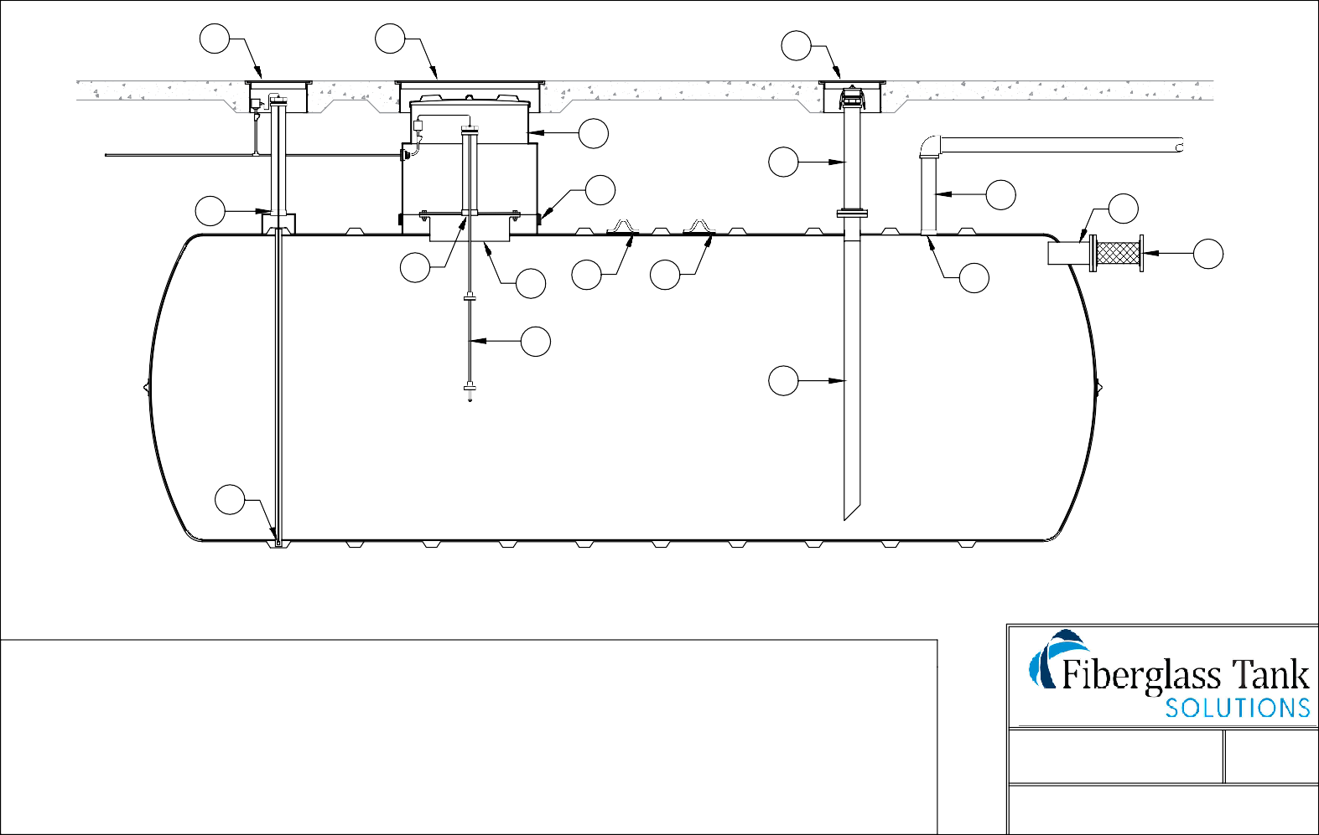
Mailing: P.O. BOX 326, Montreal, MO 65591

