D
A
E
F

H E

H

C

B F

H
F

G F

VERTICAL ABOVE GROUND TANK G G

www.fgtsolutions.com Phone: 573-317-9620
MFG: 147 Opportunity Rd., Camdenton, MO 65020
BILL OF MATERIALS
ITEM | DESCRIPTION | ITEM | DESCRIPTION
A | Ø24" TOP MANWAY W/ FIBERGLASS COVER | E | 6" FLANGE NOZZLE
B | Ø24" SIDE MANWAY W/ FIBERGLASS COVER | F | 2" FLANGE NOZZLE
C | FIBERGLASS LADDER & CAGE | G | STEEL HOLD DOWN LUGS
D | FIBERGLASS HAND RAIL & TOE PLATE | H | STEEL LIFTING LUGS

DATE:
8/20/2021

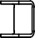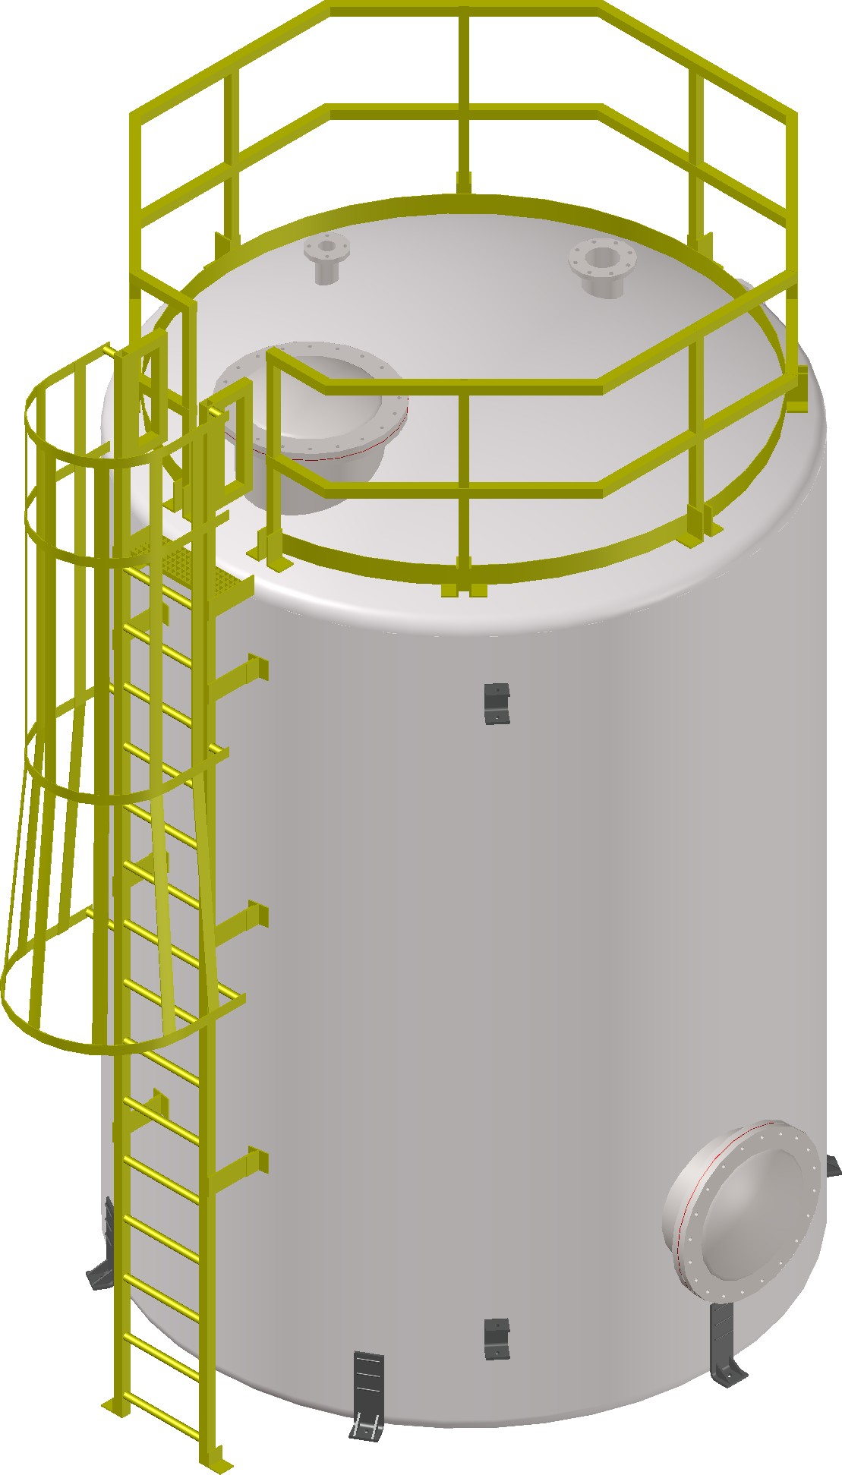Mailing: P.O. BOX 326, Montreal, MO 65591

