G F G

Q Q C N L

B
H O
M
P D E P D A

J
K

I

MEDICAL DECONTAMINATION TANK (DOUBLE WALL TANK)
BILL OF MATERIALS

www.fgtsolutions.com Phone: 573-317-9620
ITEM | DESCRIPTION | ITEM | DESCRIPTION
A | Ø24" MANWAY W/ STEEL COVER | J | LEVEL SENSORS
B | Ø42" CONTAINMENT COLLAR W/ EPOXY SOCKET | K | 4" FIBERGLASS DROP PIPE
C | Ø42" CONT. SUMP W/ Ø37" WATERTIGHT TWIST LOCK LID | L | 4" PUMP OUT CONNECTION W/ CAM-LOCK QUICK CONNECT
D | 4" HALF COUPLING, NPT MANWAY COVER FITTING | M | 6" FLANGE NOZZLE INLET
E | 4" FULL COUPLING, NPT MANWAY COVER FITTING | N | INLET PIPING W/ TEE, CLEAN OUT, AND CAP
F | Ø42" H-20 RATED STEEL MANHOLE RING & COVER | O | VENT LINE
G | Ø16" H-20 RATED STEEL MANHOLE RING & COVER | P | STEEL LIFTING LUGS
H | 4" HALF COUPLING, NPT INTERSTITIAL MONITOR FITTING | Q | ELECTRICAL SPLICE BOX
I | LEAK DETECTION SENSOR

MFG: 147 Opportunity Rd., Camdenton, MO 65020

DATE:
8/18/2021

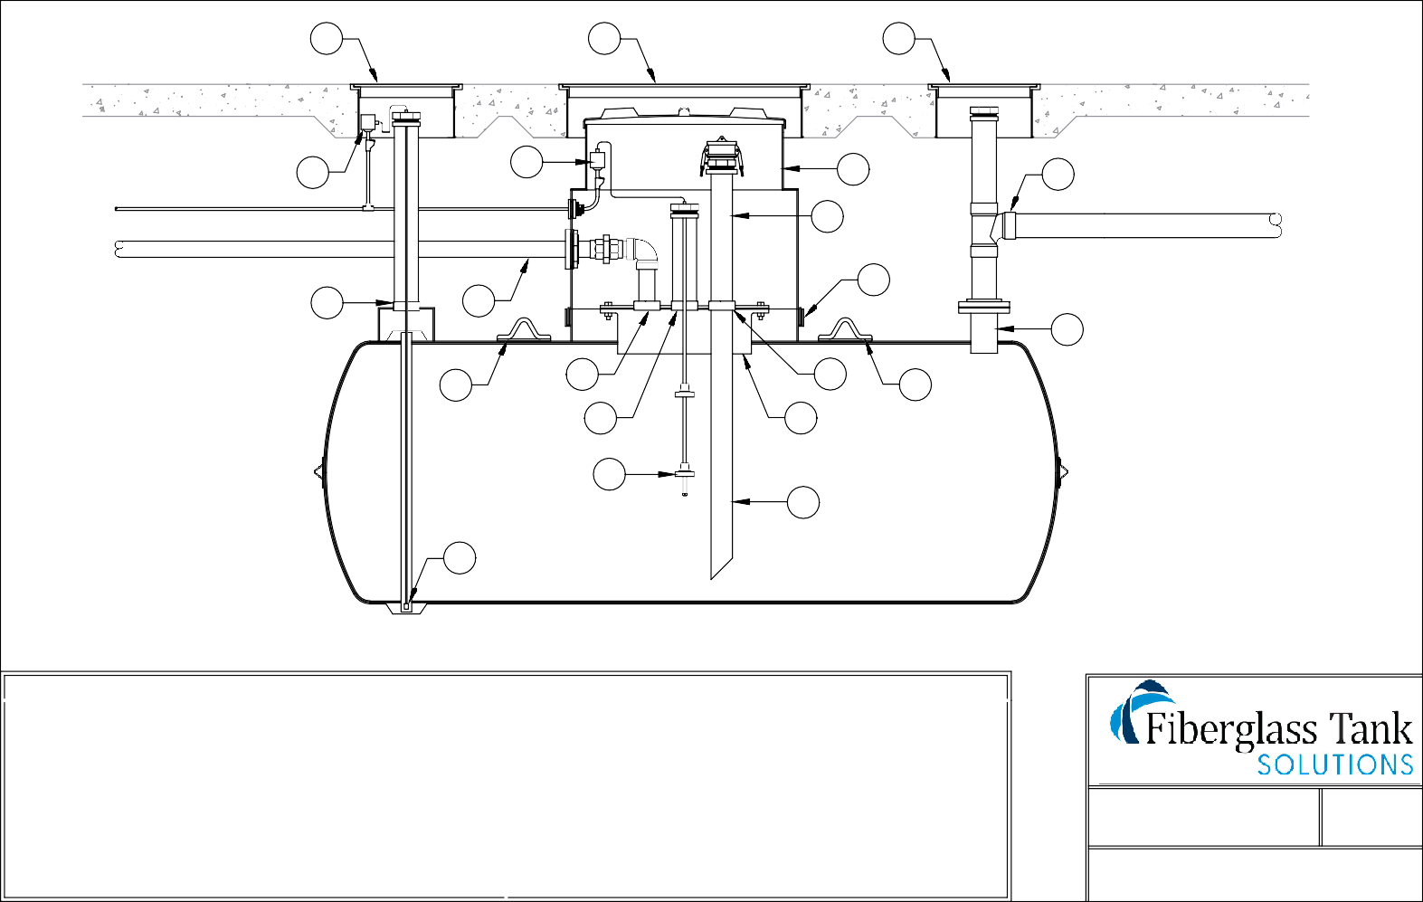
Mailing: P.O. BOX 326, Montreal, MO 65591

