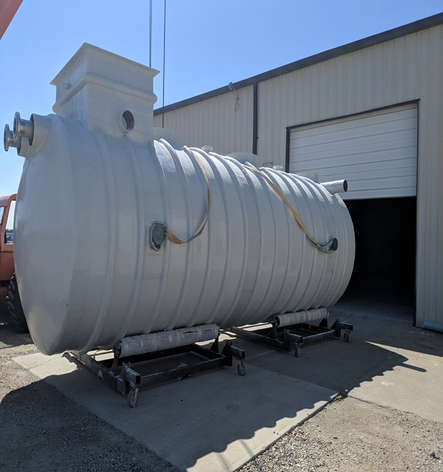FIBERGLASS UNDERGROUND HORIZONTAL TANK INSTALLATION MANUAL
& OPERATING GUIDELINES

1. INTRODUCTION

SAFETY
The following definitions will serve as a guide when reading this manual:
WARNING

Indicates a potentially hazardous situation, which if not avoided could result in death or serious injury.
CAUTION

Indicates a potentially hazardous situation, which if not avoided may result in minor or moderate injury.
CAUTION
A caution without the safety alert symbol indicates a potentially hazardous situation, which if not avoided may result in property damage.

- It is the responsibility of the owner, installer and operator to follow all requirements contained in these instructions and to comply with all federal, state, and local safety regulations that may apply to underground horizontal storage tank installation and operations.
- No instructions or procedures presented in this document should be interpreted so as to put as risk any person’s health or safety, or to harm any property of the environment.

WARNING

Follow OSHA regulations for excavations. Collapse of excavation walls could result in death or serious injury.

- Working in and around excavations is dangerous. The Occupational Safety and Health Administration (OSHA) have specific requirements that must be followed. Prior to beginning work at the site, the installer should obtain a copy of OSHA’s Standard, Part 1926 (Construction), Subpart P -Excavations. A copy of this standard is available free of charge at OSHA’s Web site (www.osha.gov).
- Careless activity or reckless operation of equipment can cause death, serious injury or property damage.
- It is important to follow the procedures and instructions in this document in order to safely and properly install an FTS underground horizontal storage tank. Failure to follow these instructions will void FTS' obligations under the limited warranty and may cause product failure, serious personal injury or property damage. A copy of the relevant FTS limited warranty is found in the printed material that accompanies each tank, and on the FTS website (www.fgtsolutions.com).
- The FTS limited warranty applies only to a underground horizontal storage tank installed according to these instructions. Since FTS does not control the parameters of any installation, FTS sole responsibility in any installation is that presented in the limited warranty.
- Comply with all applicable federal, state and local construction, health, safety and environmental codes, and industry standard practices.
- For additional information, contact your state, county and city authorities having jurisdiction, including health, fire or building departments, and environmental agencies. All work must be performed according to standard industry practices and OSHA regulations.
- Federal, state and local codes and regulations always take precedence over an FTS requirement.
- FTS must authorize – in writing and prior to underground horizontal storage tank installation –
any variation to, or deviation from, these instructions. 1

2. PREPARATION FOR INSTALLATION
- Although FTS Underground Horizontal Storage Tanks (UGT) are rugged, the UGT owner and/or the UGT owner’s representative must take care so that the UGT is not dropped or damaged during delivery, unloading and handling on the jobsite.
- Before unloading the underground horizontal storage tank from the truck, the underground horizontal storage tank owner and/or the underground horizontal storage tank owner’s representative must make sure that all tools or other items that may damage the underground horizontal storage tank during unloading are removed from the trailer bed.
- When unloading the underground horizontal storage tank from the truck, the underground horizontal storage tank owner and/or the underground horizontal storage tank owner’s representative must make sure that the underground horizontal storage tank is secured in such a way that it does not roll off the truck.

WARNING

Do not allow driver to release straps securing the underground horizontal storage tank to the truck until lifting equipment (such as a crane) is secured to the UGT lifting lug(s). Failure to do so could result in death or serious injury.
WARNING
Always chock the underground horizontal storage tank. The underground horizontal storage tank is heavy and has a large surface area. The underground horizontal storage tank will roll on sloped surfaces and could be blown about by the wind. Movement of the underground horizontal storage tank could result in death or serious injury.

- Before the underground horizontal storage tank is unloaded or relocated on the jobsite, the underground horizontal storage tank owner and/or the underground horizontal storage tank owner’s representative must complete the following steps:
  - Visually inspect the entire exterior surface of the underground horizontal storage tank to make sure that no shipping or handling damage has occurred. Look particularly for holes, cracks or deep scrapes. If damage is detected, do not attempt repairs. Contact FTS immediately.
  - Sign the shipping papers accepting the underground horizontal storage tank as delivered.
  - Be sure that all equipment used to lift the underground horizontal storage tank is rated to handle the load.
  - Select a solid, level area to place the underground horizontal storage tank, and clear that area of all rocks, trash and debris.
- When hoisting the underground horizontal storage tank follow these instructions: (See figures 2-1 –
2-2)
  - To unload these UGT, use the lifting lugs that are situated on top of the underground horizontal storage tank in its rotated position. To install the underground horizontal storage tank, carefully rotate the underground horizontal storage tank to its upright position and then use all lifting lugs situated on top of the underground horizontal storage tank in its upright position. (See FIGURES 2-1 – 2.2)
  - Do not wrap chain or cable around the underground horizontal storage tank.
  - Use guide ropes to guide the underground horizontal storage tank when needed.
  - Do not roll the underground horizontal storage tank to move it.
- Whenever a underground horizontal storage tank is temporarily placed aboveground at the site, chock it in place to prevent rolling. Tie the underground horizontal storage tank down if high winds are expected. (See Figure 2-3)
- Whenever a underground horizontal storage tank is temporarily placed above the ground in a 2
situation in which there could be freezing temperatures, always take extra care so that water does not accumulate in a way that could result in damage to the underground horizontal storage tank or any internal components.

- Excavate a hole large enough to accommodate basin, underground piping, backfill material, and adequate working space.
- When using multiple lifting lugs, the angle of the lifting sling should never exceed 30 degrees. When a situation arises that the angles will be greater than 30-degree, utilize a spreader bar to achieve an acceptable angle degree – see FIGURE 2-4 & .

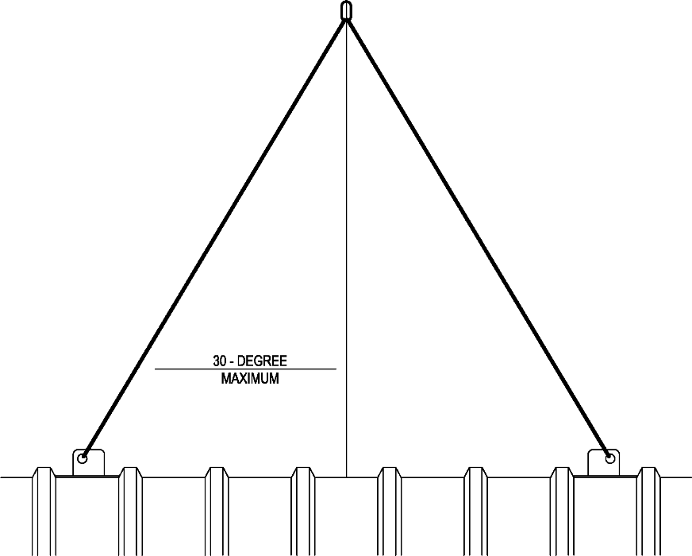

STEP 1
FIGURE 2-1

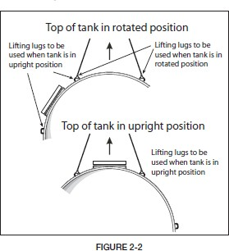

STEP 2
FIGURE 2-2

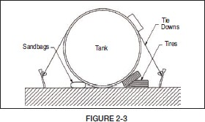

Step 3

Figure 2-3

3

3. Backfill Material
- FTS underground horizontal storage tank must be installed using pea gravel, crushed stone or select backfill as the backfill material.(See FIGURE 3-1.)
- When using rounded stone, the material is to be a mix of rounded particles, sizes between 1/8 inch and 3/4 inch. The rounded stone must conform to the specification of ASTM C-33, paragraph 9.1, sizes 6, 67 or 7.
- When using crushed stone, the material is to be mix of angular particles, sizes between 1/8 inch and 1/2 inch. The crushed stone must conform to the specifications of ASTM C-33, paragraph 9.1, sizes 7 or 8.
- If material which meets these specifications is not available, contact FTS at 573-317-9620.
TABLE 1 – Standard size of coarse aggregate meeting FTS’ rounded gravel Specifications.
Amount of material passing through each laboratory sieve given as percentage of total weight.
Grade Number | 6 | 100% | 90-100% | 20-55% | 0-15% | 0-5% | -
 | 67 | 100% | 90-100% | - | 20-55% | 0-10% | 0-5%
 | 7 | - | 100% | 90-100% | 40-70% | 0-15% | 0-5%
Sieve Size |  | 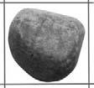 | 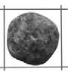 | 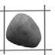
 |  | 1 inch  25.0 mm | ¾ inch  19.0 mm | ½ inch  12.5 mm | 3/8 inch  9.5 mm | 0.187 inch  4.75 mm No. 4 | 0.094 inch  2.36 mm No. 8
Note: Standard sizes of coarse aggregate per ASTMD-448, ASTM C-33 and AASHTO M 43.
TABLE 2 – Standard sizes of coarse aggregate meeting FTS’ crushed stone specifications.
Amount of material passing through each laboratory sieve given as percentage of total weight.
Grade Number | 7 | - | 100% | 90-100% | 40-70% | 0-15% | 0-5%
 | 8 | - | - | 100% | 85-100% | 10-30% | 0-10%
Sieve Size |  | 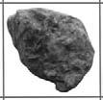 | 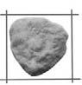 | 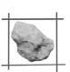 | 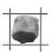
 |  | 1 inch  25.0 mm | ¾ inch  19.0 mm | ½ inch  12.5 mm | 3/8 inch  9.5 mm | 0.187 inch  4.75 mm No. 4 | 0.094 inch  2.36 mm No. 8
Note: Standard sizes of coarse aggregate per ASTM D-448, ASTM C-33 AND AASHTO M 43.

4

4. INSTALLATION
GENERAL EXCAVATION PARAMETERS
WARNING

Follow OSHA regulations for tank excavations. Collapse of excavation walls could result in death or serious injury.

- The installing contractor must take all precautions necessary to protect employees working in or near a tank excavation. These precautions should include but are not limited to the following.
- Locate and protect any utility installations near the excavation before opening the excavation.
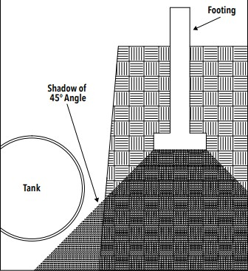
- Secure the walls of the excavation.
- Protect employees from hazards associated with water accumulation in the excavation.
- Erect barricades, etc. to prevent unauthorized vehicle or pedestrian traffic
- Inspect a minimum of once a day, the excavation and surrounding area.
- For additional information on excavation, trenching and shoring safety practice, consult OSHA’s Standard, Part 1926, Subpart P (Excavations), 650-652; and “Fall Protection Rules and Regulations.”

EXCAVATION AND TANK LOCATION

NOTICE

Improper placement of the excavation may result in damage to the tank and/or property damage.
- FTS recommends that the tank owner seek the advice of a local foundation professional engineer to determine the proper placement of a tank excavation near any existing structure(s).
- The tank owner and/or the owner’s technical representative is responsible for determining the proper placement of a tank excavation.
- In general terms, the size of the excavation is determined by:
- The number of tanks to be installed
- The size of the tanks to be installed
- The location of a tank can be affected by the location of nearby structures. When selecting a tank site, care must be taken to avoid undermining the foundations of existing structures or new buildings to be constructed. See FIGURE 4-1.
- Ensure that downward forces from loads carried by the foundations and supports of nearby structures (constructed before or after tank installation) are not transmitted to the tanks.
- Typically, the way to check the placement of the tank in relationship to a nearby structure is to do the following:

- Step 1 – Determine the depth of burial needed for the tank.
- Step 2 – Locate the footing of the structure to be considered.
- Step 3 – Determine the line that would fall into the ground from a 45-degree angle drawn downward from the corner(s) of the footing of the foundation that is closest to the tank.
- Step 4 – The tank must not fall within the “shadow” of the 45-degree-angle line drawn from the foundation’s footing. See FIGURE 4-1.
5

- Step 5 – If the tank would fall within this “shadow,” do one of the following to ensure that the tank does not fall within the “shadow”:
- Move the tank away from the existing building.
- Move the foundation of the building to be constructed away from the tank.
- Deepen the footing of the planned building’s foundation.

DRY-HOLE INSTALLATION
▪ Step 1 – Prepare a smooth, level bed, 6 inches thick, of approved backfill material, or a concrete pad designed by a project engineer.
▪ Step 2 – Place the underground horizontal storage tank onto the bed or concrete pad.
▪ Step 3 – Test base compaction to 85% density proctor and documented.

WET-HOLE INSTALLATION
▪ Step 1 – Before performing Step 1 of the dry-hole installation, pump the water from the hole and continue pumping to maintain minimum water level during underground horizontal storage tank installation.
▪ Step 2 – Test base compaction to 85% density proctor and documented.
▪ Step 3 – During Step 2 of the dry-hole installation, when setting the underground horizontal storage tank, partially ballast the underground horizontal storage tank until it settles firmly on the prepared bed. The ballast level in the underground horizontal storage tank must never exceed the water level in the hole by more than 1 foot until the backfill reaches the top of the underground horizontal storage tank.

DRY-HOLE AND WET-HOLE INSTALLATION
- From the edge of the hole, bring the backfill up in the excavation. Approved backfill material must be used at least 12 inches around the entire periphery of the underground horizontal storage tank.
- FTS recommends the use of a geotextile fabric to help separate the select backfill from the in-situ soil.
- For further information concerning geotextile specifications and installation procedures, consult the geotextile supplier’s installation guidelines or instructions.
- Polyethylene film is not considered an effective geotextile material. It may tear or degrade while in service.
- The minimum amount of back fill around the periphery of the well is normally determined by the presence or absence of traffic at the site. (See Figure 4.3 and 4.4)

Top Slab Construction Method
- The underground horizontal storage tank fiberglass top is designed to support the dead weight,
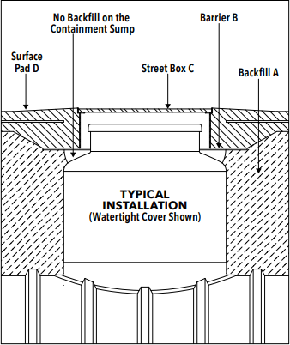
including 6” of granular bedding and 6” of a wet concrete. All load-bearing weight of the concrete pad and the traffic load exerted to the pad must be distributed to the outside perimeter of the underground horizontal storage tank. The concrete pad and outside support perimeter shall be designed by the Engineer of Record.

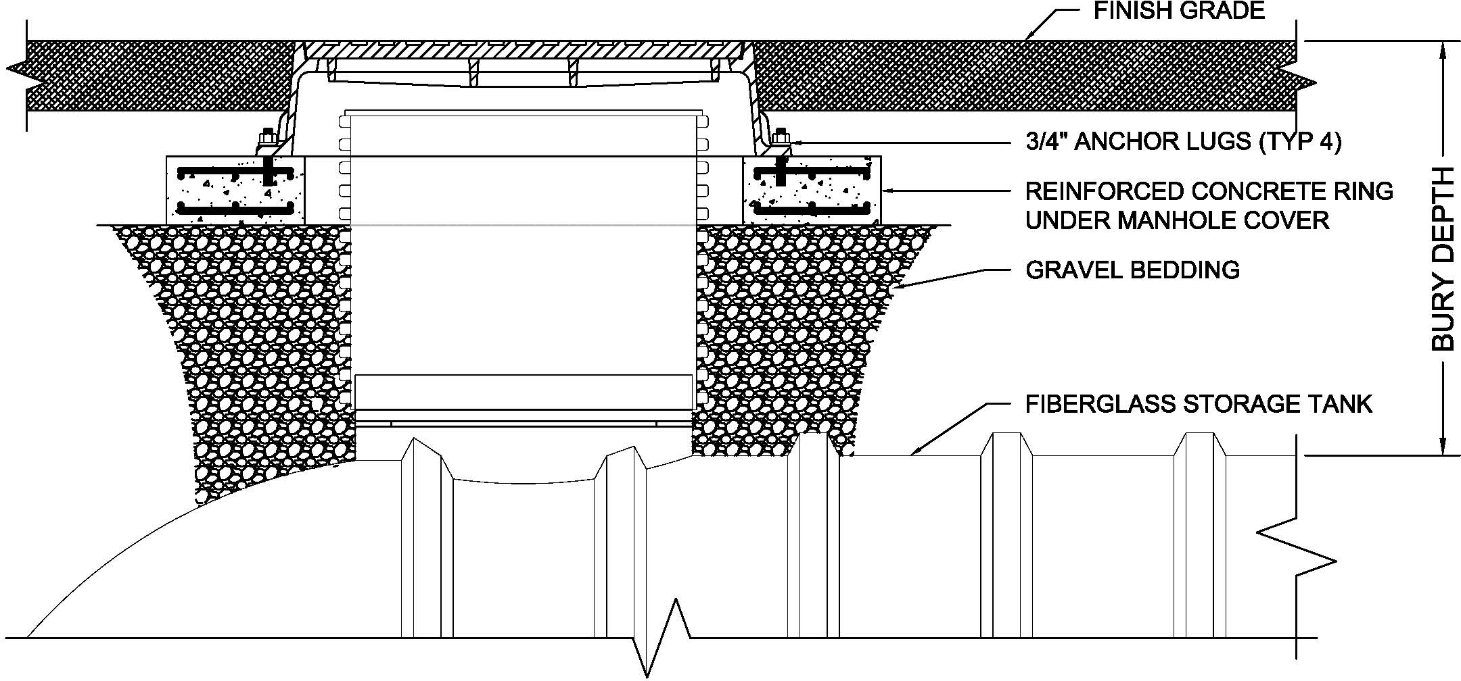
6

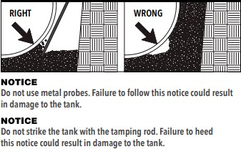
NOTICE
Overdeflection of the tank could result in damage to the tank.
- Install bottom fittings and bottom piping on water/wastewater tanks at this time.
- Place approximately 12 inches of primary backfill around bottom of the tanks between the ribs (if present and under the end domes.
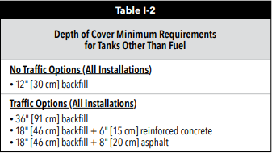
- Use a nonmetal tamping rod long enough to reach beneath the tank to push material under
the tank body and domes until solid resistance is felt. All voids must be filled and the tank must be fully supported.

5. PIPING & CONNECTION
All piping must conform to all applicable codes and standards.

CAUTION

All underground tanks shall be adequately vented to prevent the development of vacuum or pressure when filling or emptying the tank. Failure to properly vent a tank or compartment could cause tank failure and result in death or serious injury and will void manufacturer’s warranty
CAUTION
All connections to the underground horizontal storage tank must be flexible. Provisions must be made to accommodate movement and misalignment between the piping and the underground horizontal storage tank. Failure to do this may damage the underground horizontal storage tank and/or surrounding property and void manufacturer’s warranty.
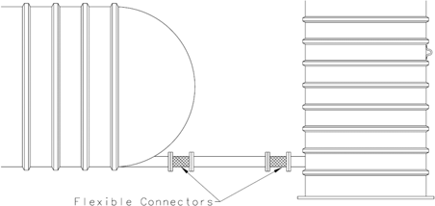

7

OPTIONAL HYDROSTATIC TEST
- Seal off influent and effluent piping with watertight caps or plugs.
- Fill the underground horizontal storage tank with water at test level openings after the hole is backfilled to top of the underground horizontal storage tank.
- Let the water stand in the underground horizontal storage tank for a minimum of 1 hour (or longer if required by applicable local codes).
- If the water level drops, check to see that plugs or caps sealing off piping are tight and then add more water to fill air voids back to the standard testing level.
- If water level does not stabilize, there may be a leak in the system. If damage is detected, do not attempt repairs. Contact the FTS by email at kevin@fgtsolutions.com, by
Phone 573-317-9620

OPERATING GUIDELINES
  - Owner must retain the underground horizontal storage tank Installation Manual and Operating Guidelines for future reference to operating guidelines.
  - In addition to the underground horizontal storage tank Installation Manual and Operating Guidelines, follow all federal, state and local laws, regulations, codes and safety precautions that pertain to underground storage UGT and/or their associated systems.
  - Consult the applicable limited warranty for each underground horizontal storage tank for further operating guidelines and limitations.
  - An FTS underground horizontal storage tank is designed to store materials identified in the manufacturer’s applicable limited warranty.

CAUTION

Storing materials other than those identified in the manufacturer’s applicable limited warranty will void FTS’ obligation under the warranty and may cause underground horizontal storage tank failure or property damage.
CAUTION
- Maximum temperature for wastewater products is 150 F.
- The minimum temperature for chemicals is 100 F.
WARNING
Do not allow anyone to enter the underground horizontal storage tank unless it has been properly emptied and vented, and unless the person entering the underground horizontal storage tank has been trained in confined- space entry procedures and applicable OSHA regulations.
Storing a material in a underground horizontal storage tank in excess of the allowable temperature may damage the underground horizontal storage tank. Failure to follow this caution may damage the underground horizontal storage tank and/or surrounding property and void manufacturer’s warranty.

Improper underground horizontal storage tank entry could cause fire, explosion or asphyxiation and could result in death or serious injury.

- RETAINING INSTALLATION MANUAL AND OPERATING GUIDELINES
After installation, underground horizontal storage tank owner must retain the underground horizontal storage tank Installation Manual and Operating Guidelines for future reference to operating guidelines.

